Student Guide

Lesson 5.07: Effective Question Delivery
Name:
Date:
Bellringer: Sort and evaluate the following questions based on the Question Matrix. What does your sorting tell you about the set of questions? How might the teacher revise the set if necessary?
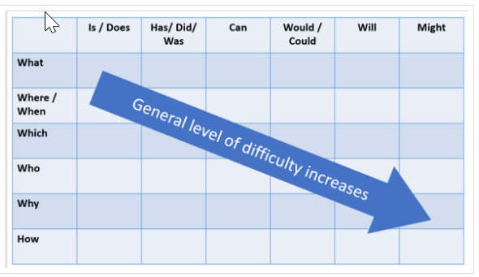
Lesson Goal: Students will be able to identify character traits and to recognize how characters change over time.
Questions (asked during a whole class read aloud of a text):
What is Stanley Woo worried about?
What is distracting Stanley from his worry?
What are some of Stanley’s thoughts?
What are some of Stanley’s actions?
What are some of Stanley’s traits?
Why does Stanley want to escape when Millie approaches him?
How would you describe Stanley Woo at the beginning of the story?
How can you support your description with evidence?

Introduction to Effective Delivery and Response

What are the three success criteria for effective delivery and response of teacher questions?

Practice Scenario:
Students are learning about the life cycle of butterflies. The goal for this lesson is for students to observe stages of the butterfly life cycle to compare how the body parts of butterflies and caterpillars help them survive. The teacher plans questions using the artifact below.

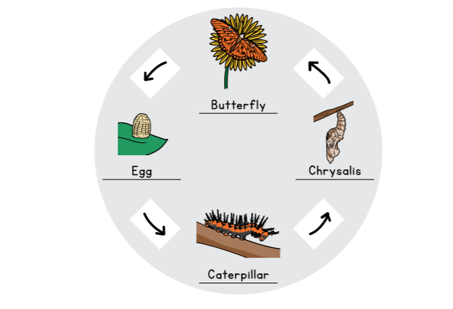

The teacher’s first question is: What do you notice about the difference between each of the stages?

Anticipated Response | Stretch-It Question(s)

Fishbowl Practice and Evaluation

 | What did the teacher do well? | What could they improve?
Wait time. The “teacher” provides at least 5 seconds of wait time before calling on or allowing a student to answer.
Direction. The “teacher” directs questions to as many students as possible.

Stretch It. The “teacher” responds to student responses in a way that provides opportunities for additional students to answer and for responses to get deeper.

Fishbowl: Fishbowl provides an opportunity for students to learn with and from their peers. To implement the fishbowl strategy, a small group of students is placed at the center or front of the classroom where they can be seen by other members of the class. From this “fishbowl” position, the small group of students engages in a discussion, role play, or other activity while their peers watch and take notes. After the discussion, role play, or activity is over, the class debriefs and shares what they noticed, what they heard, and what they learned from watching their peers.

