Student Guide

Lesson 5.09: The Exit Ticket
Name:
Date:
Bellringer:
- When are informal formative assessments useful?

- Based on your understanding of informal formative assessments when might teachers need to use additional types of formative assessments?

Introduction to the Exit Ticket

Definition:

Purpose:

Success Criteria:

Video Viewing Guide:
Respond to the following questions as you watch the video.
- Why might a teacher want to use an exit ticket every day?

- What are some considerations for designing an exit ticket?

Think-Aloud:
Annotate the following examples as the teacher guides you.
Example 1:
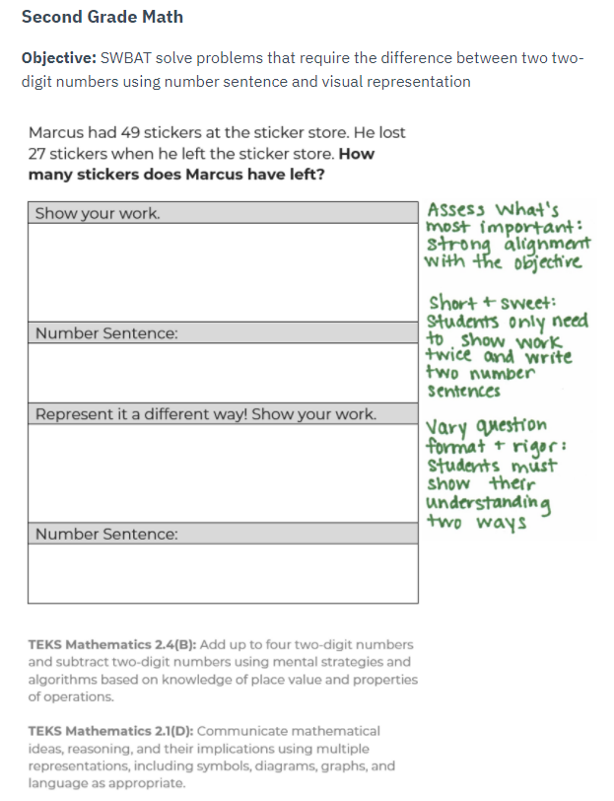

Example 2:

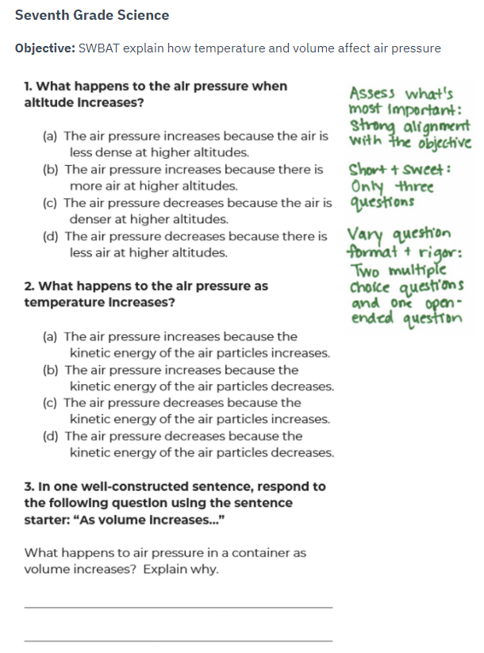

Practice 1: Analysis of Examples
Example 1
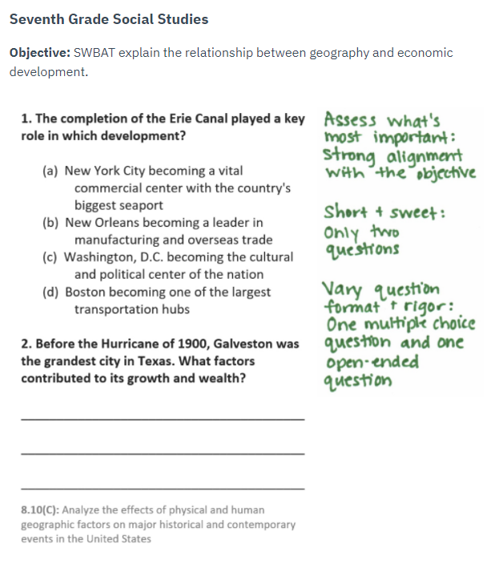

Example 2

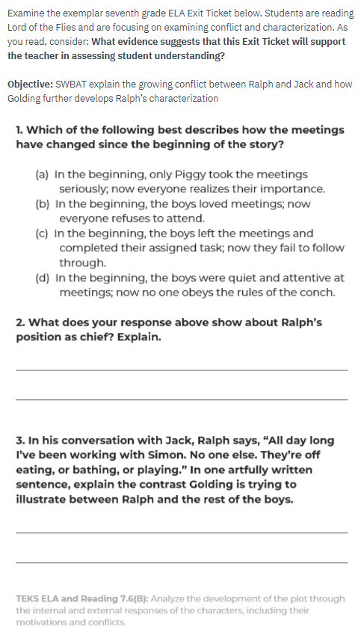

Practice 2: Revise a Non-example
Examine the good (but not great) sixth-grade science Exit Ticket below. As you read, consider whether the exit ticket meets each indicator of the success criteria or not. Complete the graphic organizer to show your thinking and provide suggestions for improvement if criteria are not met.
Objective: Students will be able to evaluate whether questions are testable.
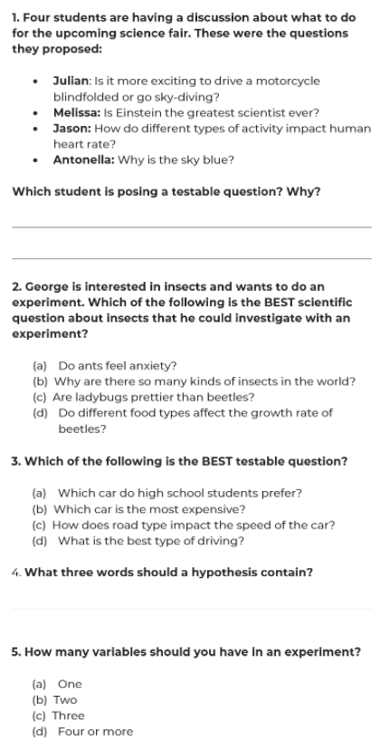

Indicator | Met/Not Met | Explanation and Suggestions for improvement (if necessary)
Assess what’s most important

Vary question format

Vary question rigor

Keep it short and sweet

