Student Guide – Answer Key

Lesson 5.09: The Exit Ticket
Name:
Date:
Bellringer:
- When are informal formative assessments useful?
Quick pulse check, looking for patterns and trends, not individual needs, when self-assessment is sufficient

- Based on your understanding of informal formative assessments when might teachers need to use additional types of formative assessments?
When a teacher wants to know individual outcomes, when the content is more specific and self-assessment is not enough

Introduction to the Exit Ticket

Definition: short informal assessments administered at the end of class to gauge students’ progress towards the lesson’s objective
Purpose: to gain insight into who learned what and who requires additional help (or enrichment) tomorrow; provides an opportunity to respond to individual students, to determine what to focus on in upcoming lessons, and to reflect on what works and doesn’t work in your classroom
Success Criteria:
- Assess what’s most important
- Vary question format
- Vary question rigor
- Keep it short and sweet

Video Viewing Guide:
Respond to the following questions as you watch the video.
- Why might a teacher want to use an exit ticket every day?
To have an artifact that shows what students learned and what they didn’t learn each day
- What are some considerations for designing an exit ticket?
Start from the goal – figure out what the objective is for the day, determine what task students can complete to show mastery, ensure the exit ticket has the same challenges they faced during the lesson

Think-Aloud:
Annotate the following examples as the teacher guides you.
Example 1:
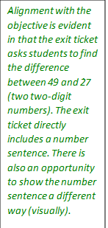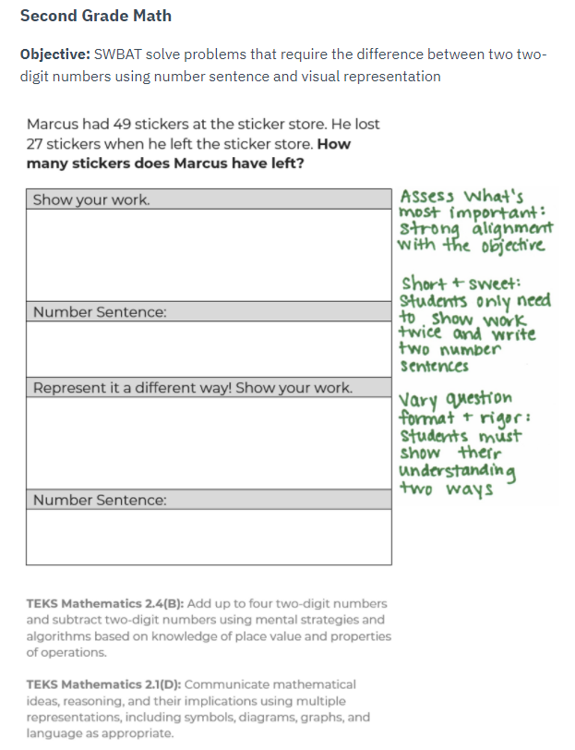

Example 2:

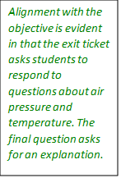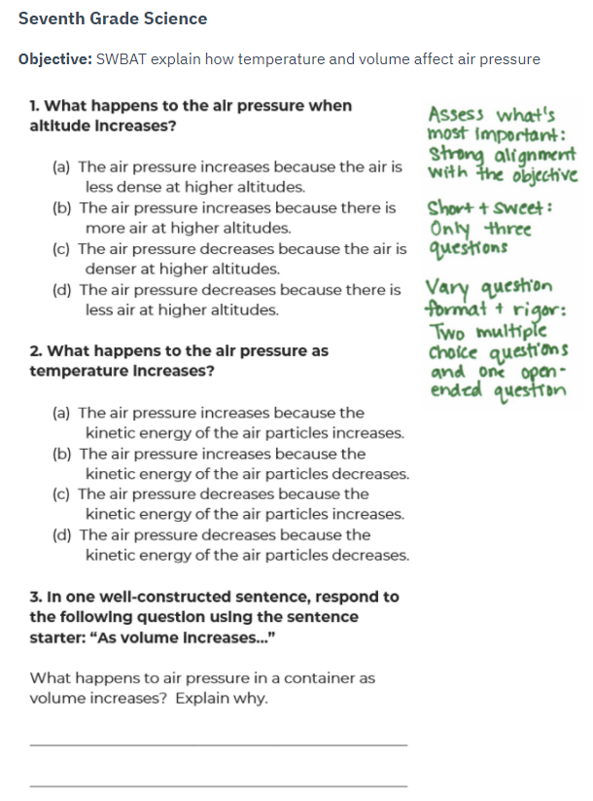

Practice 1: Analysis of Examples
Example 1
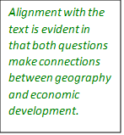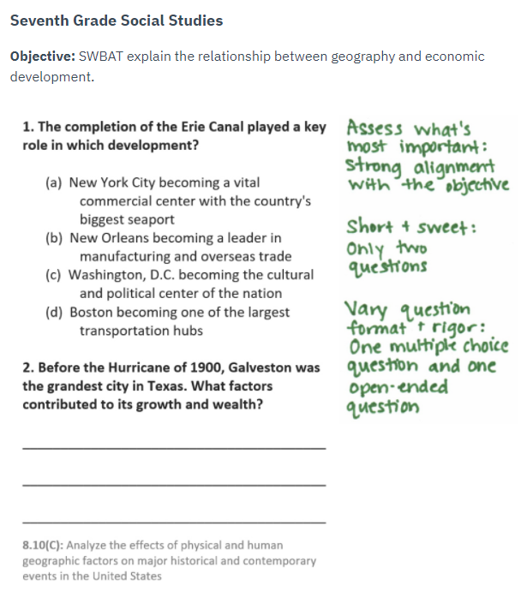

Example 2

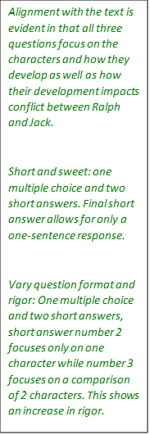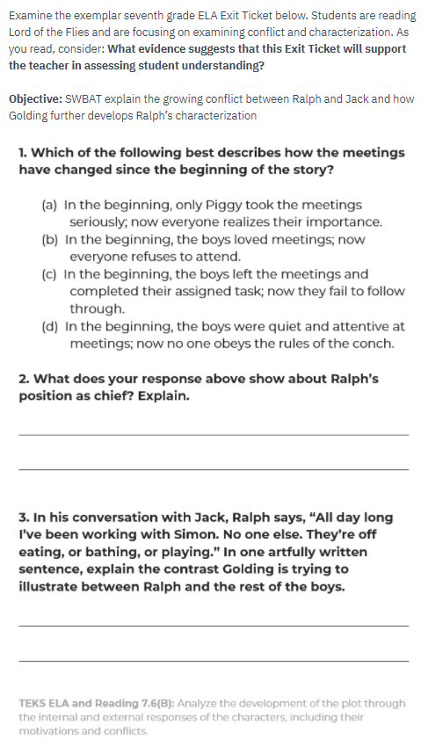

Practice 2: Revise a Non-example
Examine the good (but not great) sixth-grade science Exit Ticket below. As you read, consider whether the exit ticket meets each indicator of the success criteria or not. Complete the graphic organizer to show your thinking and provide suggestions for improvement if criteria are not met.
Objective: Students will be able to evaluate whether questions are testable.
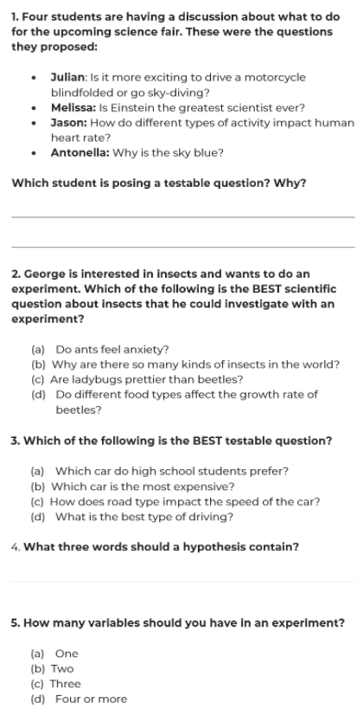

Indicator | Met/Not Met | Explanation and Suggestions for improvement (if necessary)
Assess what’s most important | Not Met | Questions 1 – 3 assess what is most important. Questions 4 and 5 do not and can be cut.
Vary question format | Met | There are multiple choice and short answer questions represented.
Vary question rigor | Not Met | All three of the first questions are essentially the same. Students are evaluating the testability of questions. The teacher could vary the rigor by asking students to create their own testable question or by adding easier questions that ask about the criteria for testable questions. The new question(s) should replace at least one of the 3 similar questions.
Keep it short and sweet | Not Met | There are 5 questions, 2 of which are unnecessary. Cut the last 2.

