Student Guide

Lesson 5.10: Exploring Other Formative Assessment Options
Name:
Date:
Bellringer:
Examine the 1st grade Exit Ticket below. As you read, consider whether the exit ticket meets each indicator of the success criteria or not. Complete the graphic organizer to show your thinking and provide suggestions for improvement if criteria are not met.

Objective: Find the area of a rectangle through multiplication of the side lengths.
- Complete the following multiplication problems:
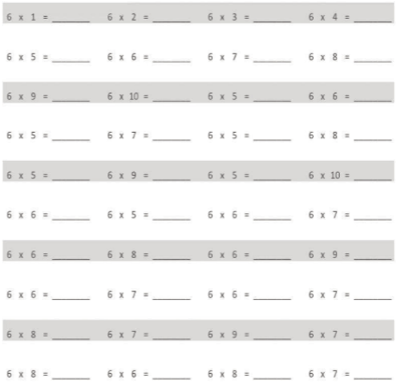

- Write a multiplication equation to find the area of a rectangle with a height of 6 inches and a width of 8 inches.

- Eliza’s bedroom measures 6 feet by 7 feet. Her brother’s measures 5 feet by 8 feet. Eliza says their rooms have the same exact floor area. Is she right? Why or why not?
Adapted from: https://digital.greatminds.org/insync/teacher/resources/emtx.g3.m4/file/60ffa26d3a22e40042b71cfd (Lesson 5)

Indicator | Met/Not Met | Explanation and Suggestions for Improvement (if necessary)
Assess what’s most important

Vary question format

Vary question rigor

Keep it short and sweet

Jigsaw Note-Catcher
Strategy and Description (What is it? What can a teacher learn from it?) | When to Use/Not Use? | What does the teacher do/say? | What do the students do/say?

Practice 1: Scenario Analysis
Review each scenario below. Work with your home group to determine the best assessment choice for each scenario. Explain your group’s reasoning for each choice.
Scenario | Assessment Choice | Reasoning
Ms. Rodriquez wants to assess her students’ awareness of rhetorical devices. She wants to provide students with a quotation and see if they can quickly identify the correct rhetorical device used in the quotation. What kind of assessment might she use? Explain your reasoning.

Mr. Tyler is introducing his math students to word problems for the first time. In order to do word problems, students will need to engage a number of skills including reading, problem-solving, identifying important and not important information. He plans for this introduction to take a week and he wants students to think deeply about the process of completing word problems as well as their own strengths and opportunities for learning. What type of formative assessment should he use?
Mr. Carpenter wants to assess his students’ ability to analyze historical documents – including texts, images, and political cartoons – to identify and engage in discussion about major themes related to the impact of the Industrial Revolution on various economic classes. What kind of assessment(s) might he use? Explain your reasoning.
Ms. Kahn is teaching her students about ecosystems. Specifically, they are going to learn about how the elements of ponds work together to create ecosystems that sustain a variety of life forms. Students have learned some key vocabulary terms and before she goes further, Ms. Kahn would like to know how students are making sense of the vocabulary terms and their relationship to one another. What type of formative assessment should she use?

Jigsaw
Jigsaw is a strategy teachers can use to help students learn with and from each other. Jigsaw is often used when a teacher wants to introduce a significant amount of information all at once. During Jigsaw, the teacher breaks the information into smaller pieces. Working in home groups, students assign different pieces to each member of their group. Home groups then split up into expert groups. In their expert groups, students become experts on their assigned piece of the lesson with other students who have chosen the same piece. After becoming experts on their part of the lesson, they return to their home groups to teach their classmates what they learned and to learn about the other pieces of the lesson from their classmates.

