Student Guide

Lesson 5.12: Summative Assessments | Paper and Pencil Assessments
Name:
Date:
Bellringer:
In most of your classes, you take pencil and paper assessments regularly. Perhaps you take Friday quizzes and/or have big tests at the end of units that take all or most of a class period. Take the below pre-assessment about pencil and paper assessment practices and be ready to talk about your thinking on each of these questions.
Practice | True or False? | Why?
- Teachers should include things on the pencil and paper test that they haven’t taught and ask questions that try to trick students.
- How a pencil and paper text is formatted and spaced is important to capturing student thinking accurately.
- Students should have more questions on the assessments than they can get to in the time that they have.
- Teachers should make sure students clearly understand all directions on a test before they begin.
- Questions should always be aligned to the most challenging material and should never assess recall or basic facts.
- Students need to learn to block out distractions in the classroom when they take tests. Teachers don’t need to worry about distractions – that is part of life.
- Taking the test yourself as a teacher before you give it is a good strategy to refine the test.

Paper and Pencil Assessments - Best Practice Graphic Organizer
Development - Designing and writing a summative pencil and paper assessment to accurately measure learning.
No Surprises
Take it yourself
Vary the question challenge
Format with space and clarity
Clear directions and scoring
Administration - Giving the assessment to ensure accurate results.
Reduce distractions
Focus on the why
Retake policy
Scoring - Determining which questions were answered correctly and which were not and using that to determine an overall grade or assessment score.
Score with feedback
Look whole class patterns to guide instruction
Intervene for struggling students

Practice – Pencil and Paper Best Practice Examples and Non-examples.
Scenario or Assessment | Which best practice is relevant to this scenario? | Is this and example or non-examples and why? If a non-example, what would suggest changing?
#1 Ms. Costa takes a few moments prior to the test to tell everybody that, “This a great opportunity to do your best on the test and show all that you have learned this quarter! The test isn’t a judgment of how smart you are and but to give you and me an understanding of what you have learned. It is important that you relax and do your best.” | Focus on the why.
#2 Mr. Waits has students take a big, important end-of-quarter essay test on the novel they have been reading. When he hands that test back to Renee, she sees “B+ Good job!” at the top and sees no other marks on the test. | Score with feedback.
#3 Mr. Phillips gave his students a test and notices that nearly ¾ of the class didn’t even get to the last half of the test. | Take it yourself.
#4 Ms. Tarbert wrote a math test at the end of the unit which she will grade. She wants to challenge her students, so she included some questions that she will teach later in the year, thinking that this will give her a chance to understand which students already know some of the content. | No Surprises.
#5 Ms. Wilson gives the following assessment on a sheet of paper. Which two best practices are relevant to this scenario?  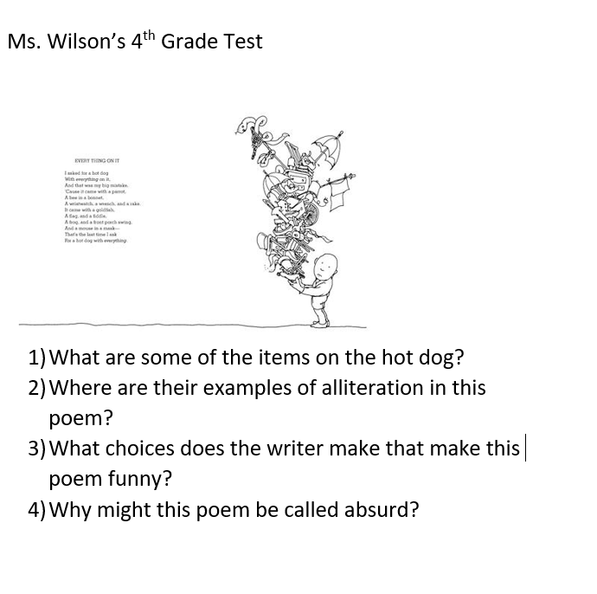 | Format with space and clarity.  Clear directions and scoring.
#6 Mr. Wells’ classroom has a large window on one side that looks out onto the courtyard. His fifth period class is taking a test while some other students are on their lunch break and are hanging out in the courtyard taking a brain break, talking, and having fun. It is warm, so Mr. Wells has the windows cracked and sound from the courtyard filters into the room. Mr. Wells’ class sits down to take their Friday math quiz. | Reduce distractions.
#7 Ms. Jones, an upper elementary school math teacher, scores the unit tests from her last quarter test. While all the students clearly had time to complete the test, she notices that more than half of the students had trouble with the last word problems. As a result, Ms. Jones spends time the following week practicing this type of word problem with her class. | Look whole class patterns to guide instruction.

