Student Guide – Answer Key

Lesson 5.12: Summative Assessments | Paper and Pencil Assessments
Name:
Date:
Bellringer:
In most of your classes, you take pencil and paper assessments regularly. Perhaps you take Friday quizzes and/or have big tests at the end of units that take all or most of a class period. Take the below pre-assessment about pencil and paper assessment practices and be ready to talk about your thinking on each of these questions.
Practice | True or False? | Why?
- Teachers should include things on the pencil and paper test that they haven’t taught and ask questions that try to trick students. | False | Pencil and paper tests should test what was taught. You are not trying to make a test more difficult than the content you taught. There should be no surprise questions on the test.
- How a pencil and paper text is formatted and spaced is important to capturing student thinking accurately. | True | Poor formatting (for instance, leaving too little space for answers, include unclear or pixelated pictures, etc.) can impede student’s ability to show what they know – the entire point of assessment.
- Students should have more questions on the assessments than they can get to in the time that they have. | False | Generally, pencil and paper assessment length should give students enough time to answer all the questions so that the teacher can get a full picture of what students know across all the learning goals that are being assesses.
- Teachers should make sure students clearly understand all directions on a test before they begin. | True | Quickly and clearly reviewing any directions for the test will make sure that students can show their knowledge and thinking (for instance, if students are allowed to reference a novel they are reading to answer questions about it, repeating that direction at the beginning is a good practice.)
- Questions should always be aligned to the most challenging material and should never assess recall or basic facts. | False | Different types of questions may be used for different purposes. It is helpful to include assessments that questions that both determine whether a student has a basic understanding of core vocabulary and facts and to assessing deeper, conceptual understanding.
- Students need to learn to block out distractions in the classroom when they take tests. Teachers don’t need to worry about distractions – that is part of life. | False | Students can do their best work in a testing environment free of distractions. It is important for the teacher to remove as many distractions as possible from the environment so students can concentrate on the assessment.
- Taking the test yourself as a teacher before you give it is a good strategy to refine the test. | True | Often taking the test will help you refine the directions and questions, know roughly how long it takes, and format to help capture student’s best thinking.

Paper and Pencil Assessments - Best Practice Graphic Organizer
Development - Designing and writing a summative pencil and paper assessment to accurately measure learning.
No Surprises | The questions you ask should align to content you taught.
Take it yourself | Taking the test yourself can help you make sure you the wording of the questions are clear and determine how long it will take.
Vary the question challenge | Some questions can focus on basic facts and recall and some questions should require deeper cognitive engagement.
Format with space and clarity | Anything that makes it harder for students to record their thinking (such as too little space for a written response) can make it hard for students to show what they know.
Clear directions and scoring | Always make sure it is clear exactly what you want students to do on the test and how many points each section of the test is worth.
Administration - Giving the assessment to ensure accurate results.
Reduce distractions | Ensure that the classroom has as few distractions as possible. This should mean students themselves should be silent during the assessment, outside noises are minimized, and distracting visual content is avoided (computer screen blanked, white board notes erased)
Focus on the why | The purpose of assessment is for both the teacher and student to know how the student is progressing to help learning – it isn’t to make long-term judgements or to compare students. No single test is an accurate measure of how smart a student is but instead a measure of how well they learned the content taught.
Retake policy | Generally, it can be helpful to provide students opportunities to retake tests so they have another opportunity to show their work. Some teachers may choose to not allow retakes if they think retakes are causing students to postpone learning.
Scoring - Determining which questions were answered correctly and which were not and using that to determine an overall grade or assessment score.
Score with feedback | Sometimes marking questions right or wrong is feedback enough; other times it can be very helpful to be more specific to tell the student where they could improve their work. Putting a C+ at the top of an essay is best when paired with descriptive feedback (e.g. “This paragraphs cites no evidence for your claim. You could make your writing stronger by adding clear textual evidence.”)
Look whole class patterns to guide instruction | Often, on a test, you may see a particular question that many students got wrong. This can help inform what should be retaught and practiced more in the whole class.
Intervene for struggling students | When individuals or groups of students struggle, this is your que as a teacher to figure what you can do to help them and to understand why they are struggling and help them take the steps to learn the content.

Practice – Pencil and Paper Best Practice Examples and Non-examples.
Scenario or Assessment | Which best practice is relevant to this scenario? | Is this and example or non-examples and why? If a non-example, what would suggest changing?
#1 Ms. Costa takes a few moments prior to the test to tell everybody that, “This a great opportunity to do your best on the test and show all that you have learned this quarter! The test isn’t a judgment of how smart you are and but to give you and me an understanding of what you have learned. It is important that you relax and do your best.” | Focus on the why. | Example. Ms. Costa calms the students and focuses on the purpose of the test.
#2 Mr. Waits has students take a big, important end-of-quarter essay test on the novel they have been reading. When he hands that test back to Renee, she sees “B+ Good job!” at the top and sees no other marks on the test. | Score with feedback. | Non-example. Having only the score at the top of the test leaves Renee unsure of what she did well and what she can improve on. Mr. Waits could have done things like pointed to parts of her responses that were effective and how she could strengthen her essays moving forward.
#3 Mr. Phillips gave his students a test and notices that nearly ¾ of the class didn’t even get to the last half of the test. | Take it yourself. | Non-example. Mr. Phillips seems to have given a test that was too long. One possible way to solve this would have been for him to have taken the test himself to gauge how long it might take.
#4 Ms. Tarbert wrote a math test at the end of the unit which she will grade. She wants to challenge her students, so she included some questions that she will teach later in the year, thinking that this will give her a chance to understand which students already know some of the content. | No Surprises. | Non-example. Summative pencil and paper assessments should test only what has been taught. If Ms. Tarbert wants to pre-assess students who may already have mastered some content, she can do that as part of her instruction at the beginning of a future unit – but not on a high-stakes summative assessment.
#5 Ms. Wilson gives the following assessment on a sheet of paper. Which two best practices are relevant to this scenario?  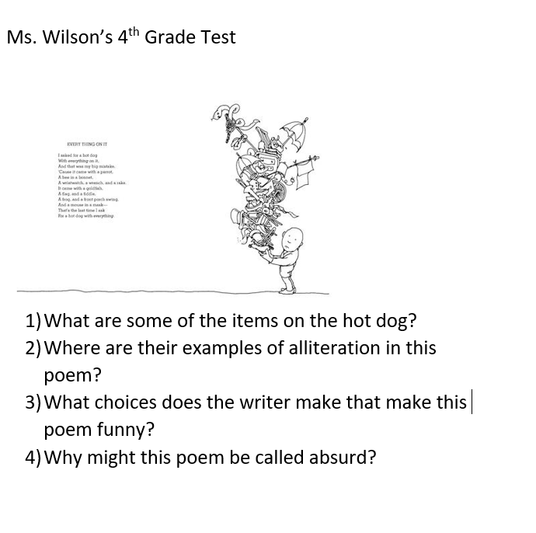 | Format with space and clarity.  Clear directions and scoring. | Non-example  Format with space and clarity. Students will not have room on this sheet of paper to write their responses beneath each question. The poem is also too small to read.  Clear directions and scoring. The assessment doesn’t have any clear directions nor does it indicate anything about how the test will be scored.
#6 Mr. Wells’ classroom has a large window on one side that looks out onto the courtyard. His fifth period class is taking a test while some other students are on their lunch break and are hanging out in the courtyard taking a brain break, talking, and having fun. It is warm, so Mr. Wells has the windows cracked and sound from the courtyard filters into the room. Mr. Wells’ class sits down to take their Friday math quiz. | Reduce distractions. | Non-example. Mr. Wells’ might consider shutting the windows and pulling the blinds for the test to make sure students have the ability to focus their full attention on the assessment.
#7 Ms. Jones, an upper elementary school math teacher, scores the unit tests from her last quarter test. While all the students clearly had time to complete the test, she notices that more than half of the students had trouble with the last word problems. As a result, Ms. Jones spends time the following week practicing this type of word problem with her class. | Look whole class patterns to guide instruction. | Example. This pencil and paper test given to the whole class has helped Ms. Jones identify word problems as a challenge area for the whole class.

