Student Guide – Answer Key

Lesson 5.13: Introduction to Rubrics
Name:
Date:
Bellringer: Match each assessment type (Essay, Performance Task, Portfolio, or Project) to the appropriate scenario below based on the purpose of the scenario.
Summative Assessment Scenario | Matching Assessment Type
Mr. Bozart is an art teacher who wants to assess his students’ progress in using color and texture. He knows that many of the students had no prior experience before this class and wants to show them how they have progress against the art standards relating to this topic. He has asked the students to collect several samples of their work and reflect on how that piece of work shows progress toward each standard. | Portfolio
Mrs. Greene is a history teacher who just finished teaching a unit how geographic factors influenced civilizations over time. She has asked her students to respond to the following prompt “Identify a key civilization studied during this unit. Describe how the geographic features surrounding this civilization contributed to the emergence, expansion and decline of this civilization.” | Essay
Mr. Thomas is a science teacher who just finished a unit on alternative energy sources and energy transfer. To assess their knowledge, he created a scenario where the students are asked to work as engineers to design, build and test a solar cell using common materials for a remote community in need of power. As a part of this activity, students will present their solar cell by sharing their research, design process and justification for materials used. | Performance Task
Mrs. Rios, a math teacher, just finished a unit on area and perimeter. As a part of the assessment, students were asked to create their own robot where each body part must be a specific perimeter or specific area. The students create their robot using graph paper, coloring, and decorating it to give it personality. | Project

Notes: Introduction to Rubrics
Rubric | Tool used to assess student performance against a set of success criteria for a task
Benefits of Rubric for Teachers | Rubrics help teachers to be clear about the criteria for grading as well adding more consistency into the grading process.
Benefits of Rubric for Students | Rubrics help students to understand the learning targets and the success criteria for the task.

Qualities of an Effective Rubric | Description
List of specific criteria | Students and raters will clearly know the expectations for the task based on the key criteria identified. These are the standards by which the task will be rated.
Focused on the most important content | the rubric should measure the key skills and knowledge aligned to the instructional objective.
Clearly defined and measurable levels of performance | these represent the level to which the task meets expectations. Typically, a quality rubric will describe 3-5 levels of performance. Each level of performance will be specifically described. The more specificity used, the easier it will be to rate, it will be rated more consistently, and students will clearly understand the rating.
Reliable | It must be descriptive enough so that various raters will identify the same or similar score.

Practice 1: Introduction to Rubrics
Please annotate/take notes the rubric below as it is discussed in class.
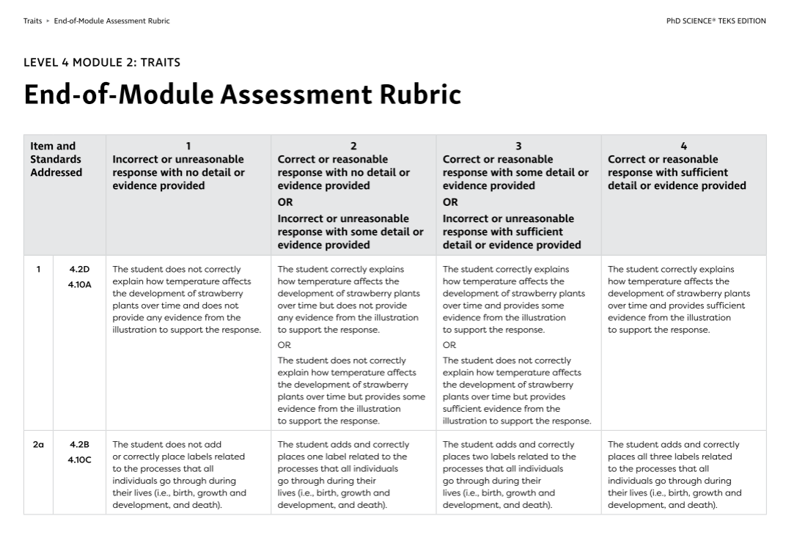

Practice 2: Non-Example of Quality Rubric
Poetry Project Rubric
Poem Analysis |  | _______/60
5 poetic terms discussed | _______/35
5 poetic terms used | _______/25
Presentation |  | _______/20
Music played | _______/15
Engaging! | _______/5
Flyer |  | _______/20
Creativity | _______/10
Clarity | _______/10
Total |  | _______/100

What recommendations can be made to improve this rubric to better align to the characteristics of quality rubrics?
Clearly defining the criteria and making sure it aligns to instructional objectives will make the rubric focus on the most important content. Creating different levels of performance, with descriptions of each level for the criteria. The more specific the descriptions, the better chance it will be reliable.

Student Practice-Revising a Rubric using Characteristics of Quality Rubrics

Below is an example of a rubric that a 5th grade science teacher is thinking of using to assess her student’s science fair projects. In the assignment, students were asked to design a science experiment, test the experiment, collect, and analyze experiment data and communicate the results via a visual display. How does this align to the characteristics of quality rubrics? What suggestions or feedback could you provide the teacher for improvement of the rubric?
5th Grade Science Fair Project Rubric
 | 4 | 2 | 0
Neatness | The display is visibly appealing and doesn’t have any errors | The display is visually appealing or doesn’t have any errors | The display is not visually appealing and has several errors
Completion | The project was completed by the deadline | Most of the project was completed by the deadline | Student did not complete the project
Explanation | The display clearly describes the experiment and its design | The display partially describes the experiment or its design, but not both | The display does not describe the project or its design
Data Collection | Project data was collected, analyzed, and represented on the display | Data was collected and analyzed or represented on the display but not both | Data was not collected or analyzed and was not represented on the display.

How does this rubric align to the characteristics of quality rubrics?
This rubric does have specific criteria and there are defined levels of performance. The descriptions of each level show some specifics as to make it easier to reproduce ratings by different raters.
What suggestions for improvement would you provide to make it a quality rubric?
Answers may vary but could include the following: Based on the description of the assignment, it does not seem that the rubric focuses on the most important content. The assignment asks students to design, conduct and collect data on a science experiment, producing a display to communicate their work. The rubric should focus on experimental design, data collection, and results of the experiment rather than neatness and completion. Also, the levels of performance do not seem as descriptive as they could be. Clarifying what a 4 means and a 2 means would be important to students.

