Unit 6: Instructional Alignment

Lesson 6.02: Sequencing a Unit Plan

Lesson at Glance
Warm-Up (5 mins)  - Bell Ringer | Instruction (20 mins)  - Intro to Sequencing a Unit Plan  - Sequencing a Unit | Application (20 mins)  - Practice #1  - Practice #2  - Debrief  - Exit Ticket

TEKS | 3 | The student explores the teaching and training profession. The student is expected to:  - Summarize and apply acquired pedagogical knowledge and skills needed by teaching and training professionals;
 | 6 | The student plans and develops effective instruction. The student is expected to:  - explain the role of the Texas Essential Knowledge and Skills in planning and evaluating instruction;  - explain the rationale for and process of instructional planning components such as vertical alignment and scope and sequence;  - demonstrate lesson planning to meet instructional goals.
Objectives | - Define and describe sequencing.  - Identify and evaluate how learning is sequenced throughout a unit to build understanding.
Rationale/  Summary | Purposeful lesson sequencing creates a continuum of learning that builds on prior knowledge from one lesson to another. In this lesson, students will increase their knowledge of sequencing by examining two units, analyzing the structure, and determining which unit is more likely to build student understanding. Students will explain how the sequencing of a unit contributes to the effectiveness of a unit plan.
Formative Assessment and Exemplar Response | Students will complete the following short answer and multiple-choice questions:  - What is sequencing as it relates to a unit plan?  The process of organizing concepts in an order that starts simple and builds in complexity.  - How does sequencing a unit in a logical way help build student mastery of the standard?  - Learning builds on prior knowledge. The sequencing of lessons within a unit considers prior knowledge on a larger scope.  - Students analyze ideas and make sense of them.  - Purposeful lesson sequencing creates a continuum of learning which builds upon the previously taught lesson.  - How does sequencing of a unit relate to the Science of Learning? Choose the BEST answer.  - Students must make meaning of the content.  - For learners to take in, process, and learn information, it must be presented in small increments and in a sequential manner.  - If students aren’t paying attention, they will not be able to learn.  - Sequencing isn’t related to the Science of Learning.  - Mr. Jones is starting a unit on two-dimensional and three-dimensional shapes with his kindergarten students. Here is the order he plans to introduce the concepts:  - Two-dimensional flat shapes (square, triangle, rectangle, circle)  - Three-dimensional flat shapes (cone, sphere, cube, cylinder)  - Two-dimensional and three-dimensional shapes (recognize shapes in different orientations and sizes)  Do you think this is the best approach to build student understanding? Why or why not?  See 6.2 Exit Ticket – Answer Key for exemplar responses.
Vocabulary | Sequencing |  | Organizing concepts in an order that starts simply and builds in complexity

Est Time | Instructional Activities (including formative assessments) | Materials
5 mins | Bellringer: Use a concept map to show the relationships between the key components of a curriculum.  T: (students can create any concept map that shows relationships, but a flow chart might be best). | Student Guide
5 mins | Intro to Sequencing a Unit Plan  T: (Display the quote on the ppt and ask students to turn and talk to discuss what it means.)  “He who would learn to fly one day must first learn to stand and walk and run and climb and dance; one cannot fly into flying.”  Friedrich Nietzsche  S: (Discuss the quote in pairs)  T: (Call on students to give their response to the quote). For a student to master reading a text fluently or tackling long division, they must first learn some prerequisite skills or prior knowledge.  T: How would you define prior knowledge and what is its role in learning?  S: Prior knowledge is information or context a learner already has about a topic before they learn new information. Prior knowledge can help students: Make connections to new information, better understand new information, and store and retrieve new information.  T: Yes - learning builds on prior knowledge and helps students better understand and retain new information. The sequencing of lessons within a unit considers prior knowledge on a larger scope.  T: (Guide students through notes using the PPT). Sequencing lessons within a unit is the process of organizing concepts in an order that starts simply and builds in complexity.  T: Purposeful lesson sequencing creates a continuum of learning which builds upon the previously taught lesson.  T: In the Science of Learning Unit, you learned about sequencing across a learning task. Now, we are going to look at sequencing across a whole unit. | PPT  Student Guide
15 mins | Sequencing a Unit  T: Let’s review the working memory model from our Science of Learning unit. (Share image via PPT.)  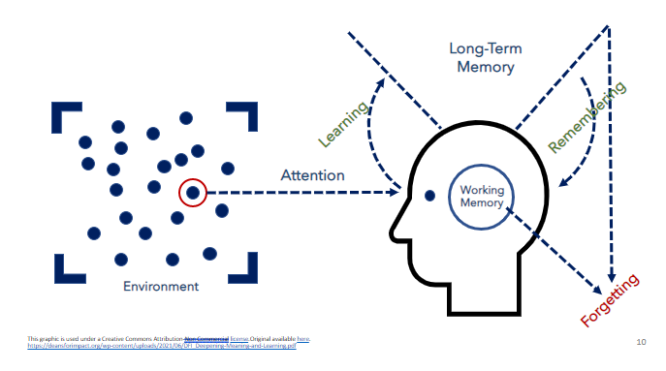  T: What do you remember about the Working Memory?  S: The Working Memory is where you wrestle with ideas and consciously make sense of them.  T: Why is it important for students to attend to and think about the content?  S: The more a learner spends time attending to the content and thinking about the content in the Working Memory, the more likely they will learn the content.  T: How does this understanding impact instruction?  S: Students must have multiple opportunities to think about and practice content to make sense of it.  T: Due to the very tight limits of working memory - the part of the mind we use to process and store information - people can only take in, absorb, and process a small amount of information at a time. Just as an expert in a subject matter didn’t become an expert all at once, learners can’t learn everything all at once either.  T: What does this mean in terms of pacing and sequencing for a teacher?  S: A teacher must teach small pieces at a time and sequence the learning in a logical way to help give students the information they need when they need it to build understanding.  T: For learners to take in, process, and learn information, it must be presented in small increments and in a sequential manner.  T: That means a teacher must consider how multiple lessons on a topic of study build on one another and how they should be ordered to achieve optimal learning outcomes.  T: Let’s look at an example of a Kindergarten Curriculum Map from HQIM. (Share image via PPT as students annotate the example and nonexample in the student guide.)  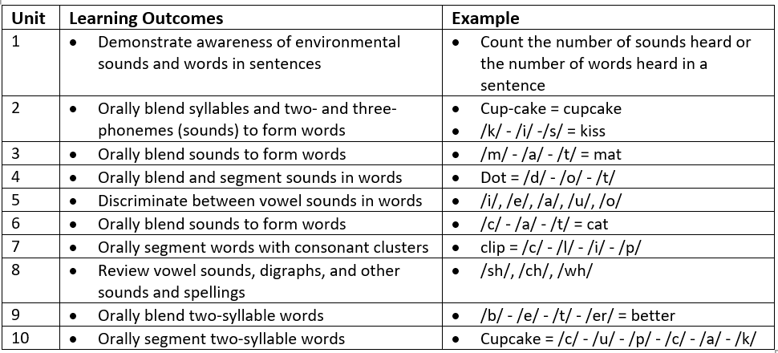  T: In this example, students begin the year counting the number of sounds heard in their environment, such as the number of taps on a desk or the number of words heard in a sentence.  Notice how students then blend sounds to form words and take them apart—segment—back into sounds.  By the end of the year, students are orally blending and segmenting the sounds in two syllable words such as better.  T: How does this sequence of skills support student learning?  S: Students start with simple skills and gradually add on new skills with greater complexity as the year progresses.  T: Let’s look at a nonexample of sequenced skills in a curriculum map.  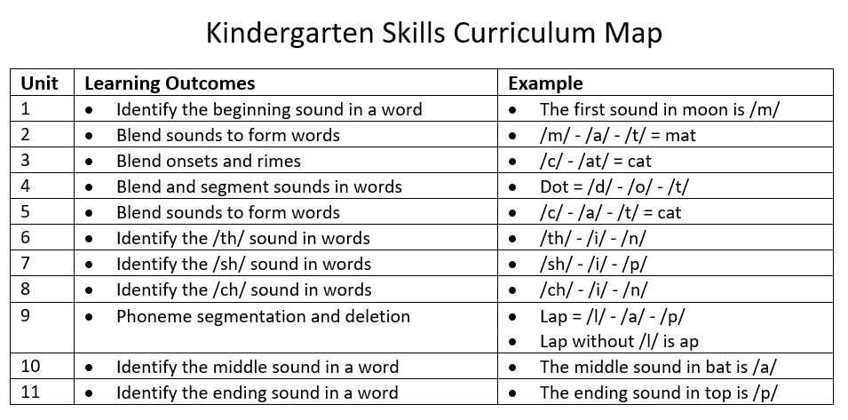  T: Many of the skills are the same as in the previous example but notice that students go straight into blending sounds in words before hearing the sounds in the words.  T: What could happen if students try to learn something complex before learning the basic skills?  S: Students will struggle to learn the more complex skills and could get frustrated or learn something incorrectly.  T: Yes – In this nonexample, the skills are not sequenced from the simple to the complex. Students begin blending sound before they ever learn how to hear the number of words in a sentence or the sound in a word.  T: How does knowing the scope and sequence help a teacher when planning to teach a unit?  S: It helps the teacher see the progression of skills that will be taught and think about how each skill builds on another to set students up for mastery of the standard. | SoL Graphic PPT
10 mins | Practice 1: Example  T: Read the Grade 1 Module 1 Survival Unit Overview. With a partner, explain how the unit is sequenced to help build a 1st grade student’s understanding and mastery of how pond plants and animals survive in their environments.  S: (Complete the activity in the student guide).  T: Let’s come back together to talk about what you learned.  T: How was the unit sequenced to help build student understanding of the content?  S: The concepts build on one another by first introducing students to the body parts of plants and animals and how they use those parts to help them survive. Students then apply that knowledge to help them understand how those body parts and external features help them respond to their environment to survive. Students then apply that knowledge to build an understanding of how those body parts and senses help them protect their offspring. | Student Guide
10 mins | Practice #2 – Nonexample  T: Now, you are going to look at the nonexample to examine how the topics are sequenced. With a partner, explain why the sequence of this unit isn’t structured in a way that is likely to help build students’ understanding of the standard.  S: (Complete the activity in the student guide.) | Student Guide
5 mins | Debrief  T: Let’s come back together to talk about what you learned.  T: Which unit overview sequenced the content from simple to more complex?  S: The first one.  T: How does the sequencing of first overview compare to the second one?  S: The first example sequenced the topics and concepts in a logical order that built on one another. The unit began with more basic concepts such as learning about plant and animal parts and how they use those parts to survive in their environment. Students then had to apply that knowledge to help them build an understanding of how plants and animals use those external parts to respond to their environment and protect their offspring.  T: How can the sequencing of unit determine the effectiveness of a unit plan?  S: A unit must sequence lessons in a logical way to help build on students’ background knowledge and give time to practice simpler skills or concepts before moving to more difficult skills or concepts. This will help build a deeper understanding of the content and lead to mastery of the standard.
5 mins | S: (Complete the exit ticket.) | Exit Ticket

