Student Guide

Lesson 6.02: Sequencing a Unit Plan
Name:
Date:
Bellringer: Create a concept map to show the relationships between the key components of a curriculum.

Sequencing a Unit

Key Vocabulary
Define the key term below.
Sequencing

Example
.

Unit | Learning Outcomes | Example
1 | Demonstrate awareness of environmental sounds and words in sentences | Count the number of sounds heard or the number of words heard in a sentence
2 | Orally blend syllables and two- and three-phonemes (sounds) to form words | - Cup-cake = cupcake  - /k/ - /i/ -/s/ = kiss
3 | Orally blend sounds to form words | /m/ - /a/ - /t/ = mat
4 | Orally blend and segment sounds in words | Dot = /d/ - /o/ - /t/
5 | Discriminate between vowel sounds in words | /i/, /e/, /a/, /u/, /o/
6 | Orally blend sounds to form words | /c/ - /a/ - /t/ = cat
7 | Orally segment words with consonant clusters | clip = /c/ - /l/ - /i/ - /p/
8 | Review vowel sounds, digraphs, and other sounds and spellings | /sh/, /ch/, /wh/
9 | Orally blend two-syllable words | /b/ - /e/ - /t/ - /er/ = better
10 | Orally segment two-syllable words | Cupcake = /c/ - /u/ - /p/ - /c/ - /a/ - /k/

Nonexample

Unit | Learning Outcomes | Example
1 | Identify the beginning sound in a word | The first sound in moon is /m/
2 | Blend sounds to form words | /m/ - /a/ - /t/ = mat
3 | Blend onsets and rimes | /c/ - /at/ = cat
4 | Blend and segment sounds in words | Dot = /d/ - /o/ - /t/
5 | Blend sounds to form words | /c/ - /a/ - /t/ = cat
6 | Identify the /th/ sound in words | /th/ - /i/ - /n/
7 | Identify the /sh/ sound in words | /sh/ - /i/ - /p/
8 | Identify the /ch/ sound in words | /ch/ - /i/ - /n/
9 | Phoneme segmentation and deletion | - Lap = /l/ - /a/ - /p/  - Lap without /l/ is ap
10 | Identify the middle sound in a word | The middle sound in bat is /a/
11 | Identify the ending sound in a word | The ending sound in top is /p/

Practice 1: Example
Read the Grade 1 Module 1 Survival Unit Overview. With a partner, respond to the questions below to help explain how the unit is sequenced to build a 1st grade student’s understanding and mastery of how pond plants and animals survive in their environments.
Unit Essential Question:

Concept 1 Focus Question
What will students need to know and be able to do at the end of this topic?

Concept 2 Focus Question
What will students need to know and be able to do at the end of this topic?

Concept 3 Focus Question
What will students need to know and be able to do at the end of this topic?

How do these skills build on each other?
.
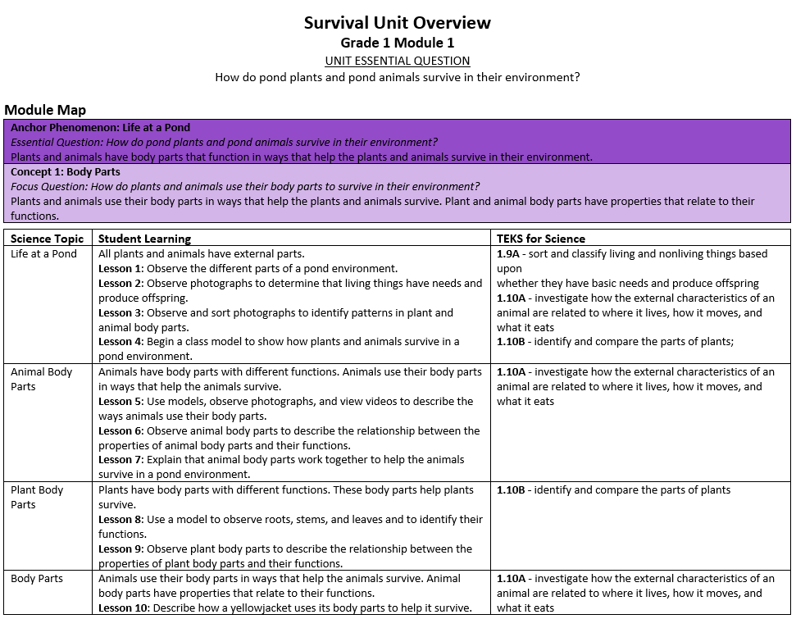

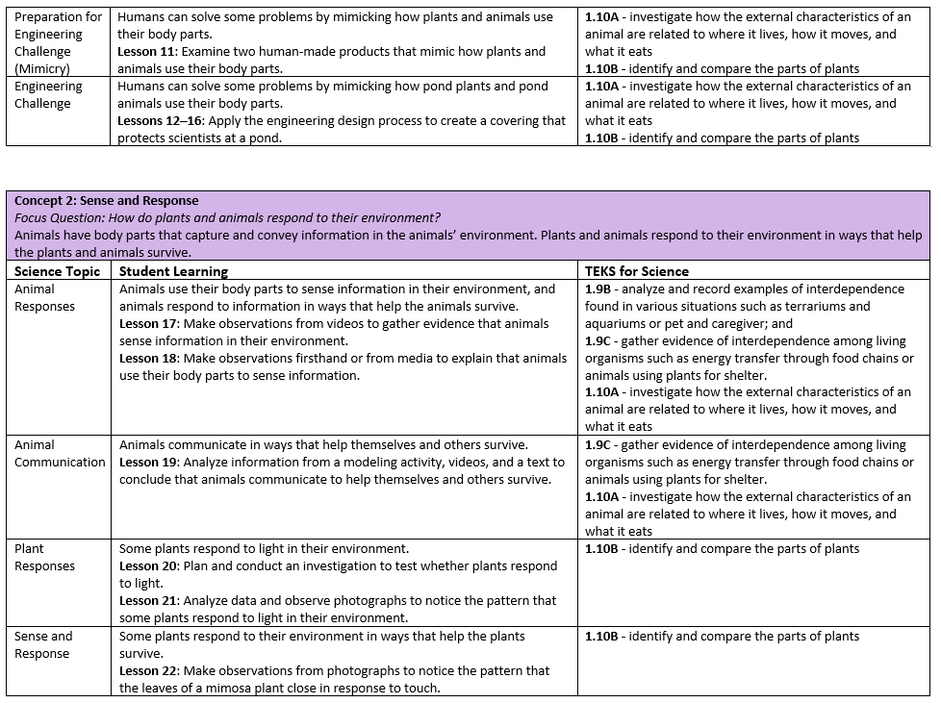
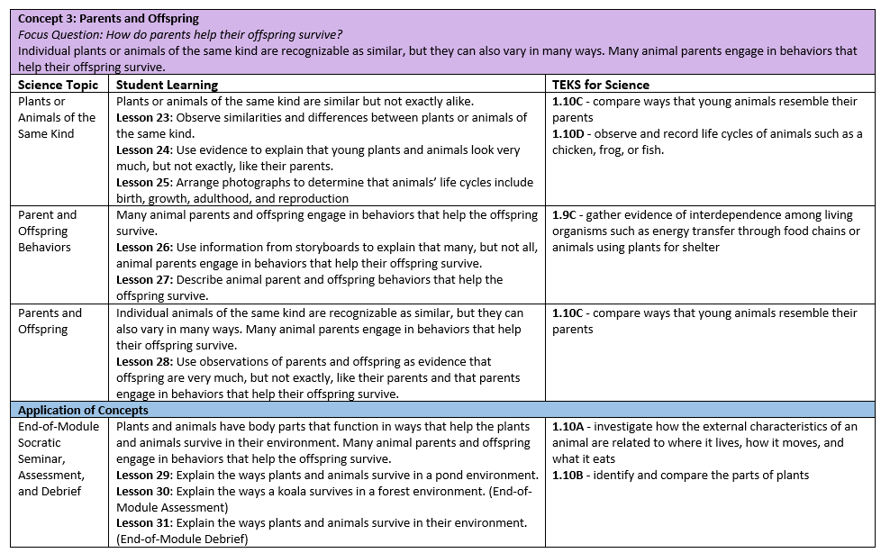

Practice 2: Nonexample
Read the nonexample Grade 1 Survival Unit Overview. With a partner, respond to the questions below to help explain why the sequence of this unit isn’t structured in a way that is likely going to help build students’ understanding of the standard.

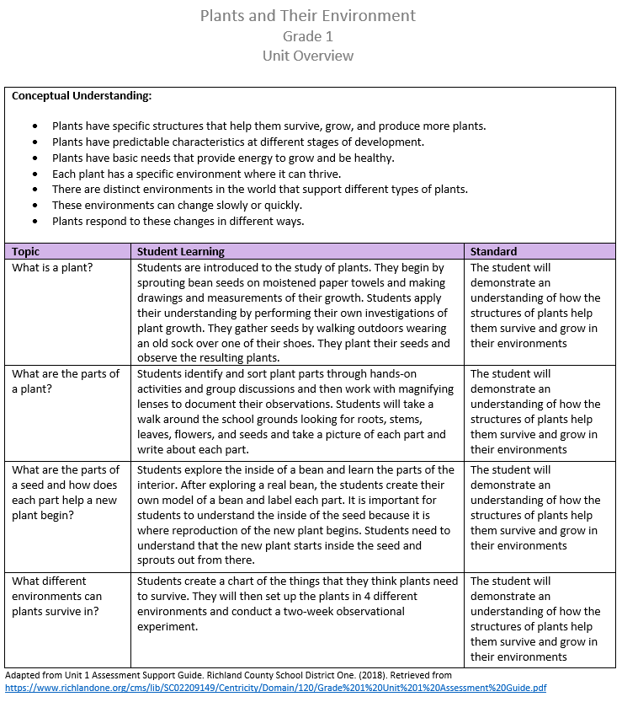

Unit Essential Question:
Unit Standard:
Topic 1 Focus Question
What will students need to know and be able to do at the end of this topic?

Topic 2 Focus Question
What will students need to know and be able to do at the end of this topic?

Topic 3 Focus Question
What will students need to know and be able to do at the end of this topic?

Topic 4 Focus Question

Explain why the sequence of this unit isn’t structured in a way that is likely to help build students’ understanding of the standard.

