Student Guide – Answer Key

Lesson 6.02: Sequencing a Unit Plan
Name:
Date:
Bellringer: Create a concept map to show the relationships between the key components of a curriculum.

Sequencing a Unit

Key Vocabulary
Define the key term below.
Sequencing | Organizing concepts in an order that starts simple and builds in complexity

Example
students begin the year counting the number of sounds heard in their environment, such as the number of taps on a desk or the number of words heard in a sentence.
By the end of the year, students are orally blending and segmenting the sounds in two syllable words such as better.
students then blend sounds to form words and take them apart—segment—back into sounds.
Unit | Learning Outcomes | Example
1 | Demonstrate awareness of environmental sounds and words in sentences | Count the number of sounds heard or the number of words heard in a sentence
2 | Orally blend syllables and two- and three-phonemes (sounds) to form words | - Cup-cake = cupcake  - /k/ - /i/ -/s/ = kiss
3 | Orally blend sounds to form words | /m/ - /a/ - /t/ = mat
4 | Orally blend and segment sounds in words | Dot = /d/ - /o/ - /t/
5 | Discriminate between vowel sounds in words | /i/, /e/, /a/, /u/, /o/
6 | Orally blend sounds to form words | /c/ - /a/ - /t/ = cat
7 | Orally segment words with consonant clusters | clip = /c/ - /l/ - /i/ - /p/
8 | Review vowel sounds, digraphs, and other sounds and spellings | /sh/, /ch/, /wh/
9 | Orally blend two-syllable words | /b/ - /e/ - /t/ - /er/ = better
10 | Orally segment two-syllable words | Cupcake = /c/ - /u/ - /p/ - /c/ - /a/ - /k/

Students begin with identifying the beginning sounds in words before they have an awareness of environmental sounds and words in a sentence
Nonexample
Students delete sounds before they’ve learned how to identify all the sounds in a word
Students start blending sounds to form words before blending syllables and chunks of words
Unit | Learning Outcomes | Example
1 | Identify the beginning sound in a word | The first sound in moon is /m/
2 | Blend sounds to form words | /m/ - /a/ - /t/ = mat
3 | Blend onsets and rimes | /c/ - /at/ = cat
4 | Blend and segment sounds in words | Dot = /d/ - /o/ - /t/
5 | Blend sounds to form words | /c/ - /a/ - /t/ = cat
6 | Identify the /th/ sound in words | /th/ - /i/ - /n/
7 | Identify the /sh/ sound in words | /sh/ - /i/ - /p/
8 | Identify the /ch/ sound in words | /ch/ - /i/ - /n/
9 | Phoneme segmentation and deletion | - Lap = /l/ - /a/ - /p/  - Lap without /l/ is ap
10 | Identify the middle sound in a word | The middle sound in bat is /a/
11 | Identify the ending sound in a word | The ending sound in top is /p/

Students go back to identifying sounds in words
Practice 1: Example
Read the Grade 1 Module 1 Survival Unit Overview. With a partner, respond to the questions below to help explain how the unit is sequenced to build a 1st grade student’s understanding and mastery of how pond plants and animals survive in their environments.
Unit Essential Question: How do pond plants and pond animals survive in their environment?
Concept 1 Focus Question | How do plants and animals use their body parts to survive in their environment?
What will students need to know and be able to do at the end of this topic? | - Students will be able to sort and classify living and nonliving thins based on whether they have basic needs and produce offspring  - Students will be able to explain how the external characteristics of an animal are related to where it lives, how it moves, and what it eats  - Students will be able to identify and compare the parts of plants
Concept 2 Focus Question | How do plants and animals respond to their environment?
What will students need to know and be able to do at the end of this topic? | - Students will be able to analyze and record examples of interdependence found in various situations  - Students will be able to gather evidence of interdependence among living organisms such as energy transfer through food chains or animals using plants for shelter.  - Students will be able to explain how the external characteristics of an animal are related to where it lives, how it moves, and what it eats  - Students will be able to identify and compare the parts of plants
Concept 3 Focus Question | How do parents help their offspring survive?
What will students need to know and be able to do at the end of this topic? | - Students will be able to compare ways that young animals resemble their parents  - Students will be able to observe and record life cycles of animals such as a chicken, frog, or fish.  - Students will be able to gather evidence of interdependence among living organisms  - Students will be able to explain how the external characteristics of an animal are related to where it lives, how it moves, and what it eats  - Students will be able to identify and compare the parts of plants
How do these skills build on each other?
The concepts build on one another by first introducing students to the body parts of plants and animals and how they use those parts to help them survive. Students then apply that knowledge to help them understand how those body parts and external features help them respond to their environment in order to survive. Students then apply that to build and understanding of how those body parts and senses help them protect their offspring.
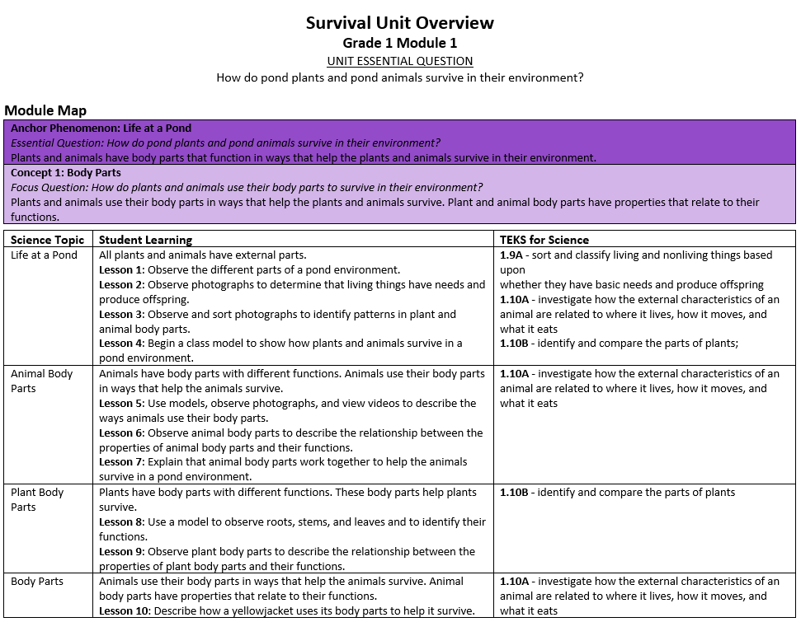

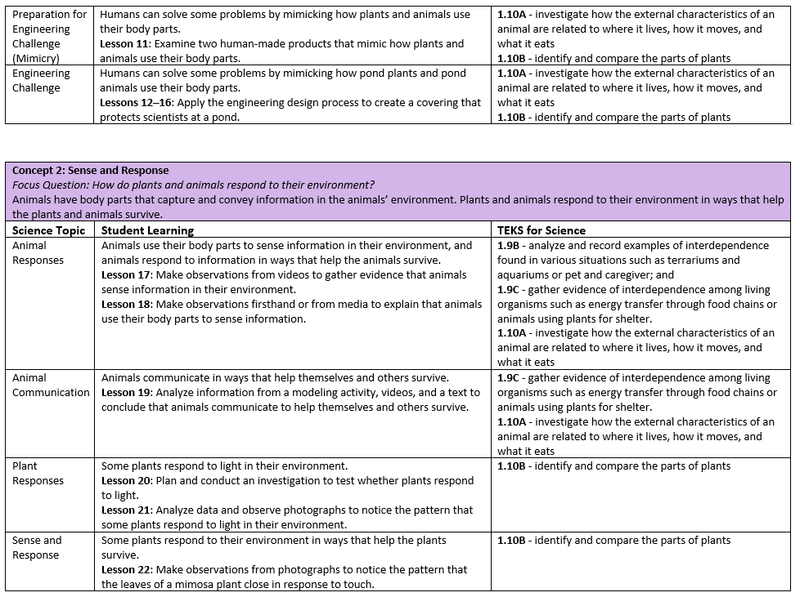
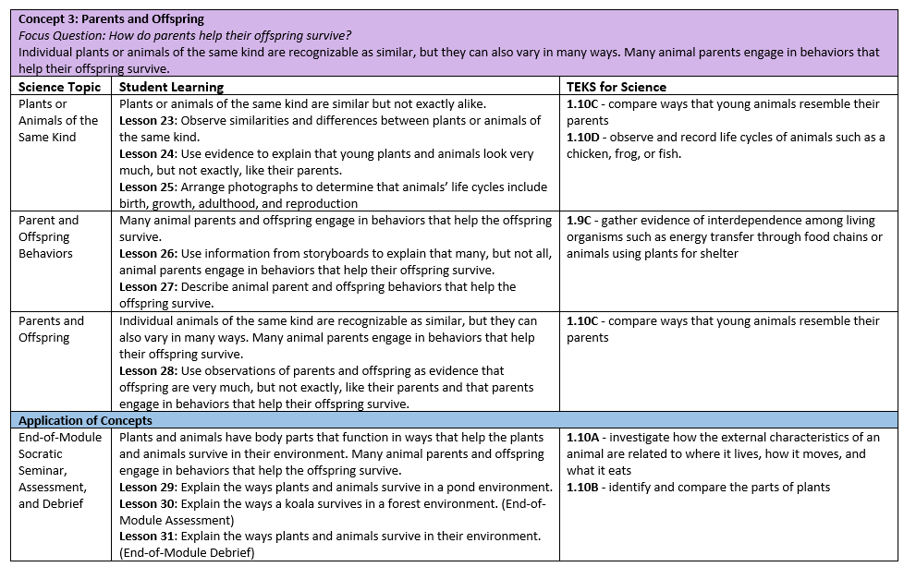

Practice 2: Nonexample
Read the nonexample Grade 1 Survival Unit Overview. With a partner, respond to the questions below to help explain why the sequence of this unit isn’t structured in a way that is likely going to help build students’ understanding of the standard.

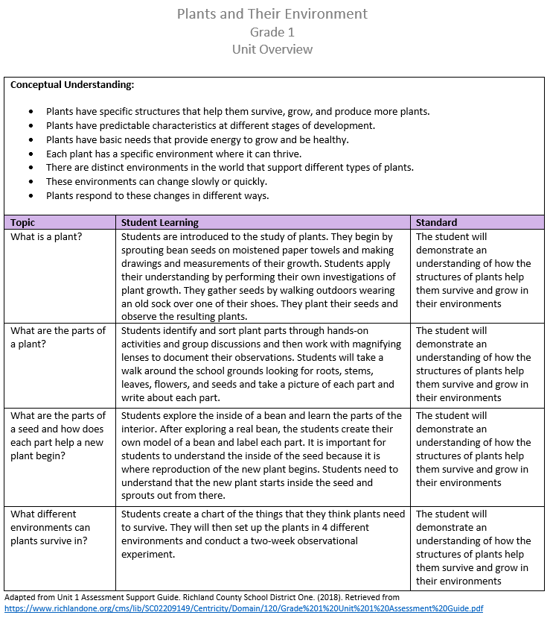

Unit Essential Question: One does not exist
Unit Standard: Demonstrate an understanding of how the structures of plants help them survive and grow in their environments
Topic 1 Focus Question | What is a plant?
What will students need to know and be able to do at the end of this topic? | - Draw and take measurements of their plant’s growth.
Topic 2 Focus Question | What are the parts of a plant?
What will students need to know and be able to do at the end of this topic? | - Identify and sort plant parts  - Write about the parts of plants
Topic 3 Focus Question | What are the parts of a seed and how does each part help a new plant begin?
What will students need to know and be able to do at the end of this topic? | - Create a model of a bean and label its parts  - Understand that a new plant starts inside the send and sprouts from there
Topic 4 Focus Question | What different environments can plants survive in?
 | - Identify what plants need to survive

Explain why the sequence of this unit isn’t structured in a way that is likely to help build students’ understanding of the standard.

The topics in this unit do not fully address the standard, which is to demonstrate an understanding of how the structures of plants help them survive and grow in their environment. Students grow seeds and examine seeds to determine their parts. Students look at the inside of the seed to help them understand that a need plant starts inside the seed. Students also conduct experiments to test the different environments plants can survive in. These lessons and activities focus only on the parts of plants and the environment plants grow best in and do not help students build an understanding of how the different plant parts help it grow and survive in their environments. The activities are surface level and do not get to the level of rigor required by the standard.

