Exit Ticket

Lesson 6.03: Components of a Lesson Plan
Name:
Date:
Examine the lesson plan below. Identify the components of a high-quality lesson plan and identify how the standards, objectives, learning activities (introduction, direct instruction, guided practice, independent practice, and debrief), and assessment align.

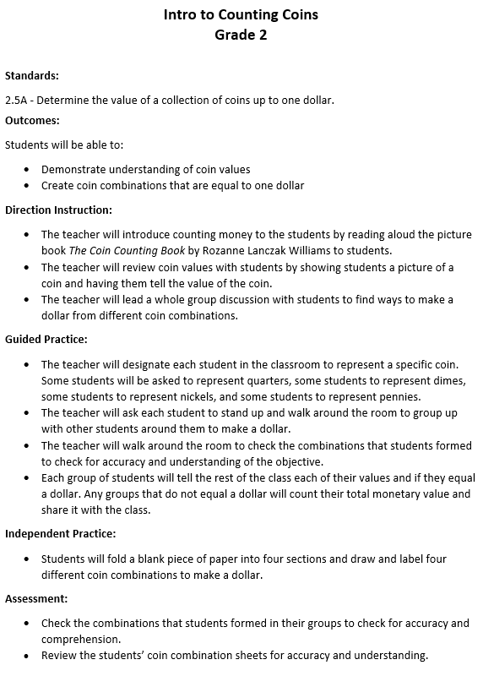

Component | Evidence from Lesson Plan
Standards
Objectives
Introduction
Direct Instruction
Guided Practice
Independent Practice
Debrief
Assessment

How are the standards, objectives, learning activities (introduction, direct instruction, guided practice, independent practice, and debrief), and assessment aligned?

How does this lesson compare with the practice lesson you examined during today’s lesson?

