Exit Ticket - Answer Key

Lesson 6.03: Components of a Lesson Plan
Name:
Date:
Examine the lesson plan below. Identify the components of a high-quality lesson plan and identify how the standards, objectives, learning activities (introduction, direct instruction, guided practice, independent practice, and debrief), and assessment align.

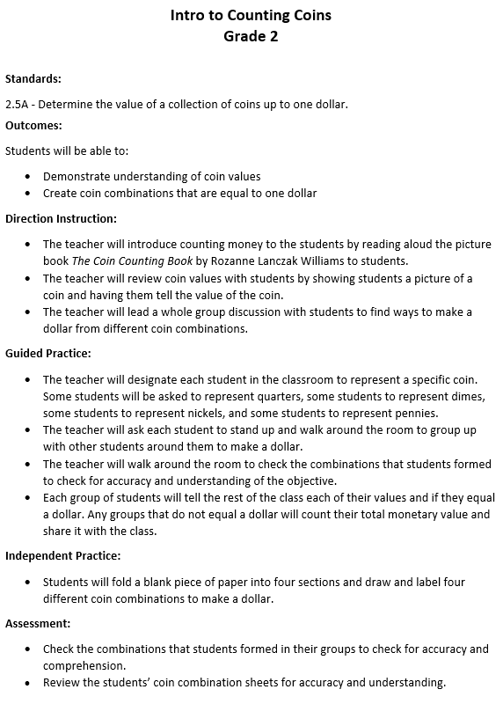

Component | Evidence from Lesson Plan
Standards | 2.5A - Determine the value of a collection of coins up to one dollar.
Objectives | - Demonstrate understanding of coin values  - Create coin combinations that are equal to one dollar
Introduction | Read aloud of the picture book The Coin Counting Book by Rozanne Lanczak Williams
Direct Instruction | The teacher does not use explicit teaching techniques and modeling to teach determine the value of a collection of coins up to one dollar.
Guided Practice | - The teacher reviews the coin values by showing a picture of each coin and have students tell the value. The teacher has a discussion with students to find ways to make a dollar from different coin combinations.  - The teacher will designate each student in the classroom to represent a specific coin. Some students will be asked to represent quarters, some students to represent dimes, some students to represent nickels, and some students to represent pennies.  - The teacher will ask each student to stand up and walk around the room to group up with other students around them to make a dollar.
Independent Practice | - Students will fold a blank piece of paper into four sections and draw and label four different coin combinations to make a dollar.
Debrief | Debrief isn’t evident.
Assessment | - Check the combinations that students formed in their groups to check for accuracy and comprehension.  - Review the students’ coin combination sheets for accuracy and understanding.

How are the standards, objectives, learning activities (introduction, direct instruction, guided practice, independent practice, and debrief), and assessment aligned?
Each of the learning activities directly align to the objectives and standards for the lesson, although there is no direct instruction to model the skill. During the learning activities, students review coin values and work in groups to create different ways to make a dollar. During the independent practice, which is also used as the assessment, the students practice by drawing and labeling four different coin combinations that make a dollar. This aligns to the learning activities, the objectives, and the standard.
How does this lesson compare with the practice lesson you examined during today’s lesson?
The lesson from the practice activity allows students to review previously taught skills that would active their prior knowledge. Students began by combining the same coins to make different values, then worked their way up to counting mixed groups of coins. The teacher supported students with strategies such as counting starting with the largest value, skip counting, and making groups of ten to help students count the value of the coin combinations. Students had opportunities to practice using these different strategies through practice problems and were assessed through an exit ticket.

