Unit 6: Instructional Alignment

Lesson 6.03: Components of a Lesson Plan

Lesson at Glance
Warm-Up (5 mins)  - Bell Ringer | Instruction (20 mins)  - Intro to the Components of a Lesson Plan | Application (25 mins)  - Practice #1  - Debrief  - Exit Ticket

TEKS | 3 | The student explores the teaching and training profession. The student is expected to:  - summarize and apply acquired pedagogical knowledge and skills needed by teaching and training professionals;
 | 6 | The student plans and develops effective instruction. The student is expected to:  - explain the role of Texas Essential Knowledge and Skills in planning and evaluating instruction;  - explain the rationale for and process of instructional planning components such as vertical alignment and scope and sequence;  - demonstrate lesson planning to meet instructional goals.
Objectives | - Define and identify the components of a high-quality lesson plan.  - Explain how a high-quality lesson plan leads to mastery of grade-level content.
Rationale/  Summary | Daily lesson plans are an essential component of a high-quality curriculum. The components of a lesson plan must align with one another. In this lesson, students will identify and define the components of a high-quality lesson plan and determine their alignment with each other. Students will identify the components of a high-quality lesson plan in HQIM. Students will reflect on their own learning experience in this lesson to explain how high-quality components of a lesson plan that leads students to mastery of grade-level content.
Formative Assessment and Exemplar Response | Students will examine and identify the components of a high-quality lesson plan and identify how the standards, objectives, learning activities (introduction, direct instruction, guided practice, independent practice, and debrief), and assessment align.  How does this lesson compare with the practice lesson you examined during today’s lesson?  See Exit Ticket – Answer Key for exemplar response.
Vocabulary | Lesson Plan |  | A daily plan for instruction that includes lesson objectives, learning activities, and assessments.
Vocabulary | Standards |  | The learning goals or expectations for what students should know and be able to do at each grade level
Vocabulary | Objectives |  | Brief statements that describe what students will be expected to learn by the end of the unit or lesson
Vocabulary | Introduction |  | An activity or question meant to engage students, captivate their interest, and offer the opportunity for students to share what they already know about the subject
Vocabulary | Direct Instruction |  | The use of explicit teaching techniques and modeling to teach a specific skill
Vocabulary | Guided Practice |  | Practice with the teacher to apply what they just learned during direct instruction
Vocabulary | Independent Practice |  | Application of new learning without support from the teacher or peers
Vocabulary | Assessment |  | Any tool used to collect, analyze, and respond to information about student understanding of learning targets
Vocabulary | Debrief/Closing |  | Examination and analysis of a teaching and learning experience after the completion of an activity or lesson

Est Time | Instructional Activities (including formative assessments) | Materials
3 mins | Bellringer: Look at the objective and the two scenarios and answer the questions that follow.  Objective: Students will examine primary and secondary sources to analyze various perspectives on the events that led to the surrender at Appomattox Court House  Scenario 1: Students perform a historical reenactment of the surrender at the Appomattox Court House. Students research historically accurate costumes and create props for the characters. On the day of the reenactment, students play the role of General Grant and General Lee with a great deal of enthusiasm and emotion. After the reenactment, students engaged in a writing assignment to reflect on how well they portrayed the characters.  Scenario 2: Students prepare to perform a historical reenactment of the surrender at the Appomattox Court House. Students analyze primary and secondary sources of the event. After the reenactment, students give each other feedback on the accuracy of their portrayal of General Grant and General Lee based on their research. Lastly, students engage in a writing assignment to compare two different perspectives from the event.  - What are the students expected to do according to the objective?  - What do the students do in scenario 1?  - What do the students do in scenario 2?  - Which scenario better matches the objective?
2 mins | T: How did the two scenarios compare? (Solicit a few responses from the class.)  S: Scenario 1 focused more on historically accurate costumes and props for the reenactment, whereas scenario 2 focused more on understanding what happened at Appomattox Court House from the perspectives of Grant and Lee.  T: In lesson 1, we talked about the importance of alignment to standards and objectives, which are the learning goals or expectations for what students should know and be able to do. Do you think the activity in scenario 1 was focused on the standard?  S: No.  T: Why is it important for lessons to align to the standards and objectives?  S: So that a teacher can make sure that he or she is teaching the most important content.  T: Right – and in the case of our scenario, historically accurate costumes and props were not the most important concepts students needed to learn. It was understanding various perspectives about what happened at Appomattox Court House. | Student Guide  Scenarios adapted from “Our Planning Framework” - https://www.youtube.com/watch?v=jY-NDeMt5c8
20 mins | Intro to the Components of a Lesson Plan  T: We are going to dive into what a lesson plan is, the components of a lesson plan, and how those components work together to create a high-quality lesson plan.  T: (Review the components of a lesson plan using the PPT). As we learned in an earlier lesson, a lesson plan is a daily plan for instruction that includes lesson objectives, learning activities, and assessments. The lesson plan gives a detailed description of the instruction and the trajectory of the lesson. It outlines what students will learn, how the lesson will be taught, and how student progress will be measured.  S: (Take notes on the student guide.)  T: This sample lesson plan template shows the common components or learning activities included in a lesson plan. Learning activities is a collective term used to describe the introduction, direct instruction, guided practice, independent practice, and debrief.  T: Looking at this lesson plan template, we can see that a lesson plan starts with standards and objectives.  T: As we learned in our lesson on unit plans, standards are the learning goals or expectations for what students should know and be able to do at each grade level. We learned in a previous lesson that Texas uses two sources of standards, Texas Essential Knowledge and Skills (TEKS) and the English Language Proficiency Standards (ELPS).  Objectives are brief statements that describe what students will be expected to learn by the end of the unit or lesson.  T: What do you already know about the relationship between standards and objectives in high quality instructional materials?  S: They should be aligned.  T: Let’s look at an example of standards and objectives for Lesson 1 of the Grade K Skills 5 Unit (page 7 of Grade K Skills K Teacher Guide).  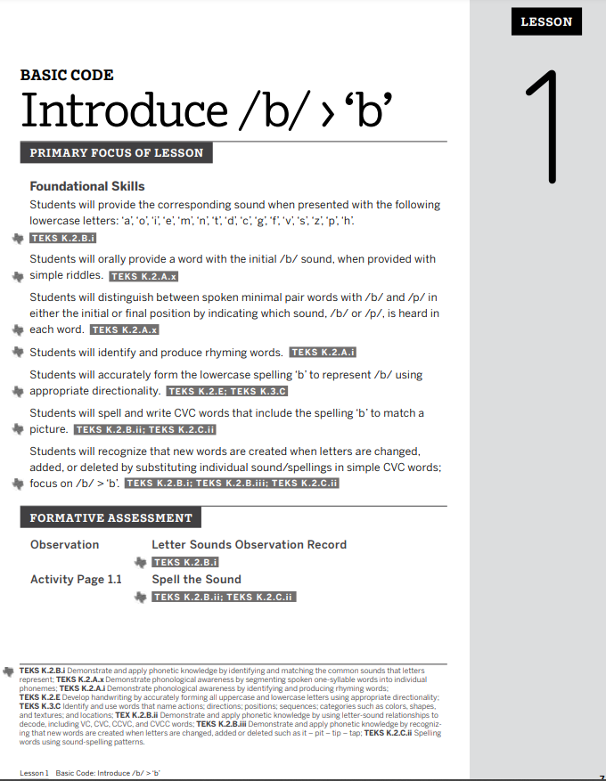  T: I can clearly see the objectives that will be covered in Lessons 1 with the corresponding TEKS listed in more detail at the bottom of the overview.  T: Why is it important to include the standards and objectives in a lesson plan?  S: It helps the teacher stay focused on the most important content that students need to know and helps the teacher know what students need to understand and be able to do to achieve mastery of the standard.  T: A high-quality lesson plan also needs to include an introduction or engagement activity. The introduction is an activity or question meant to activate prior knowledge, engage students, captivate their interest, and offer the opportunity for students to share what they already know about the subject.  T: Let’s look at an intro activity for Lesson 1 of the Grade K Skills 5 Unit (Share launch activity via PPT – pages 12-13 of Grade K Skills 5 Teacher Guide).  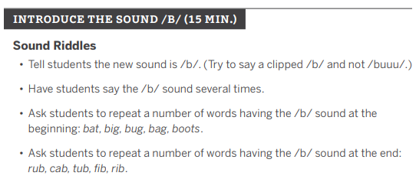  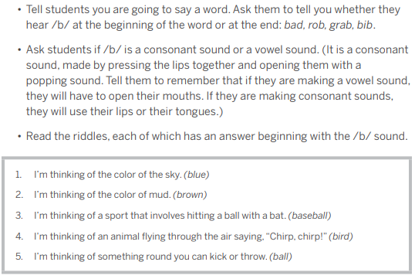  T: We learned that an introduction activity should activate prior knowledge, engage students, captivate their interest, and offer students the opportunity to share what they already know about a subject. Does this activity meet all three of those criteria?  S: The warm-up engages students in the learning by having them practice saying different sounds that begin with /b/ and end with /b/. This helps activate prior knowledge. The sound riddles help captivate a kindergarten students’ interest. The activity did not offer students the opportunity to share their prior knowledge, but it did allow them to demonstrate what they already know about hearing the /b/ sound at the beginning of end of words.  T: Once students are engaged in the learning, it is time for direct instruction.  T: Direction instruction is the use of explicit teaching techniques and modeling to teach a specific skill. This is where new content is introduced.  T: Let’s look at an example of direct instruction from Lesson 1 of Grade K Skills 5 Unit. (Share lesson plan via PPT – pages 14-15 of Grade K Skills 5 Teacher Guide).  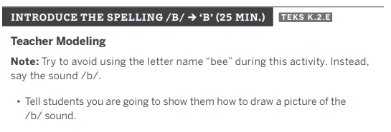  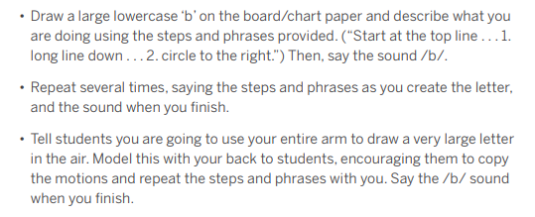  T: What new content are students learning? What do you notice about how the teacher delivers the direct instruction in this lesson? Highlight evidence of direct instruction on this lesson plan in your student guide.  S: They are drawing a picture or writing the letter for the /b/ sound. The teacher clearly breaks down how to write letter b and models each step. As the teacher models, they verbally explain the steps.  T: Now, I want you to practice delivering this direction instruction with a partner. You will each have 3 minutes.  S: (Deliver instruction with a partner.)  T: It is also important that a teacher provides opportunities for students to practice the skill with support from the teacher. This is known as guided practice. During the guided practice, students work with the teacher to practice and apply what they just learned during the direction instruction.  T: Look at the guided practice activity for the Lesson example we just examined. (Share lesson plan via PPT – pages 15 of Grade K Skills 5 Teacher Guide).  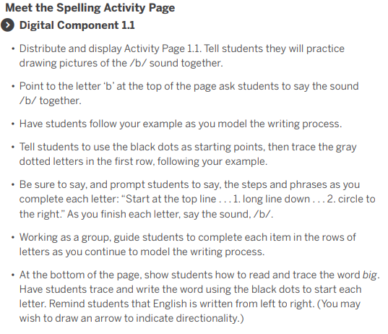  T: What evidence do you see of students working with the teacher to practice the skill? Highlight evidence on the lesson plan in your student guide.  S: Students follow the teacher’s example as they practice writing the letter B.  T: It is also important that a teacher gives students the opportunity to practice the skill individually. This is known as independent practice. During the independent practice, students apply what they have just learned without support from the teacher or peers. This is an opportunity for a teacher to monitor students’ progress toward mastery of the skill or content. Note that the teacher should not ask students to engage in a skill that hasn’t been practiced together yet.  T: To be high-quality, independent practice should be deliberate. Does anyone remember the criteria for deliberate practice?  S: Be authentic, spaced over time, low-stakes, and paired with feedback.  T: We will return to these criteria in more detail in a later lesson. Independent practice, like everything else in a lesson and unit plan, should be aligned to the standards and objectives and other parts of the lesson including direct instruction and guided practice.  T: In the kindergarten lesson we’ve been looking at, this is the independent practice for that part of the lesson (Share lesson plan via PPT – pages 16 of Grade K Skills 5 Teacher Guide).  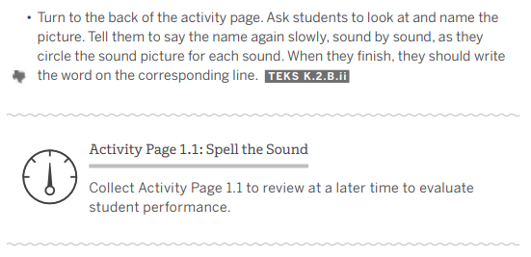  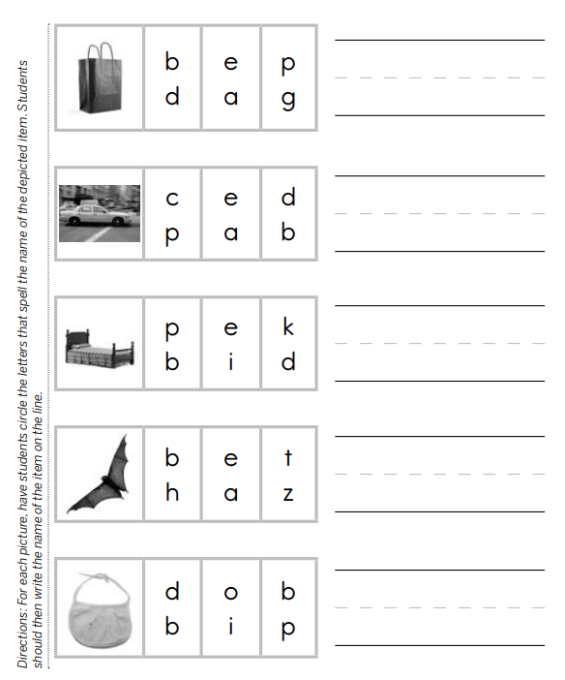  T: How does this activity align to the objectives, direct instruction, and guided practice we examined earlier?  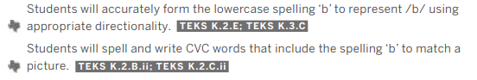  S: Students are practicing the same skills modeled during the direct instruction. The practice aligns directly to the objectives listed.  T: Let’s look at a series of direct instruction, guided practice, and independent practice and identify why the different components are not aligned.  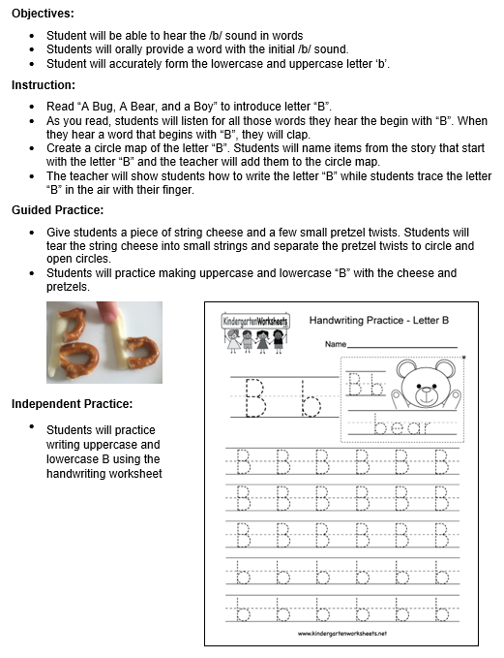  T: Why is this a nonexample?  S: The teacher does not model how to write the letter ‘b’ and students do not have time to practice writing letter ‘b’ with teacher support before moving into the independent practice.  T: Why is it important that the independent practice aligns to the objectives, the direct instruction, and guided practice?  S: Students should only engage in practice of skills and tasks that they’ve had time to practice together with the teacher. The practice should also align to the objectives to ensure students are practicing the most important content.  T: The independent practice is a time for students to internalize the content and build upon the information they have learned. It is also an opportunity for the teacher to informally assess students’ progress toward mastery of the skill or content.  T: When an assessment comes in the middle of a lesson, what type of assessment is it?  S: Formative.  T: Yes - as we discussed in a previous unit, an assessment is a tool used to collect, analyze, and respond to information about student understanding of learning targets.  T: If we look at the same Grade K Skills 5 lesson, we see that letter sound observation and activity page 1.1 were both used as formative assessments to check student progress on the skills that were introduced.  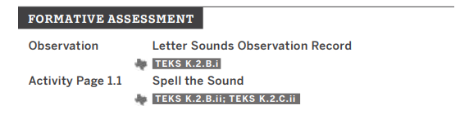  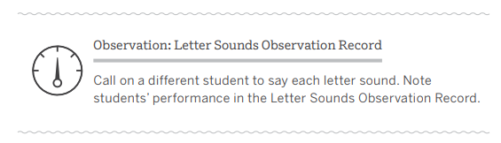  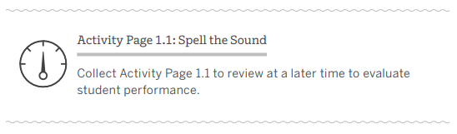  T: How closely did the introduction, direct instruction, guided practice, independent practice, and assessments align to the standards and objectives for the lesson?  S: Those components of the lesson plan aligned directly to the TEKS and the objectives. The standard (TEKS) was also listed beside each activity which helps the teacher know exactly which standard that activity addresses.  T: Why is it important to ensure the instruction, tasks, and assessment align to the standards and objectives?  S: To ensure the grade-level expectation is the focus of the lesson and what is being assessed. The alignment helps focus students on the most important content and provides multiple opportunities for students to practice what is being explicitly taught to move new learning to long-term memory.  T: One way to address how those components align is through our final component of a high-quality lesson plan, which is a debrief or closing to the lesson. A debrief is where the teacher and students examine and analyze their experience and learning after the completion of an activity or lesson.  T: Let’s look at the debrief for an activity completed in Grade K Skills 5 Unit.  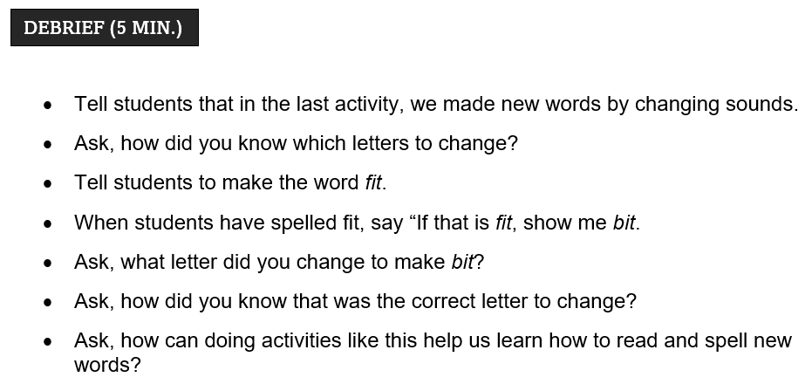  T: How does this debrief allow the teacher and students to examine and analyze their experience and learning?  S: The debrief ask students to think about how they knew which letters to change in the previous activity. Students then practiced changing the word fit to bit. The teacher asked students to tell how they knew what letter to change and how this activity could help them with reading and spelling new words.  T: Why it is important to follow up an activity or lesson with a debrief?  S: It allows students to reflect on and demonstrate their learning. It also allows the teacher to see students’ progress toward mastery.
  Standards (TEKS):
  Objectives:
  Learning Task | Teacher Action | Student Action
  Introduction
  Direct Instruction
  (I Do)
  Guided Practice
  (We Do)
  Independent Practice
  (You Do)
  Debrief/
  Closing
  Assessment
15 mins | Practice 1: Lesson Analysis  T: Now that we’ve learned about the components of a lesson plan and the importance of alignment between the different components in a lesson plan, let’s look at a high-quality 2nd grade math lesson to find evidence of the different components we discussed and identify how those components align.  T: In groups, read Grade 2 Module 7 Lesson 6. As you read, identify the components of a high-quality lesson plan. Identify how the standards, objectives, learning activities (introduction, direct instruction, guided practice, independent practice, and debrief), and assessment align.  Record your evidence in your student guide and be prepared to share your learning with the group.  S: (Complete practice activity in the student guide).  T: (Guide students in a discussion of their answers based on the 6.3 Student Guide – Answer Key.) | Student Guide
5 mins | Debrief  T: Let’s come back together to talk about what you learned.  T: Think about the instruction and practice activities we engaged in during today’s lesson. What are some components of a high-quality lesson plan that you experienced during our lesson today?  S: You engaged us in an introduction activity through the bellringer, provided direct instruction on the components of a lesson plan and what makes each component high-quality, you provided opportunity for guided practice, you are leading us through the debrief right now, and we will probably have an exit ticket after this.  T: How did each of those components support your learning?  S: The bell ringer helped focus our attention and engage us in the lesson. The direction instruction provided explicit instruction and modeled how to examine a lesson plan for high-quality components. The guided practice allowed us to work together to process new learning and practice how to evaluate a lesson plan for high-quality components. The debrief helps clarify any misunderstanding and sums up what we learned. All components work together to build our understanding of what makes a high-quality lesson plan and what we need to look for when digging into a lesson.
5 mins | (Students complete exit ticket) | Exit Ticket

