Student Guide – Answer Key

Lesson 6.03: Components of a Lesson Plan
Name:
Date:
Bellringer: Look at the objective and the two scenarios and answer the questions that follow.
Objective: Students will examine primary and secondary sources to analyze various perspectives on the events that led to the surrender at Appomattox Court House
Scenario 1: Students perform a historical reenactment of the surrender at the Appomattox Court House. Students research historically accurate costumes and create props for the characters. On the day of the reenactment, students play the role of General Grant and General Lee with a great deal of enthusiasm and emotion. After the reenactment, students engaged in a writing assignment to reflect on how well they portrayed the characters.
Scenario 2: Students prepare to perform a historical reenactment of the surrender at the Appomattox Court House. Students analyze primary and secondary sources of the event. After the reenactment, students give each other feedback on the accuracy of their portrayal of General Grant and General Lee based on their research. Lastly, students engage in a writing assignment to compare two different perspectives from the event.
- What are the students expected to do according to the objective?
Students are expected to use primary and secondary sources to analyze different perspectives on the events that lead to the surrender at Appomattox Court House.
- What do the students do in scenario 1?
Students researched historically accurate costumes and created props for the characters to reenact the surrender at Appomattox Court House. Students played the role of General Grant and General Lee. After the reenactment, students had to write to reflect on how well they portrayed their character.
- What do the students do in scenario 2?
Students analyzed primary and secondary sources of the event. Students reenact the surrender at Appomattox Court House. After the reenactment, students gave feedback on the accuracy of their portrayal of General Grant and General Lee based on their prior research. Students completed a writing assignment to compare two different perspectives from the event.
- Which scenario better matches the objective?
Scenario 2 because students use primary and secondary sources to analyze various perspectives on the event.

Intro to the Components of a Lesson Plan
Write the definitions and examples for each component of a lesson plan below as they are discussed in the lesson.
Component | Definition | Example
Standards | The learning goals or expectations for what students should know and be able to do at each grade level. | - TEKS K.2.B.i - Demonstrate and apply phonetic knowledge by identifying and matching the common sounds that letters represent.
Objectives | Brief statements that describe what students will be expected to learn by the end of the unit or lesson. | - Students will provide the corresponding sound when presented with the following lowercase letters: a, o, i, e, m, n, t, d, c, g, f, v, s, z, p, h.  - Students will orally provide a word with the initial /b/ sound, when provided with simple riddles
Introduction/  Engagement | An activity or question meant to engage students, captivate their interest, and offer the opportunity for students to share what they already know about the subject. | - The warm-up engages students in the learning by having them practice saying different sounds that begin with /b/ and end with /b/. This helps activate prior knowledge.  - The sound riddles help captivate a kindergarten students’ interest. The activity did not offer students the opportunity to share their prior knowledge, but it did allow them to demonstrate what they already know about hearing the /b/ sound at the beginning of end of words.
Direct Instruction | The use of explicit teaching techniques and modeling to teach a specific skill. This is where new content is introduced. | 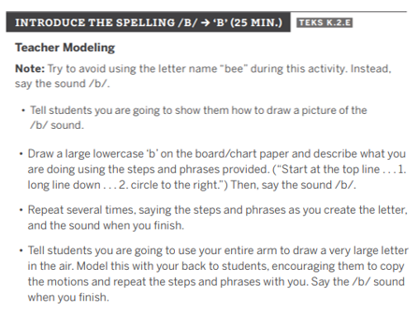  The teacher clearly breaks down how to write letter b and models each step. As the teacher models, they verbally explain the steps.
Guided Practice | Students work with the teacher to practice and apply what they just learned during the direction instruction | 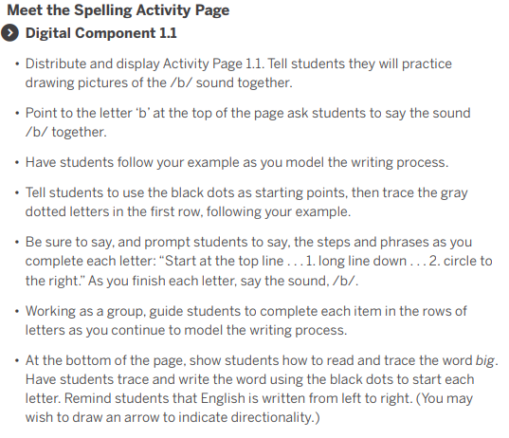  Students follow the teacher’s example as they practice writing the letter B.
Independent Practice | Students apply what they just learned without support from the teacher or peers | 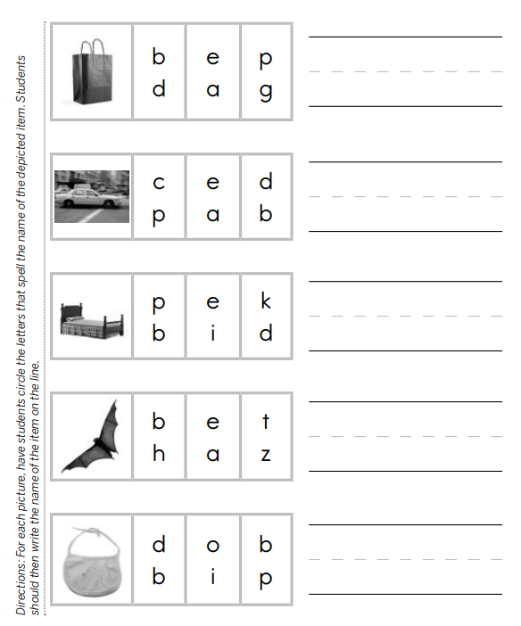  Students are practicing the same skills modeled during the direct instruction. The practice aligns directly to the objectives listed
Debrief/Closing | The teacher and students examine and analyze their experience and learning after the completion of an activity or lesson. | 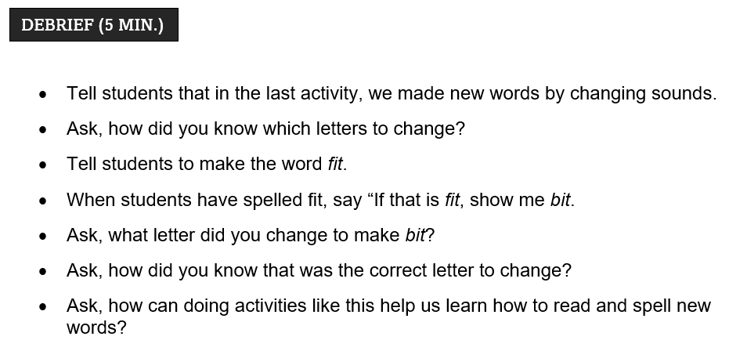  The debrief ask students to think about how they knew which letters to change in the previous activity. Students then practiced changing the word fit to bit. The teacher asked students to tell how they knew what letter to change and how this activity could help them with reading and spelling new words.
Assessment | Any tool used to collect, analyze, and respond to information about student understanding of learning targets. | 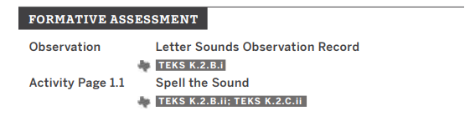  The assessment aligns to the standards, objectives, and practice.

Practice 1: Lesson Analysis
Read Grade 2 Module 7 Lesson 6 . As you read, identify the components of a high-quality lesson plan. Identify how the standards, objectives, learning activities (introduction, direct instruction, guided practice, independent practice, and debrief), and assessment align.

Note: The standards are not listed on the lesson plan but are included in the topic overview.
The standards for Lesson 6 are as follows:

- 2.4A - Recall basic facts to add and subtract within 20 with automaticity.
- 2.4B - Add up to four two-digit numbers and subtract two-digit numbers using mental strategies and algorithms based on knowledge of place value and properties of operations.
- 2.5A - Determine the value of a collection of coins up to one dollar.

Component | Evidence from Lesson Plan?
Standards | - 2.4A - Recall basic facts to add and subtract within 20 with automaticity.  - 2.4B - Add up to four two-digit numbers and subtract two-digit numbers using mental strategies and algorithms based on knowledge of place value and properties of operations.  - 2.5A - Determine the value of a collection of coins up to one dollar.
Objectives | Recognize the value of coins and count up to find their total value
Introduction | - The Fluency Differentiated Practice –review and mastery of the sums and differences with totals through 20  - Decomposition Tree - Students are given 90 seconds to decompose a specified amount in as many ways as they can.
Direct Instruction | There is no evidence of direct instruction. The instruction seems to be more of a guided practice than direct instruction. The teacher does not use explicit teaching techniques and modeling to teach a specific skill.
Guided Practice | Part 1: Count Coins in Isolation.  Part 2: Count mixed groups of coins starting with the largest value coin.  Part 3: Count mixed groups of coins by making ten.  The teacher asks questions or ask students to use their white boards to show the values of different sets of coins. For the concept development portion of the lesson students work with the teacher to practice the skills they are learning.
Independent Practice | Students can independently practice what they learned through the problem set and application problems.
Debrief | During the Student Debrief, the teacher and students examine and analyze their experience and learning. Students review their solutions for the problem set and compare answers with a partner to check their work. The teacher uses this time to address any misunderstandings.
Assessment | Count or add to find the total value of each group of coins. Write the value using the ¢ or $ symbol.

How are the standards, objectives, learning activities (introduction, direct instruction, guided practice, independent practice, and debrief), and assessment aligned?
Each of the learning activities directly align to the objectives and standards for the lesson. During the learning activities, students learn how to recognize the value of coins and count up to find their total value. During the practice, the students practice what they learned during the instruction/guided practice portion of the lesson. The Exit Ticket directly aligns with what students learned and practiced during the lesson and aligns to the standards and objectives for this lesson.

