Unit 6: Instructional Alignment

Lesson 6.04: Standard & Objective Alignment

Lesson at Glance
Warm-Up (5 mins)  - Bellringer | Instruction (15 mins)  - Intro to Lesson Standards & Objectives | Application (30 mins)  - Practice #1  - Practice #2  - Debrief  - Exit Ticket

TEKS | 3 | The student explores the teaching and training profession. The student is expected to:  (B) summarize and apply acquired pedagogical knowledge and skills needed by teaching and training professionals
 | 6 | The student plans and develops effective instruction. The student is expected to:  - explain the role of the Texas Essential Knowledge and Skills in planning and evaluating instruction  - explain the rationale for and process of instructional planning components such as vertical alignment and scope and sequence  - demonstrate lesson planning to meet instructional goals.
Objectives | - Define and describe standards and objectives.  - Explain the key differences between standards and objectives.  - Identify and evaluate objectives to determine alignment with the standards.
Rationale/  Summary | Standards and objectives form the basis of high-quality curriculum and lesson plans. In this lesson, students will explore key differences between standards and objectives. Students will examine the standards in a lesson from HQIM to identify what students need to know and do and analyze the objectives in the lesson plan to determine how they are aligned to the standards. Students will also look at a nonexample lesson plan to determine how well the objectives align and make suggestions for improvement.
Formative Assessment and Exemplar Response | Students will read a scenario and write a short answer to explain why the use of consistent state standards is beneficial in this situation.  Students will read an example standard and circle the objectives that most closely align to the standard.  See 6.4 Exit Ticket Answer Key for exemplar response.
Vocabulary | Standards |  | The statewide learning goals or expectations for what students should know and be able to do at each grade level
Vocabulary | Objectives |  | Brief statements that describe what students will be expected to learn by the end of the unit or lesson

Est Time | Instructional Activities (including formative assessments) | Materials
3 mins | Bellringer: Consider this 3rd grade standard:  The student understands the purposes of earning, spending, saving, and donating money. The student is expected to:  - Identify ways of earning, spending, saving, and donating money.  Work with a partner to underline the verbs in the student expectation and brainstorm ways in which students would show their learning of this concept. | Student Guide  PPT
2 mins | T: What were the verbs you identified?  S: Understand and identify  T: What do students need to understand and identify?  S: They need to understand the purpose of earning, spending, saving, and donating money and they need to identify ways to earn, spend, save, and donate money.  T: How might students show that they understand these ideas?  S: They can respond to scenarios in which they have to make decisions about how to use a set amount of money; they can create a budget plan; create business/store where students must earn, spend, save, and donate money; create a poster that explains earning, spending, saving, and donating money and tips for each.  T: How can this process of identifying the verbs and determining what students have to do with the content benefit a teacher during planning?  S: It helps identify what students have to do with the content and the level of rigor needed to master the standard. It also helps them think about how they might have students show their learning, just as we did in this activity.  T: Today, we are going to discuss how this process helps create objectives or learning goals for students that derive from the standard.
15 mins | Intro to Lesson Standards & Objectives  T: Based on what we learned in previous lessons, what is a standard?  S: Standards are statewide learning goals or expectations for what students should know and be able to do at each grade level.  T: (Share PPT). Right - standards are the learning goals or expectations for what students should know and be able to do at each grade level. Remember that here in Texas, these standards are called TEKS.  T: Standards are important because they inform everyone involved in a student’s education—teachers at all grade levels and content areas, principals, parents, students, etc.—what a student should know and be able to do at each grade level.  This means that if a student changes teachers or moves to a new Texas public school in the fourth grade, they will still have the same learning goals for the year. Standards keep learning consistent throughout the state.  T: As we discussed in the bellringer, the verbs in the standard help determine what students need to be able to do to achieve mastery of the content in the standard.  T: Let’s look at an example and determine what students need to know and do based on the verbs and content in the standard.  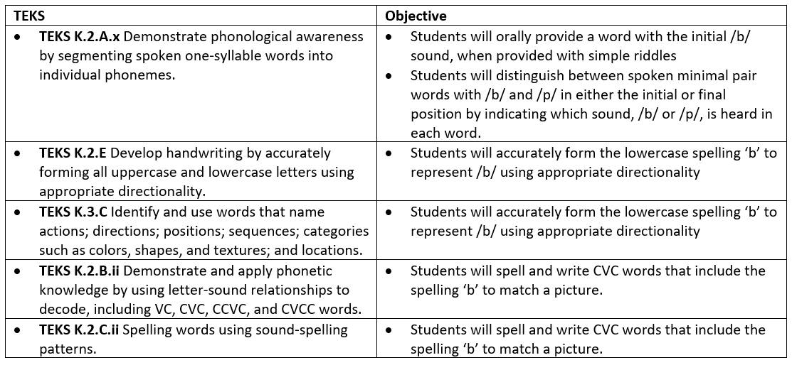  T: What verbs do you see in this standard?  S: develop, forming, using  T: What do students have to develop?  S: handwriting  T: How?  S: By correctly forming all uppercase and lowercase letters.  T: Students also have to use appropriate directionality, which means being able to form a letter that is facing the correct direction, a letter that isn’t turned backward or upside down.  T: Let’s put this in a chart to help us think about what students need to be able to know and do.  T: By pulling out the verbs and identifying the content or what students must learn, a teacher knows what to expect from their students by the end of the year. The teacher can use the objectives in the lesson plans to identify how this standard is taught through the year  T: Based on our previous learning, how would you define objectives?  S: Objectives are brief statements that describe what students will be expected to learn by the end of the unit or lesson.  T: Yes – Objectives also help the students know what they will be learning within a lesson.  T: Objectives are derived from standards. Standards are broad and are used to guide curriculum through the year; whereas objectives state what students will know and be able to do by the end of a lesson.  T: (Share image via PPT). Let’s look at one objective that aligns to the standard we just examined.  T: What do you notice about the standard and objective for this lesson?  S: The objective is more specific about what sound and letter students will be segmenting, whereas the standard covers all sounds and letters. In the objective we can see that students will form the lowercase letter ‘b’ to represent the /b/ sound using appropriate directionality. The objective also directly aligns to the standard.  T: It’s important to include standards aligned objectives in a lesson plan because it shows how the learning target for the day’s lesson supports the learning targets for the whole year.  T: Because standards are so broad, they often aren’t met in one lesson. It’s not realistic for kindergarten students to learn to write all of the upper and lowercase letters in one lesson. The objectives are what students should be able to master within a lesson.  T: Objectives help guide the development of assessments and instructional activities.  T: Why is it important for the standards and objectives to align?  S: The standards tell what students need to know and be able to do by the end of the year. The objectives are smaller learning targets that build toward achievement of the standards. If they are not aligned, the lesson tasks and assessments will likely not align, and the student may not be learning the necessary grade-level content. | Student Guide  PPT
  Do (verbs) | Content (nouns) | Students will…
  Develop | Handwriting | Develop handwriting
  Form | All upper and lowercase letters | Form upper and lowercase letters
  Use | Appropriate directionality | Use appropriate directionality
15 mins | Practice #1 – Examples  T: You are going to work in groups to examine the standards and objectives for a grade 1 science lesson plan. You will look at the standards in the lesson plan to identify the verbs and the content and use that to determine what students need to know and do. You will then analyze each objective in the lesson plan to determine which standard it aligns to.  T: Let’s do the first one together. (Share image via PPT as student record notes in graphic organizer on student guide.)  T: The first standard is 1.9A. Who can read that standard for me?  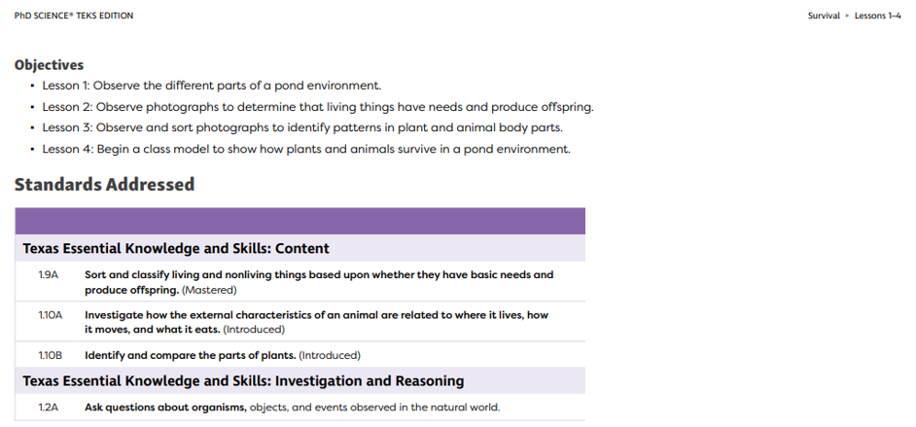  S: Sort and classify living and nonliving things based upon whether they have basic needs and produce offspring.  T: As I reread this standard, I see that the verbs or what students must do are sort and classify. Write those in your graphic organizer under the “do”.  S: Students record notes on graphic organizer.  T: Now, let’s look for the nouns or the content that students will have to sort and classify.  T: I see living and nonliving things, basic needs, offspring. That tells me what students need to classify and sort. Add those to your student guide.  S: Students record notes on graphic organizer.  T: Now, let’s look at each objective in the lesson plan to determine which objectives align to this standard.  T: The only objective I see that relates to living and nonliving things is the objective for lesson 2 - Observe photographs to determine that living things have needs and produce offspring. Add that objective to your graphic organizer.  S: Students record notes on graphic organizer.  T: Now, you are going to work in groups to examine the standards and objectives for a grade 1 science lesson plan. Look at the standards in the lesson plan to identify the verbs and the content and use that to determine what students need to know and do. Then analyze each objective in the lesson plan to determine which standard it aligns to. Record your notes in the graphic organizer in the student guide.  T: (Place students in groups and provide time to complete the activity.)  S: (Complete practice activity in the student guide).  T: What were some of the verbs you identified in the standards?  S: Sort, classify, investigate, identify, compare, ask  T: How did looking at the verbs and content in the standard help you determine which objective to choose?  S: It helped us know what students had to do with the content and identify how that related to the different objectives.  T: Yes – to say that students just need to know the parts of a plant would be incorrect for the level of rigor in this standard. This standard requires students to be able to identify and compare the parts of plants. | Student Guide  Grade 1 Science Module 1 Lesson 1 – Page 15
  Standard | Do (Verbs) | Content (Nouns) | Objective that Aligns to the Standard
  1.9A | Sort, classify | living and nonliving things based on basic needs and production of offspring. | Observe photographs to determine that living things have needs and produce offspring
10 mins | Practice #2 – Nonexamples  T: Now, you are going to work in the same groups to examine the standards and objectives for another grade 1 science lesson plan. For this activity, you will review the standards (same as in practice #1) and analyze the objectives in the lesson plan to determine if they are aligned to the standards. Provide evidence to support your claim and make suggestions for improvement where needed.  T: Let’s look at the first objective together.  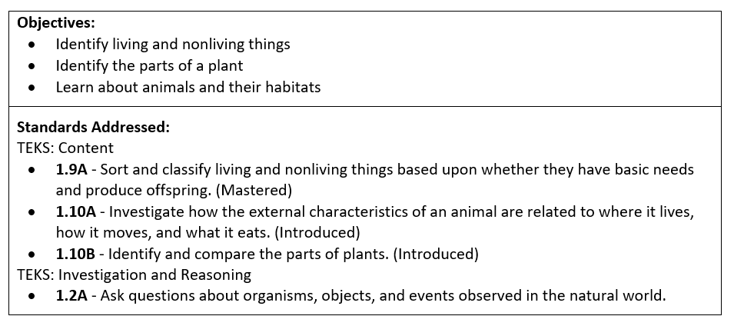  T: The objective is to identify living and nonliving things. We will assume that it goes with TEKS 1.9A  T: Let’s write that in the first column in our chart.  T: Does the objective match the corresponding standard?  S: No  T: Why not?  S: Because the standard requires student to sort and classify living and nonliving things, not just identify them. Also, students must sort and classify based upon whether the living and nonliving things have basic needs and produce offspring.  T: Now, you will work with your group to finish the chart for the other objectives.  T: (Place students in groups and provide time to complete the activity.) | Student Guide  PPT
  Objective | Standard | Aligned to Standards?  (Y, N, or Partially) | Evidence to Support Your Claim
  Identify living and nonliving things | 1.9A – Sort and classify living and nonliving things based upon whether they have basic needs and produce offspring.
  Objective | Standard | Aligned to Standards?  (Y, N, or Partially) | Evidence to Support Your Claim
  Identify living and nonliving things | 1.9A – Sort and classify living and nonliving things based upon whether they have basic needs and produce offspring. | N | The standard requires student to sort and classify living and nonliving things, not just identify them. Also, students must sort and classify based upon whether the living and nonliving things have basic needs and produce offspring.
5 mins | Debrief  T: Let’s come back together to talk about what you learned.  T: What difference did you notice about the two sets of standards and objectives?  S: The objectives in the first activity were aligned directly to the standards. The objectives narrowed in on exactly what students would be doing to gain an understanding of the standard. In the second activity, the objectives used similar language from the standards but did not actually address the standard.  T: What is the key difference between a standard and an objective.  S: The standard is the broad expectation for what students need to know and do by the end of the grade-level. The objective is a more defined goal that students need to achieve by the end of the lesson. | Student Guide
5 mins | (Students complete the exit ticket.) | Exit Ticket

