Student Guide

Lesson 6.04: Standard & Objective Alignment
Name:
Date:
Bellringer: Consider this 3rd grade standard:

The student understands the purposes of earning, spending, saving, and donating money. The student is expected to:
- Identify ways of earning, spending, saving, and donating money.

Work with a partner to underline the verbs in the student expectation and brainstorm ways in which students would show their learning of this concept.

Intro to Lesson Standards & Objectives
Write the definition and notes for each term below as they are discussed in the lesson.
Term | Definition | Notes:
Standards
Objectives

Practice #1
You are going to work in groups to examine the standards and objectives for a grade 1 science lesson plan. You will look at the standards in the lesson plan to identify the verbs and the content and use that to determine what students need to know and do. You will then analyze each objective in the lesson plan to determine which standard it aligns to.

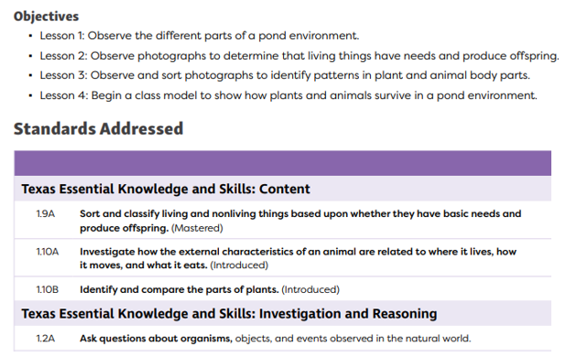

Standard | Do (verbs) | Content (nouns) | Objective that aligns to the standard
1.9A
1.10A
1.10B
1.2A

Practice #2
Review the standards (same as in practice #1) and analyze the objectives in the lesson plan to determine if they are aligned to the standards. Provide evidence to support your claim. Make suggestions for improvement.

Objectives:
- Identify living and nonliving things
- Identify the parts of a plant
- Learn about animals and their habitats
Standards Addressed:
TEKS: Content
- 1.9A - Sort and classify living and nonliving things based upon whether they have basic needs and produce offspring. (Mastered)
- 1.10A - Investigate how the external characteristics of an animal are related to where it lives, how it moves, and what it eats. (Introduced)
- 1.10B - Identify and compare the parts of plants. (Introduced)
TEKS: Investigation and Reasoning
- 1.2A - Ask questions about organisms, objects, and events observed in the natural world.

Objective | Standard | Aligned to Standards (Y, N or partially) | Evidence to support your claim
Identify living and nonliving things | 1.9A - Sort and classify living and nonliving things based upon whether they have basic needs and produce offspring.
Identify the parts of a plant | 1.10B - Identify and compare the parts of plants.
Learn about animals and their habitats | 1.10A - Investigate how the external characteristics of an animal are related to where it lives, how it moves, and what it eats.  1.2A - Ask questions about organisms, objects, and events observed in the natural world.

