Unit 6: Instructional Alignment

Lesson 6.06: Sequencing the Content of a Lesson

Lesson at Glance
Warm-Up (5 mins)  - Bell Ringer | Instruction (15 mins)  - Intro to Sequencing the Content of a Lesson  - Example of Sequencing in a Lesson | Application (25 mins)  - Practice #1  - Debrief  - Exit Ticket

TEKS | 3 | The student explores the teaching and training profession. The student is expected to:  (B) summarize and apply acquired pedagogical knowledge and skills needed by teaching and training professionals
 | 6 | The student plans and develops effective instruction. The student is expected to:  - explain the role of the Texas Essential Knowledge and Skills in planning and evaluating instruction;  - explain the rationale for and process of instructional planning components such as vertical alignment and scope and sequence;  - demonstrate lesson planning to meet instructional goals.
Objectives | - Describe and explain how a lesson is intentionally structured to build student understanding.  - Identify and evaluate how learning is sequenced within a single lesson to build understanding.
Rationale/  Summary | Concepts in a lesson need to be organized in an order that starts simply and builds in complexity. In this lesson, students will apply their understanding of sequencing a unit plan to describe and explain how the concepts and skills in a lesson are intentionally structured to build student understanding. Students will examine a lesson plan from HQIM to identify and evaluate how the learning is sequenced and how the sequence builds student understanding.
Formative Assessment and Exemplar Response | Students will look at a lesson sequence and determine if the learning is structured to build student understanding. If not, students will make suggestions for how the teacher could better sequence the instruction. Students will respond to the following questions about the lesson sequence:  - What do you notice about how the learning is sequenced?  - What could the teacher do to better sequence the instruction and build student understanding?  Students will respond to the following questions:  - How does intentionally sequencing the concepts and skills in a lesson support student learning?  - How does the sequencing of a lesson relate to the Science of Learning?  - What might be the impact of a lesson where the learning is not sequenced?  (Exemplar response included in exit ticket answer key)
Vocabulary | Sequencing |  | Organizing concepts in an order that starts simply and builds in complexity

Est Time | Instructional Activities (including formative assessments) | Materials
 | Prior to this lesson, determine how you would like to share the sample lessons: Lesson 1 of Grade K Skills 5 Unit and Grade 2 Module 1 Lesson 3 You can find these resources as separately uploaded PDFs with the other resources for Lesson 6.06. The lesson excerpts can be shared electronically or can be printed.
5 mins | Bellringer: Look at the list of skills below and place them in order from the skill that is taught first to the skill that is taught last.  - Writing an essay  - Drawing a line  - Writing a complete sentence  - Drawing a circle  - Writing the letter C  - Writing a simple word  - Writing a paragraph | Student Guide  PPT
5 mins | Intro to Sequencing the Content of a Lesson  T: How did you determine the order of these skills?  S: I thought about which skills were more simplistic and which were more complex. I arranged them from most simple to most complex.  T: Why should a teacher consider the order in which they introduce content?  S: They must make sure students have the prior knowledge and skills needed to apply to the new concept or skill being taught.  T: Yes – it would not make sense to introduce adding and subtracting 2-digit numbers before students have successfully mastered adding and subtracting 1-digit numbers.  T: Although the skills just discussed are skills that would be introduced over multiple units or even years, it is also important to consider how we introduce students to new content within a single lesson.  T: We have discussed and identified the different components of a high-quality lesson plan. Today, we want to take it a step further and talk about how a lesson is structured to build student understanding.  T: We know from the Science of Learning that for learners to take in, process, and learn information, it must be presented in small increments and in a sequential manner.  T: In our previous lesson on sequencing a unit, we learned that purposeful lesson sequencing creates a continuum of learning which builds upon the previously taught lesson. A teacher must think about how to pace out and sequence the learning in a logical way to give students the information they need when they need it to build a deeper understanding of the concepts.  T: (Share PPT). Just like the lessons within a unit must be sequenced, the learning within a single lesson also needs to be organized in an order that starts simple and builds in complexity.  S: (Take notes in student guide.)
10 mins | Example of Sequencing in a Lesson  T: Let’s look at an example of how the concepts and skills are sequenced in Lesson 1 of Grade K Skills 5 Unit. (Provide students a copy of the lesson – pages 11-18 of Grade K Skills 5 Teacher Guide.)  T: At the beginning of the lesson, students do a warm-up activity to practice the short vowel sounds i, a, and o.  T: Next, students move into a sound riddle activity where students are introduced to the sound /b/. Students must first repeat several words that have the /b/ sound that the beginning and then repeat words that have the /b/ sound at the end.  T: What do students do next?  S: They listen to the teacher say words and tell whether they hear /b/ at the beginning of the word or the end of the word.  T: Next, students listen to riddles and respond with the correct answer which all begin with the /b/ sound.  T: The lesson then moves into helping students hear the different between the /b/ sound and the /p/ sound. The lesson introducing rhyming words by using words that have the /b/ and /p/ sounds.  T: What happens next in the lesson?  S: The teacher introduces the spelling for the /b/ sound. The teacher first models how to write a B, then students practice writing B as the teacher models.  T: The last activity is a word chaining activity where students make new words from old words by chaining one letter in the word. For example, “if b-o-p is bop, show me top.” For this activity, all the words use the short vowels o, a, and i reviewed at the beginning of the lesson and the /b/ and /p/ sounds introduced in the lesson.  T: Let’s look back at the different activities and think about how the concepts were sequenced.  T: How were the concepts and skills sequenced throughout the lesson?  S: The concepts were ordered from simple to more complex. The lesson started by helping students hear the short vowel sounds and the /b/ and /p/ sounds and then asked students to practice producing the sounds. Students then had to recognize the difference between the /b/ sound and the /p/ sound and identify rhyming words with those two sounds. The lesson then moved into writing the letter B. The last activity pulled all the skills together by having students create words with the sounds introduced in the lesson.  T: How did the progression of the lesson help build student understanding?  S: Students were able to work with the different sounds in multiple ways, which helped build a deeper understanding of the sounds. | Lesson 1 of Grade K Skills 5 Unit (copies printed or shared electronically)
  Activity | Skills/Concepts
  Warm-up | Producing short vowel sounds for i, a, and o
  Sound Riddles | Repeat, identify, and produce words with /b/
  Minimal Pairs | Recognizing the difference between the /b/ sound and /p/ sound
  Rhyming Words | Identifying rhyming words with /b/ and /p/
  Spelling /b/ | Teacher models how to write B, students practice writing B
  Student Chaining | Students make new words from old words by chaining one letter in the word. All the words use the short vowels o, a, and i and the /b/ and /p/ sounds.
Nonexample of Sequencing in a Lesson
T: Now, let’s look at a nonexample of sequencing in a lesson.

T: Take a couple minutes to read the activities students will engage in during the lesson. (Provide time for students to scan the lesson).

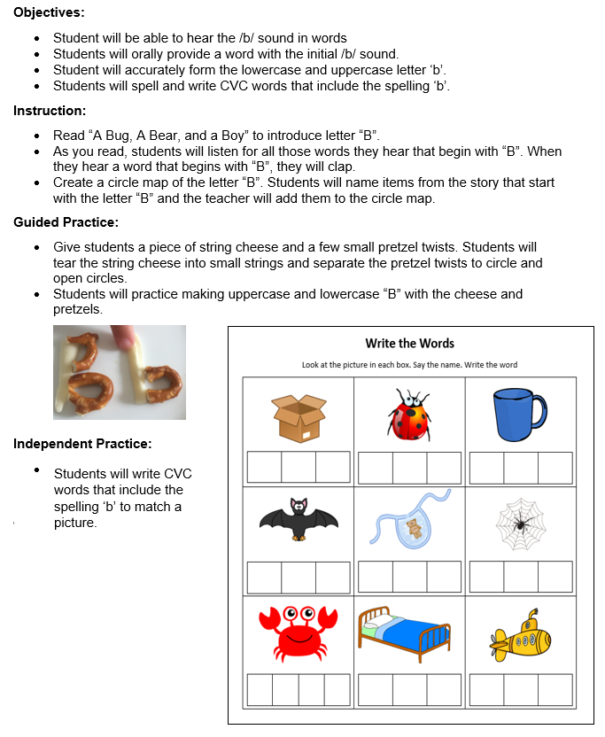
T: What is the first activity?

S: The teacher reads “A Bug, A Bear, and a Boy” while students listen for words that begin with ‘b’.

T: What happens next?

S: Circle Map - Students name items from the story that started with letter ‘b’ – teacher adds to the circle map.

T: What acitivity do students engage in next?

S: Students make upper- and lowercase ‘b’ with string cheese and pretzels

T: What is the last activity?

S: Students write CVC words with initial and final ‘b.’ (Note: Teacher may need to explain CVC – consonant, vowel, consonant – construction to help students understand the lesson.)

Activity | Skills/Concepts
Story | Listen for words that begin with ‘b’ and clap
Circle Map | Students name items from the story that started with letter ‘b’ – teacher adds to the circle map
Letter ‘b’ with string cheese and pretzels | Students make upper- and lowercase ‘b’ with string cheese and pretzels
CVC Worksheet | Students write CVC words with initial and final ‘b’
T: Look at the chart of the activities and skills. What do you notice about the progression of the skills?

S: The students went from listening for words that begin with ‘b’ to writing CVC words with initial and final ‘b.’

T: Yes – the objectives state that students will accurately form lowercase and uppercase ‘b,’ but students did not have any instruction on how to write letter ‘b’. The teacher had students just making the letter ‘b’ with cheese and pretzels, which doesn’t help students practice how to accrurately write the letter. The objective also has students focusing on hearing and providing words that begin with letter ‘b’, but in the practice, students are writing CVC word for pictures that begin and eng with /b/.

T: How migth this impact students’ ability to complete the independent practice?

S: Students likely will not be able to write letter ‘b’ accurately because they were not provided guidance on how to write the letter. Students may also have difficulty writing the words that end with letter ‘b’ since students haven’t learned how to hear the ending sounds in words.
15 mins | Practice #1  T: Now, it is your turn to look at a lesson from a Grade 2 math lesson to identify and evaluate how the learning is sequenced to build student understanding. (Give students a copy of Grade 2 Module 1 Lesson 3– Pages 51-60 of the teacher guide).  T: This lesson is about adding and subtracting like units, such as tens and ones, to solve problems within or up to 100. This simply means that the numbers students are working with will not be over 100.  T: With a partner, examine the lesson plan for Grade 2 Module 1 Lesson 3. Look at each of the learning activities the students engaged in based on the chart in your student guide and determine the concepts and skills introduced through those different learning activities. Then, evaluate how the learning is sequenced to build student understanding.  S: (Complete practice activity in the student guide). | Student Guide  Grade 2 Module 1 Lesson 3– pages 51-60 of the teacher guide
5 mins | Debrief  T: What did you notice about how the lesson was sequenced?  S: The complexity of the skills increased throughout the lesson. Students began with a sprint activity to practice their fluency with easier problems to help them solve more complex addition and subtraction problems up to 100 later in the lesson. During the concept development, the lesson started with adding and subtracting like units, ones, to solve problems up to 100 then moved to adding and subtracting like units, tens, to solve problems up to 100. The remainder of the lesson provided time for students to practice those concepts and apply their understanding to solve a problem where they needed to subtract to find the answer where the result is unknown.  T: How do you think the sequence of learning helped students build a deeper understanding of the concept?  S: Students were able to make connections between the more simplistic problems they solved earlier in the lesson to the more complex problems. Students examined the relationship between the different problems and identified how easier problems can be used to solve other, more complex problems.
5 mins | (Students complete the exit ticket.) | Exit Ticket

