Student Guide

Lesson 6.06: Sequencing the Content of a Lesson
Name:
Date:
Bellringer: Look at the list of skills below and place them in order from the skill that is taught first to the skill that is taught last.
Skill | Order
Writing an essay
Drawing a line
Writing a complete sentence
Drawing a circle
Writing the letter C
Writing a simple word
Writing a paragraph

Intro to Sequencing the Content of a Lesson
Write the definition and notes for each term below as they are discussed in the lesson.
Term | Definition
Sequencing

Example of Sequencing in a Lesson
Activity | Skills/Concepts
Warm-up
Sound Riddles
Minimal Pairs
Rhyming Words
Spelling /b/
Student Chaining

Read the activities below in which the students will engage during the lesson.
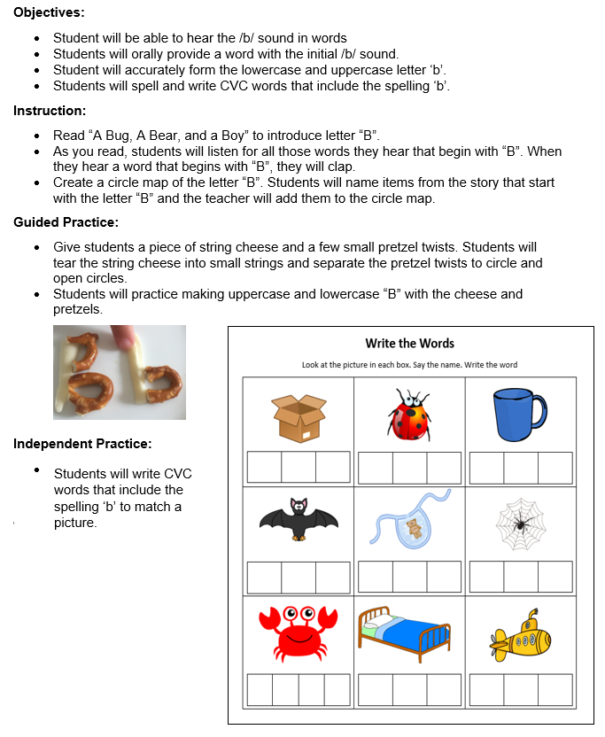

Nonexample of Sequencing in a Lesson
Activity | Skills/Concepts
Story
Circle Map
Letter ‘b’ with string cheese and pretzels
CVC Worksheet

Practice #1
With a partner, examine the lesson plan for Grade 2 Module 1 Lesson 3. Look at each of the learning activities the students engaged in below and determine the concepts and skills introduced through those different learning activities. Then, evaluate how the learning is sequenced to build student understanding.

Activity | Skills/Concepts
Sprint: Related Facts
Concept Development: Part 1
Concept Development: Part 2
Application Problem
Problem Set
Student Debrief
Exit Ticket

How was the learning sequenced to build student understanding?

