Student Guide – Answer Key

Lesson 6.06: Sequencing the Content of a Lesson
Name:
Date:
Bellringer: Look at the list of skills below and place them in order from the skill that is taught first to the skill that is taught last.
Skill | Order
Writing an essay | 7
Drawing a line | 1
Writing a complete sentence | 5
Drawing a circle | 2
Writing the letter C | 3
Writing a simple word | 4
Writing a paragraph | 6

Intro to Sequencing the Content of a Lesson
Write the definition and notes for each term below as they are discussed in the lesson.
Term | Definition
Sequencing | Organizing concepts in an order that starts simple and builds in complexity

Example of Sequencing in a Lesson
Activity | Skills/Concepts
Warm-up | Producing short vowel sounds for i, a, and o
Sound Riddles | Repeat, identify, and produce words with /b/
Minimal Pairs | Recognizing the difference between the /b/ sound and /p/ sound
Rhyming Words | Identifying rhyming words with /b/ and /p/
Spelling /b/ | Teacher models how to write B, students practice writing B
Student Chaining | Students make new words from old words by chaining one letter in the word. All the words use the short vowels o, a, and i and the /b/ and /p/ sounds.

Read through the activities below in which the students will engage during the lesson.
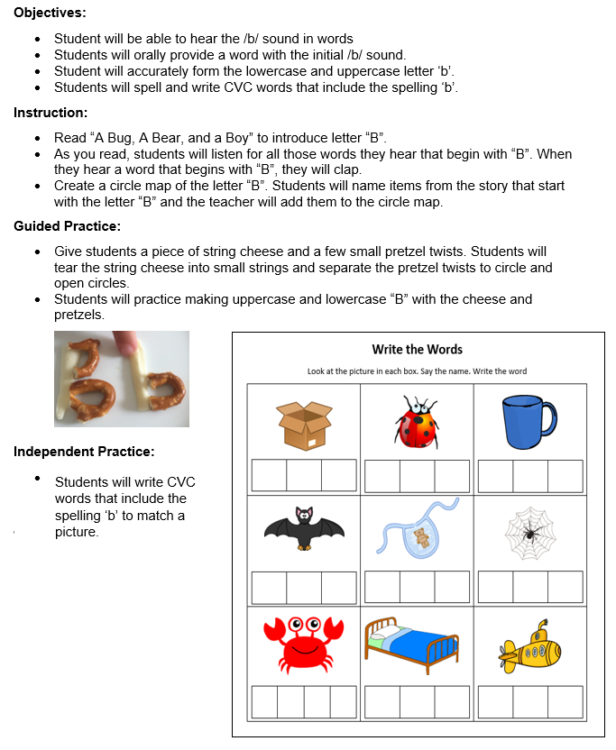
Nonexample of Sequencing in a Lesson
Activity | Skills/Concepts
Story | Listen for words that begin with ‘b’ and clap
Circle Map | Students name items from the story that started with letter ‘b’ – teacher adds to the circle map
Letter ‘b’ with string cheese and pretzels | Students make upper- and lowercase ‘b’ with string cheese and pretzels
CVC Worksheet | Students write CVC words with initial and final ‘b’

Practice #1
With a partner, examine the lesson plan for Grade 2 Module 1 Lesson 3. Look at each of the learning activities the students engaged in below and determine the concepts and skills introduced through those different learning activities. Then, evaluate how the learning is sequenced to build student understanding.

Activity | Skills/Concepts
Sprint: Related Facts | Students build their fluency with simple problems in order to solve more complex addition and subtraction problems within 100.
Concept Development: Part 1 | Add and subtract like units, ones, to solve problems within 100 (5+2; 45+2; 7-2; 47-2). This concept builds on the sprint activity.
Concept Development: Part 2 | Add and subtract like units, tens, to solve problems within 100 (51+20; 54+20; 71-20; 74-20)
Application Problem | Students apply their understanding of adding and subtracting like units to solve a takeaway with results unknown problem
Problem Set | Students apply their understanding of adding and subtracting like units to solve problems.
Student Debrief | Students compare 24+5 to 24+50 and explain what is different to a partner. Students explain their thinking and understanding of the concept
Exit Ticket | Students independently complete the exit ticket problems to assess their understanding of adding and subtracting like units within 100.
How was the learning sequenced to build student understanding?
The complexity of the skills increased throughout the lesson. Students began with a spring activity to practice their fluency with easier problems in order to help them solve more complex addition and subtraction problems within 100 later in the lesson. During the concept development, the lesson started with adding and subtracting like units, ones, to solve problems within 100 then moved to adding and subtracting like units, tens, to solve problems within 100. The remainder of the lesson provided time for students to practice those concepts and apply their understand to a take away from result unknown problem. This helped students understand how easier problems can be used to solve other, more complex problems.

