Unit 6: Instructional Alignment

Lesson 6.07: Scaffolding a Lesson | Intro to Gradual Release

Lesson at Glance
Warm-Up (10 mins)  - Bell Ringer  - Review Exit ticket from previous lesson | Instruction (15 mins)  - Intro to Scaffolding a Lesson  - Intro to Gradual Release of Responsibility | Application (25 mins)  - Practice #1  - Debrief  - Exit Ticket

TEKS | 3 | The student explores the teaching and training profession. The student is expected to:  (B) summarize and apply acquired pedagogical knowledge and skills needed by teaching and training professionals
 | 6 | The student plans and develops effective instruction. The student is expected to:  - explain the role of the Texas Essential Knowledge and Skills in planning and evaluating instruction  - explain the rationale for and process of instructional planning components such as vertical alignment and scope and sequence  - demonstrate lesson planning to meet instructional goals.
Objectives | - Describe and explain how a lesson is intentionally structured to build student understanding within a lesson  - Define and explain the stages of gradual release of responsibility and how each stage scaffolds student learning  - Identify and evaluate how learning is scaffolded within a lesson plan
Rationale/  Summary | In the Science of Learning, students learned that due to the limited capacities of the working memory, learners need to take in, process, and learn information in small increments and in a logical order. In this lesson, students will learn how a lesson is intentionally structured to build student understanding using the gradual release of responsibility framework or “I do, we do, you do”. Students will look at examples of each stage of the framework within a lesson plan then apply that knowledge in the practice activity. Students will evaluate a lesson plan from HQIM to identify the “I do, we do, you do” sections of the lesson and explain the teacher actions and student actions for each section.
Formative Assessment and Exemplar Response | Students will examine a list of activities and sort them into I do, we do, you do. Students will then explain why scaffolding is important.  (Exemplar response included in exit ticket answer key)
Vocabulary | Scaffolding |  | Structured supports offered to students by the teacher to help students attain a strong command of a new skill and/or concept
Vocabulary | Gradual Release of Responsibility |  | An instructional framework that gradually shifts the cognitive load from the teacher to the student.
Vocabulary | Modeled Instruction |  | The part of the lesson where the teacher demonstrates how to perform a skill while describing each step with a rationale.
Vocabulary | Shared Instruction |  | A form of practice in which the teacher continues to provide explicit instruction but invites students to contribute.
Vocabulary | Guided Practice |  | A form of practice in which students practice the new skill or concept with support from the teacher and/or peers.
Vocabulary | Independent Practice |  | A form of practice in which students independently apply what they have learned without support from the teacher or peers.

Est Time | Instructional Activities (including formative assessments) | Materials
 | Prior to this lesson, determine who you would like to share the sample lesson: Lesson 1 from Grade 1 Knowledge 1 Fables and Stories Unit - pages 12-19. You can find this resource as a separately uploaded PDF with the other resources for Lesson 6.07. The lesson excerpts can be shared electronically or can be printed.
4 mins | Bellringer: Compare each parent’s approach to teaching their child how to ride a bike. Which approach likely led to more success and why?  - Parent #1: When teaching her son to ride a bike, the parent sat on the bike to demonstrate how to ride. She provided her son with training wheels to start then gradually raised the training wheels. Once she felt her son was ready, the mom took off the training wheels and instead used her hand to guide her son as she walked beside him. Once the boy felt steady, the mom removed her guiding hand and let her son take off on his own.  - Parent #2: When teaching his son to ride a bike, the parent explained how to ride the bike. He explained to his son how to sit on the seat, steady himself, and use the peddles. Then, he put his son on the bike and gave him a push. | Student Guide  PPT
1 min | T: Let’s discuss the bellringer. What support or scaffolds did parent #1 provide that likely led to a higher level of success for the child learning to ride a bike? What could parent #2 have done differently?  S: Parent #1 showed the child how to ride the bike, gave him training wheels until he felt steady enough riding. After she removed the training wheels, she used her hand to steady her son then allowed him to go off on his own. Parent #2 could have showed the son how to ride the bike instead of just talking him through the process. He could have provided him with supports such as the training wheels. | Student Guide  Activity adapted from: IRIS Center
5 mins | Review Exit Ticket from Previous Lesson  T: In our previous lesson, we discussed how a lesson is intentionally sequenced to build student understanding. Let’s take a couple minutes to debrief the exit ticket you completed at the end of yesterday’s lesson.  T: What did you notice about how the learning was sequenced?  S: The teacher moves from introducing the individual values of coins to having students use different coin combinations to make a dollar.  T: What could the teacher do to better sequence the instruction and build student understanding?  S: The lesson should include more instruction and practice with counting coins with the same values, such as 3 dimes make 30 cents. Students could then build on their understanding of skip counting by fives and tens to find the value of a set of coins. The teacher could then move into introducing how to count a mixed group of coins. Students need more instruction on how to use prior knowledge of skip counting and adding to determine the value of different coin combinations before moving into the guided activity and independent practice.  T: How does intentionally sequencing the concepts and skills in a lesson support student learning?  S: Intentionally sequencing the concepts and skills in a lesson support student learning by presenting the information in a logical order that helps students build on previously taught skills. A lesson that is intentionally sequenced considers that students need to be presented small amounts of information at a time and considers what information a student needs to know at different points in the lesson to best support their learning.  T: How does the sequencing of a lesson relate to the Science of Learning?  S: For learners to take in, process, and learn information, it must be presented in small increments and in a sequential manner.  T: What might be the impact of a lesson where the learning is not sequenced?  S: Students may miss out on prior knowledge and/or skills needed to fully understand the concept or skill being taught in the lesson. The lesson may be disjointed causing confusion for students. | Student Guide  Exit Ticket from Lesson 6.06
5 mins | Intro to Scaffolding a Lesson  T: (Share PPT.) Today, we are going to talk about scaffolding a lesson using the gradual release of responsibility, which is another key element of intentionally structuring a lesson to build understanding.  S: (Take notes in the student guide.)  T: Scaffolding is when structured supports are offered to students by the teacher to help students attain a strong command of a new skill and/or concept  T: Let’s consider Parent #1 from our bellringer.  Parent #1: When teaching her son to ride a bike, the parent sat on the bike to demonstrate how to ride. She provided her son with training wheels to start then gradually raised the training wheels. Once she felt her son was ready, the mom took off the training wheels and instead used her hand to guide her son as she walked beside him. Once the boy felt steady, the mom removed her guiding hand and let her son take off on his own.  T: What scaffolds or temporary supports did parent #1 provide her son?  S: The mom showed how to ride the bike, provided training wheels, raised the training wheels as the son became more comfortable, guided her son with her hand after she removed the training wheels.  T: Yes – the mom provided just enough support to help her son build his skills and confidence until he was ready to achieve the task on his own. While the son was building his skills, the mom gradually removed the supports she offered to provide a little less guidance. This is scaffolding.  T: Let’s look at an example of what scaffolding looks like in the context of a lesson. | Student Guide  PPT
10 mins | Intro to Gradual Release of Responsibility  T: (Share PPT.) The Gradual Release of Responsibility is an instructional framework that gradually shifts the cognitive load from the teacher to the student. It is also referred to as the I Do, We Do, You Do framework. With this structure, teachers provide guidance, opportunities for practice, and lead students toward independent understanding. (Give students 2 minutes to review the chart on their own, then share with a partner what they observed)  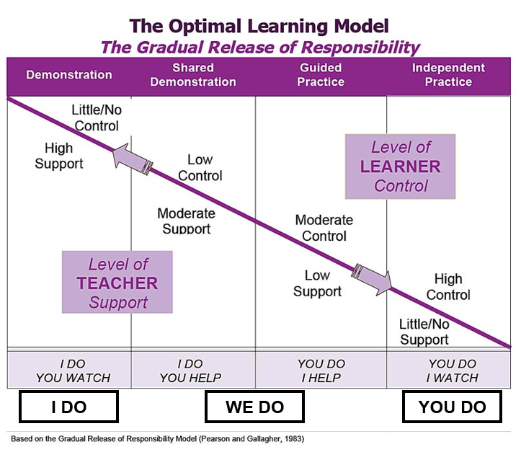  S: (Turn and talk with a partner about what they observed in the chart.)  T: What happens to teacher support as instruction moves from, I Do to You Do?  S: The level of teacher support decreases.  T: What happens to the level of learner control as instruction moves from, I Do to You Do?  S: The level of learner control increases.  T: Yes. So as the level of teacher support decreases, students have more control over their learning. (Direct students to take notes in their student guides)  T: The gradual release framework begins with ‘I do.’ This is where the teacher provides explicit instruction, demonstrates, and models the learning for the students.  T: During the modeled instruction, the teacher demonstrates how to perform a skill while describing each step with a rationale. In this stage, the teacher is implementing approximately 90 percent of the ‘heavy lifting' (Archer & Hughes, 2011).  T: Let’s return to Lesson 1 of Grade K Skills 5 Unit to see what the ‘I do’ portion of a lesson might look like in HQIM.  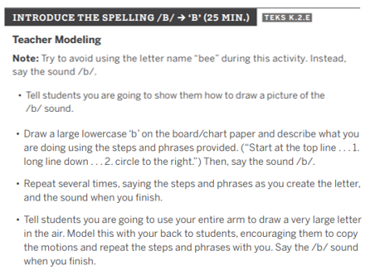  T: How is this an example of the ‘I do’ stage of the gradual release model?  S: The teacher is the one doing the heavy lifting by modeling and demonstrating how to spell the /b/ sound.  T: Yes – the teacher has the cognitive load at this point. The teacher is doing the work while students watch.  T: Next is the ‘We do’. This is where the teacher encourages students to participate in the learning. This takes the form of shared instruction and guided practice.  T: Shared practice is where the teacher continues to provide explicit instruction but invites students to contribute.  T: The guided practice is where students practice the new skill or concept with support from the teacher and/or peers.  T: Both shared and guided practice provide opportunities for students to ask questions, contribute ideas, and solve problems using strategies from the direct instruction.  T: Look at the guided practice activity for the lesson example we just examined. (Share lesson plan via PPT – pages 15 of Grade K Skills 5 Teacher Guide.)  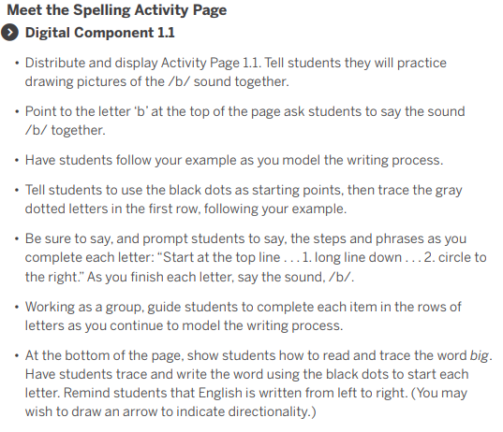  T: How does this represent the ‘We do’ stage of the gradual release model?  S: The teacher continues to model as students practice writing the letter B with her.  T: Looking at the Gradual Release graphic, you can see that as teachers and students transition to the ‘We do' stage, the level of responsibility begins to shift for both the teacher and the student.  T: The heavy lifting is almost equal as the teacher begins to transition more learning ownership on to the students. At this point, students have about more responsibility. The teacher is still highly involved and supports students as they work with peers to apply new learning.  T: The last stage is the ‘You do’ or independent practice. This is where students independently apply what they have learned without support from the teacher or peers. Now, about 90 percent of the heavy lifting is placed on the students to demonstrate their own learning and mastery of the content.  T: Here is the independent practice for the lesson we’ve been examining. (Share lesson plan via PPT – pages 16 of Grade K Skills 5 Teacher Guide.)  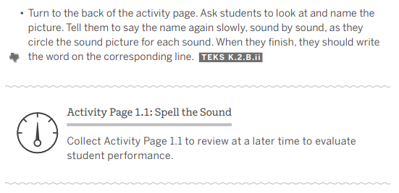  T: How does this represent the ‘You do’ stage of the gradual release model?  S: Students must independently complete Activity Page 1:1 where they name a picture, say the name sound by sound, and write the word. This allows students to demonstrate their understanding of the standard without teacher or peer support. | Student Guide  PPT
15 mins | Practice #1  T: (Provide students with a copy of the lesson plan.) With a partner, you are going to examine Lesson 1 from Grade 1 Knowledge 1 Fables and Stories Unit - pages 12-19 to identify the I do, we do, and you do sections of the lesson. Identify what the teacher actions are and what the student actions are in each section. Then, determine how this structure helped build students’ understanding within the lesson.  S: (Complete practice activity in the student guide.) | Student Guide  Lesson 1 from Grade 1 Knowledge 1 Fables and Stories Unit - pages 12-19
5 mins | Debrief  T: How does intentionally structuring a lesson help build student understanding within a lesson?  S: It allows learners to take in, process, and learn information in small increments and in a logical order. It allows learners to build on their prior knowledge and provides the right amount of scaffolding needed to build understanding toward mastery.  T: Why is a gradual release of responsibility framework useful for scaffolding student learning?  S: This framework is useful in scaffolding student learning because it gradually shifts the cognitive load from the teacher to the student. Learning starts with the teacher doing a lot of modeling to demonstrate the concept or skill. Once students are ready, the teacher invites students to participate in the learning through guided practice. This is where students can apply their learning with teacher and peer support. The final stage is where students independently apply their new learning. This process sets students up for success, builds on student learning, and increases confidence in students.
5 mins | (Students complete the exit ticket.) | Exit Ticket

