Unit 6: Instructional Alignment

Lesson 6.09: Scaffolding a Lesson | Modeling, Part II

Lesson at Glance
Warm-Up (5 mins)  - Bell Ringer | Instruction (5 mins)  - Intro to Modeling a Lesson/ Success Criteria | Application (40 mins)  - Practice #1  - Practice #2  - Debrief  - Exit Ticket

TEKS | 3 | The student explores the teaching and training profession. The student is expected to:  (B) summarize and apply acquired pedagogical knowledge and skills needed by teaching and training professionals
TEKS | 6 | The student plans and develops effective instruction. The student is expected to:  - explain the role of the Texas Essential Knowledge and Skills in planning and evaluating instruction  - explain the rationale for and process of instructional planning components such as vertical alignment and scope and sequence  - demonstrate lesson planning to meet instructional goals.
Objectives | - Define and describe characteristics of effective modeling  - Identify and apply examples of modeling within a lesson  - Evaluate the modeling within a lesson based on characteristics of effective modeling
Rationale/  Summary | In the Science of Learning unit, we learned that the working memory has limited capacities which can become overwhelmed by tasks that are too cognitively demanding. By providing a step-by-step model of how to perform a task or solve a problem, a teacher helps avoid cognitive overload. In this lesson, students will learn the purpose of modeling and identify the criteria for successful modeling. Students will use the success criteria analyze examples and nonexamples of modeling in a lesson.
Formative Assessment and Exemplar Response | Students will read a scenario to determine whether it meets the characteristics of effective modeling. If the criteria are not met, provide a suggestion for improvement.  Students will respond to the following question: How does teacher modeling help build student understanding and mastery of the standard?  (Exemplar response included in exit ticket answer key)
Vocabulary | Modeling |  | An instructional strategy where the teacher demonstrates how to perform a skill while describing each step with a rationale.

Est Time | Instructional Activities (including formative assessments) | Materials
4 mins | Bellringer: Look at each lesson example and determine if it is an example of the “I do”, “We do”, or “You do” portion of the lesson. Write if it is “I do”, “we do”, or “you do” beside the example number. | Student Guide
1 min | T: (Review correct responses.)  T: How did you determine if each lesson clip was an example of “I do”, “we do”, or “you do”?  S: I thought about what the task was asking the student to do vs what the teacher was doing.  T: What is it important for a lesson to include these components?  S: It helps ensure that the cognitive load gradually shifts from the teacher to the student. It allows learners to take in, process, and learn information in small increments and in a logical order. It allows learners to build on their prior knowledge and provides the right amount of scaffolding needed to build understanding toward mastery. | Student Guide
5 mins | Intro to Modeling a Lesson  T: In our previous lesson, we discussed how a lesson should be intentionally structured to build student understanding using a gradual release of responsibility framework, such as “I do, we do, you do.” (Share image via PPT.)  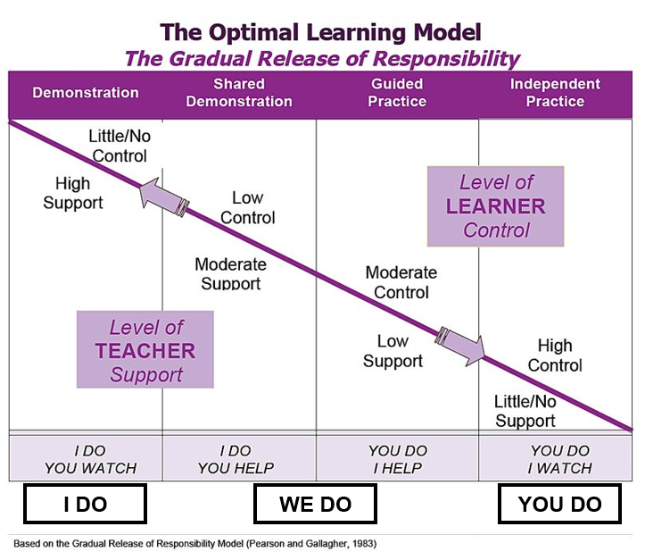  T: Today, we are going to discuss a key component of the “I do” stage of the gradual release framework, which is where the teacher provides explicit instruction, demonstrates, and models the learning for the students.  S: (Take notes in student guide.)  T: Modeling is an instructional strategy where the teacher demonstrates how to perform a skill while describing each step with a rationale.  T: Modeling allows students to see how to perform each step of a process as well as understand why each step is important.  T: Modeling also reduces a student’s cognitive burden. Why is it important to avoid overload?  S: Too much information at once or tasks that are too cognitively demanding can interfere with learning.  T: Yes – Students have a limited working memory capacity which can become overwhelmed by tasks that are too cognitively demanding. By providing a step-by-step demonstration of how to perform a task or solve a problem, a teacher helps avoid cognitive overload.  Success Criteria  T: Let’s look at the criteria for successful modeling. When modeling a concept or skill, a teacher must:  - Break down the skill into learnable steps  - Visually demonstrate the steps as students watch  - Think Aloud = Verbally explain what the student is seeing as you model  - Make important connections between the steps  - Check for student understanding along the way and re-model steps as necessary  - Ensure pacing is just the right speed  - Allow opportunities for students to ask questions and get clarification  T: It is also important to note that the modeling must align to the language and rigor of the objective to ensure students are focused on the most important content expected for the lesson and the content that will be assessed in the future. This is why it is essential that the objective align to the standards for the grade-level. | Student Guide  PPT
10 mins | Practice #1 – Video Example of Modeling  T: Let’s look at an example of modeling in a 2nd grade math class to find evidence of successful modeling based on the criteria we just discussed. (Direct students to where they will record evidence in their student guides)  According to the success criteria, what will we be looking for?  S: (Name the success criteria from their student guides.)  T: As you watch, record evidence of the success criteria and consider how the model is related to the objective, how the students are engaged in learning, and what the teacher’s role is.  T:(Start video at 17:05 and end at 21:40.)  S: (Watch video example and record evidence in student guide.)  T: How does this model align to the success criteria? (Guide student discussion based on answers in 6.8 Student Guide – Answer Key.) | Video Link: https://drive.google.com/file/d/1lHi5hQwbWuIhCER7G3hNn8DHZkA-zwGO/view?usp=sharing (Start at 17:05 - End at 21:40)
20 mins | Practice #2 - Nonexample of Modeling  T: Use the following script to model a nonexample. Pay close attention to the directions for how you are to deliver the lesson. As you model, students will evaluate your delivery based on the success criteria.  T: Now, let’s look at a nonexample of modeling. I am going to deliver a lesson while you all play the role as second grade students in my class. As we go through the lesson, evaluate my delivery based on the success criteria for modeling and record your notes in the student guide.  T: (read the script below) | Lesson Source  Student Guide  PPT
  T: (Quickly introduce the outcomes.) The outcomes for today are to demonstrate understanding of coin values and create coin combinations that are equal to one dollar.
  T: Repeat that with me.
  S: Students repeat outcomes with the teacher.
  T: (Review coin values with students.)
  T: (Hold up a picture of a quarter.) What coin is this?
  S: Quarter.
  T: What is the value of a quarter?
  S: 25 cents
  T: (Hold up a picture of a penny.) What coin is this?
  S: Penny.
  T: What is the value of a penny?
  S: 1 cent
  T: (Hold up a picture of a dime.) What coin is this?
  S: dime.
  T: What is the value of a dime?
  S: 10 cents
  T: (Hold up a picture of a nickel.) What coin is this?
  S: Nickel
  T: What is the value of a nickel?
  S: 5 cents
  T: (Quickly discuss how to find ways to make a dollar from different coin combinations.)
  T: Let’s look at how to make a dollar using different coin combinations.
  T: I can use 4 quarters. (Draw 4 quarters on the board.)
  T: I can use 10 dimes. (Draw 10 dimes on the board.)
  T: I can use 2 quarters and 5 dimes. (Draw 2 quarters and 5 dimes on the board.)
  T: I could also use 100 pennies or 20 nickels.
  T: All of these combinations make one dollar.
  T: You are now going to create your own combinations to make a dollar.
  T: Each of you will be assigned a specific coin to represent. You will then walk around the room and group up with other students around the room to make a dollar.
  T: I’m now going to assign each of you a value by giving you a picture of a coin. (Give each student a picture of a coin).
  T: Stand up and walk around the room to group up with other students around the room to make a dollar based on your coin values.
  S: (Stand up and walk around the room to group up with others to make a dollar based on their coin values.)
  T: (Walk around the room to check for understanding but do not provide specific feedback to students or remodel steps).
  T: Let’s come back together.
  T: What were some of the combinations you created?
  S: Students share coin combinations that made a dollar.
5 mins | Debrief  T: Why is this a nonexample of modeling?  S: You did not break down the concept of how to use different combinations of coins to make a dollar into learnable steps. You did not visually demonstrate the steps as students watched. Since there wasn’t a visual demonstration, you could not make important connections between the steps. You moved through the lesson at a fast pace and didn’t allow opportunities for us to ask questions and get clarification.  T: What could I have done differently to support student understanding before moving into the practice activity?  S: You could have visually shown students how to use different coin combinations to make a dollar while doing a think aloud to explain the process. This would have allowed an opportunity for you to make connections between the steps in the process. You could have gone at a slower pace and allowed time for students to ask questions and get clarification.  T: How does modeling help build student understanding?  S: Teacher modeling helps build student understanding by scaffolding the concepts and skills into learnable steps. Modeling allows students to see how to perform each step of a process as well as understand the connections between each step and why each step is important. Modeling also communicates what a successful outcome looks like, and the importance of the concept being taught.
5 mins | (Students complete the exit ticket.) | Exit Ticket

