Student Guide

Lesson 6.09: Scaffolding a Lesson | Modeling, Part II
Name:
Date:
Bellringer: Look at each lesson example below and determine if it is an example of the “I do”, “We do”, or “You do” portion of the lesson. Write if it is “I do”, “we do”, or “you do” beside the example number.
Example 1: ________________

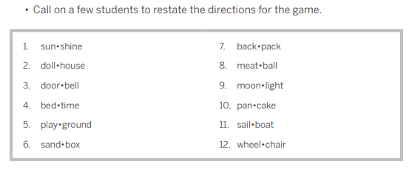
Example 2: ________________
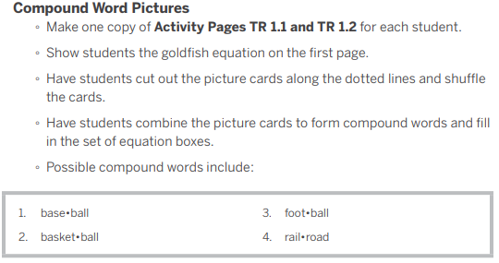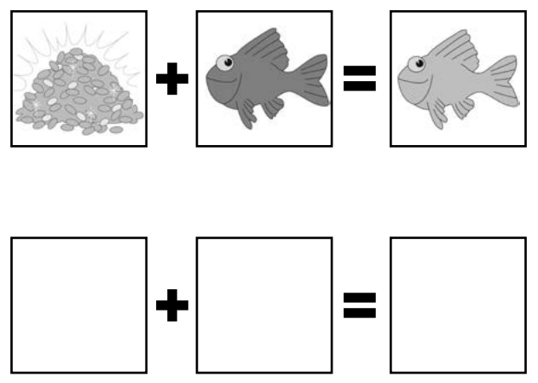
Example 3: ________________
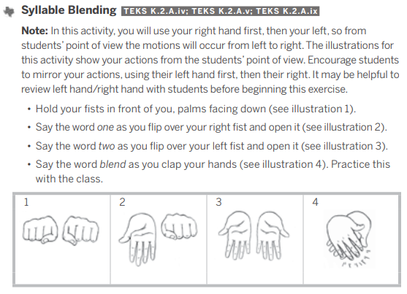
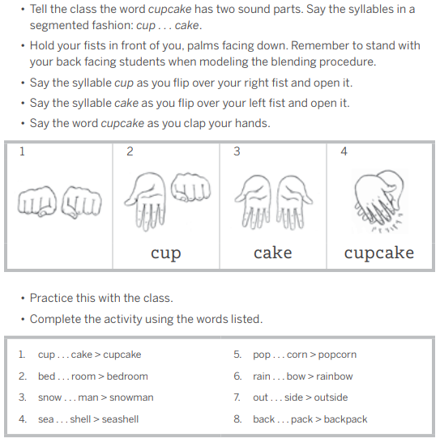

Intro to Modeling a Lesson
Write the definition and notes for each term below as they are discussed in the lesson.
Term | Definition
Modeling

Success Criteria
Criteria for successful modeling:

Practice #1 - Video Example of Modeling
Watch an example of modeling in a 2nd grade math class. As you watch, find evidence of successful modeling based on the criteria we discussed and record evidence of the success criteria in the chart below. Then, consider how the model was related to the objective, how the students were engaged in learning, and what the teacher’s role was.

Objective: Students will use math drawings to represent equal groups and relate to repeated addition.

Criteria for Successful Modeling | Evidence from the Lesson
Break down the skill into learnable steps
Visually demonstrates the steps as students watch
Verbally explain what the student is seeing as you model
Make important connections between the steps
Check for student understanding along the way and re-model steps as necessary
Ensure pacing is just the right speed
Allow opportunities for students to ask questions and get clarification

- How was the model related to the objective?

- How were the students engaged in learning?

- What was the teacher’s role?

Practice #2 - Nonexample of Modeling
Evaluate the teacher’s delivery of the model based on the success criteria.

Criteria for Successful Modeling | Teacher’s Model
Break down the skill into learnable steps | - Met  - Not Met  Reasoning:
Visually demonstrates the steps as students watch | - Met  - Not Met  Reasoning:

