Student Guide – Answer Key

Lesson 6.09: Scaffolding a Lesson | Modeling, Part II
Name:
Date:
Bellringer: Look at each lesson example below and determine if it is an example of the “I do,” “We do,” or “You do” portion of the lesson. Write if it is “I do,” “we do,” or “you do” beside the example number.
Example 1: ___We do_____
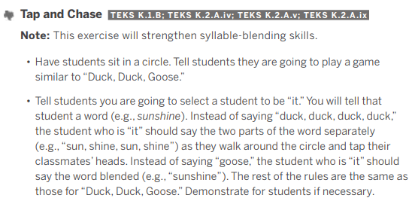
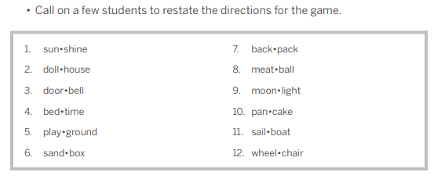
Example 2: ____You do______
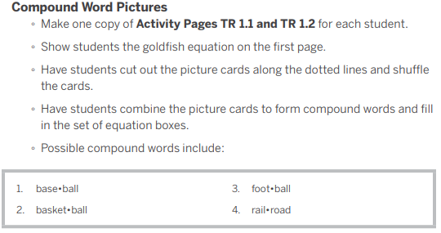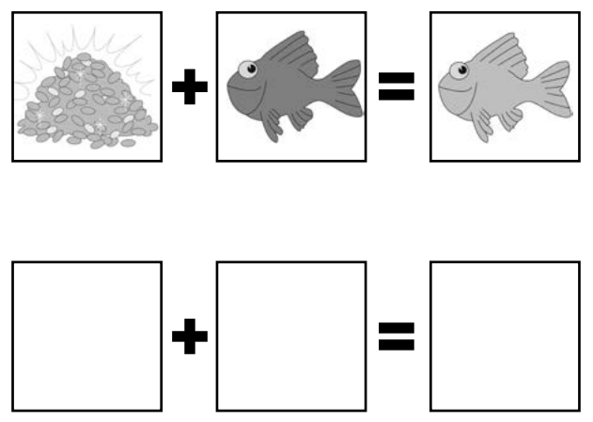

Example 3: ___I do_____
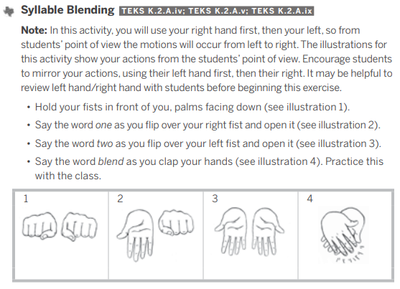
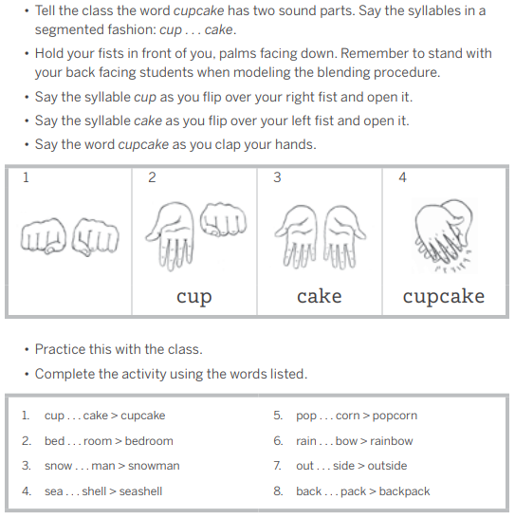

Intro to Modeling a Lesson
Write the definition and notes for each term below as they are discussed in the lesson.
Term | Definition
Modeling | An instructional strategy where the teacher demonstrates how to perform a skill while describing each step with a rationale.

Success Criteria
Criteria for successful modeling:

- Break down the skill into learnable steps.
- Visually demonstrate the steps as students watch.
- Think Aloud - Verbally explain what the student is seeing as you model.
- Make important connections between the steps.
- Check for student understanding along the way and re-model steps, as necessary.
- Ensure pacing is just the right speed.
- Allow opportunities for students to ask questions and get clarification.

Practice #1 - Video Example of Modeling
Watch an example of modeling in a 2nd grade math class. As you watch, find evidence of successful modeling based on the criteria we discussed and record evidence of the success criteria in the chart below. Then, consider how the model was related to the objective, how the students were engaged in learning, and what the teacher’s role was.

Objective: Students will use math drawings to represent equal groups and relate to repeated addition.

Criteria for Successful Modeling | Evidence from the Lesson
Break down the skill into learnable steps | Reads the word problems and takes students step by step through how to draw a picture to solve the problem.
Visually demonstrates the steps as students watch | Visually demonstrates how to draw 4 circles to represent 4 boxes and modeled how to put 6 pencils in each box.
Verbally explain what the student is seeing as you model | The teacher thinks aloud through each of the steps as they model on the board.
Make important connections between the steps | He asks students to describe the groups (4 groups) and how to write and repeated addition sentence to represent the drawing. Students had to make the connection between the repeated addition sentence and the number of items in each group.
Check for student understanding along the way and re-model steps as necessary | The teacher frequently asks students to repeat what he said or did or what was said in the word problem. He asks students questions to check to see if they understand the process of using repeated addition to solve problems.
Ensure pacing is just the right speed | He moved quickly to keep students engaged, but not too quickly to where students didn’t understand the concept
Allow opportunities for students to ask questions and get clarification | He asked if students if they had any questions.

- How was the model related to the objective?
The teacher modeled how to use a drawing to represent equal groups and then modeled how to write a repeated addition to represent the picture.

- How were the students engaged in learning?
The students repeated the steps in the process as the teacher modeled them. Students responded to questions the teacher asked. The students helped the teacher count the number of groups and number of items in each group as the teacher modeled on the board.

- What was the teacher’s role?
The teacher modeled the process of using a drawing to represent equal groups and how to write a related repeated addition sentence. The teacher visually demonstrated and talked student through each step and had students support him in the counting. He asked students questions to engage them in the learning.

Practice #2 - Nonexample of Modeling
Evaluate the teacher’s delivery of the model based on the success criteria.

Criteria for Successful Modeling | Teacher’s Model
Break down the skill into learnable steps | - Met  - Not Met  Reasoning: The teacher reviewed coin values and led a discussion with students to find ways to make a dollar from different coin combinations, but the teacher did not break down the steps for how to accomplish this task.
Visually demonstrates the steps as students watch | - Met  - Not Met  Reasoning: The teacher did not visually demonstrate the steps of how to use different coin values to make a dollar.
Think Aloud - Verbally explain what the student is seeing as you model | - Met  - Not Met  Reasoning: The teacher verbally explained how to make a dollar using different coin values but did not visually model for students as they were explaining. They just showed an example.
Make important connections between the steps | - Met  - Not Met  Reasoning: The teacher did not break the process into steps; therefore, they could not make connections between the steps.
Check for student understanding along the way and re-model steps as necessary | - Met  - Not Met  Reasoning: The teacher checked for student understanding during the activity but did not re-model the steps or provide specific feedback.
Ensure pacing is just the right speed | - Met  - Not Met  Reasoning: The teacher quickly moved through the lesson.
Allow opportunities for students to ask questions and get clarification | - Met  - Not Met  Reasoning: The teacher did not provide any opportunities for students to ask questions or get clarification.

