Unit 6: Instructional Alignment

Lesson 6.10: Scaffolding a Lesson | Practice

Lesson at Glance
Warm-Up (5 mins)  - Bell Ringer | Instruction (20 mins)  - Intro to Practice  - Success Criteria | Application (20 mins)  - Practice #1  - Practice #2  - Debrief  - Exit Ticket

TEKS | 3 | The student explores the teaching and training profession. The student is expected to:  (B) summarize and apply acquired pedagogical knowledge and skills learned in needed by teaching and training professionals
TEKS | 6 | The student plans and develops effective instruction. The student is expected to:  - explain the role of the Texas Essential Knowledge and Skills in planning and evaluating instruction  - explain the rationale for and process of instructional planning components such as vertical alignment and scope and sequence  - demonstrate lesson planning to meet instructional goals.
Objectives | - Identify examples of practice within a lesson  - Evaluate how the student practice within a lesson is aligned with the objectives and assessments  - Identify and evaluate how practice is sequenced to scaffold student understanding
Rationale/  Summary | We know that learning within a single lesson needs to be sequenced and scaffolded in a logical way to create an optimal learning experience for students. Concepts need to be organized in an order that starts simple and builds in complexity. This concept also applies to deliberate practice. In the Science of Learning, students learned about the characteristics and importance of deliberate practice. In this lesson, students will go deeper by exploring how practice is scaffolded and sequenced to build student understanding. Students will examine examples and nonexamples of deliberate practice to explain how the practice builds on itself to scaffold student understanding and evaluate how the student practice within a lesson is aligned with the objectives and assessments.
Formative Assessment and Exemplar Response | Students will look at the lesson objective and assessment, then sort the practice activities into examples and nonexamples.  (Exemplar response included in exit ticket answer key)
Vocabulary | Guided Practice |  | A form of practice in which students practice the new skill or concept with support from the teacher and/or peers.
Vocabulary | Independent Practice |  | A form of practice in which students independently apply what they have learned without support from the teacher or peers.
Vocabulary | Deliberate Practice |  | Practice that performs the learning goal (authentic), is spaced over time, is low-stakes and is paired with feedback for improvement
Vocabulary | Authentic |  | The practice requires the student to perform the actual learning goal.
Vocabulary | Low stakes |  | An activity has little or no impact on the student’s grade.
Vocabulary | Feedback |  | Practice of giving students information about their performance against a standard with the purpose of improving student performance
Vocabulary | Debrief |  | The teacher facilitates a conversation after an activity has taken place that outlines key questions to drive the group’s learning.

Est Time | Instructional Activities (including formative assessments) | Materials
5 mins | Bellringer:  - Complete the anticipation guide to review the criteria for deliberate practice.  - Based on the anticipation guide, what are the criteria for deliberate practice that you explored in the Science of Learning Unit? | Student Guide  PPT
10 mins | T: (Start video at 21:40 and end at 26:40.)  T: What evidence of deliberate practice did you see in the video lesson?  S: The practice was authentic, low stakes, and paired with feedback. Authentic – the task aligned to the learning goal which was to use math drawings to represent equal groups and relate to repeated addition; Low stakes – the activity was not collected for a grade but was reviewed as a whole group; Paired with feedback – the teacher walked around and provided specific feedback to students as they worked. The teacher also debriefed the activity to address misunderstanding and solidify student understanding.  T: The criteria “spaced over time” could not be observed in this short video clip. What could the teacher do ensure the practice is spaced over time?  S: He could provide additional problems for students to practice for homework, for a bell ringer, or practiced activities over the course of the next few days or weeks.  T: What is the benefit to spreading out the practice over a period opposed to only engaging in one practice session with a concept and moving on?  S: Practice spaced over time helps students remember the content over the long-term. Knowledge or skills are made more lasting and permanent in your long-term memory when you practice them regularly over time.  T: Why is it important for our practice to be deliberate?  S: We need to make sure that our practice is aligned to the task (authentic), that it is spaced out over time to strengthen and refine the learning in long term memory, that students have an opportunity to practice without the pressure of grades to build confidence and that we receive feedback to ensure that our practice is on the right track.  T: What role does feedback play in deliberate practice?  S: Feedback should be given to the student throughout practice and should be timely, specific, and actionable so students can immediately make corrections to accurately practice the skill. | Video Example: https://drive.google.com/file/d/1lHi5hQwbWuIhCER7G3hNn8DHZkA-zwGO/view?usp=sharing (Start at 21:40 – End at 26:40)
5 mins | Intro to Practice  T: In our previous lessons, we discussed how a lesson should be intentionally structured to build student understanding using a gradual release of responsibility framework. (Share via PPT as students record notes in student guide.)  T: How does gradual release align to the Five Principles for Teaching?  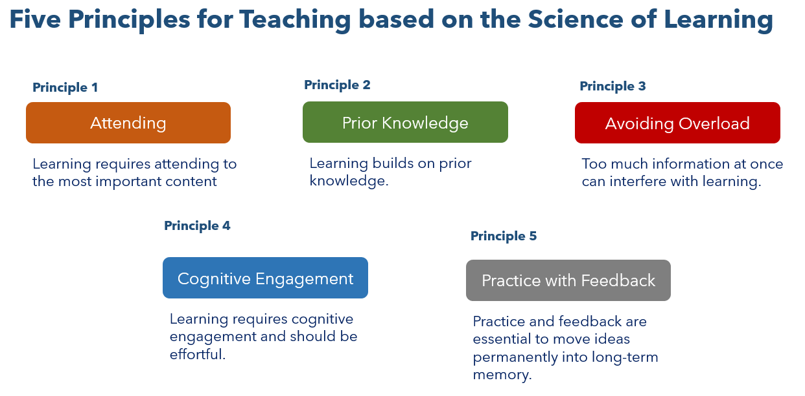  S: Gradual release helps learners build on their prior knowledge and avoid overload through logically sequenced and scaffolded lessons. It also provides space for students to practice and receive feedback which are essential to move ideas permanently into long-term memory.  T: Today, we are going to discuss the “We do” and “You do” stages of the gradual release framework. These two stages are where students practice the skills and concepts that were explicitly taught during the direct instruction.  T: One of the mistakes many new teachers make is thinking that teaching is all about explaining and “telling” students things. While direct instruction is an important part of teaching, it is just as important to give students multiple opportunities to practice applying knowledge or skills. Practice involves making mistakes and using feedback to adjust your understanding until you fully understand the content or skill.  T: One of the most important considerations when developing practice activities and tasks is whether they are aligned to the objective and assessment.  T: Why should practice be aligned to the objective and assessment?  S: Students needs to practice the most important content established by the standards and need to practice in the same way they will be assessed.  T: Practice happens after you introduce students to new content. What are some ways that your teachers ask you to practice new learning?  S: In math class, we complete practice problems. In art we practice new techniques, we use flash cards for vocabulary, etc.  T: How does practice help engage your working memory?  S: It engages the working memory in sense-making and learning.  T: Yes - Practice helps you move from a novice, meaning knowing a little about the content, to expert, meaning understanding the content and how it works.  T: What is guided practice?  S: Where students solve problems or apply a skill with support.  T: Yes – Guided practice is practice in which students practice the new skill or concept with support from the teacher and/or peers. This provides scaffolding to make sure they do not lose their way.  T: What is independent practice?  S: Where students solve problems or apply a skill by themselves.  T: Yes- Independent practice is where students independently apply what they have learned without support from the teacher or peers.  T: Remember that not all practice is the same. Practice needs to be deliberate practice.  T: Deliberate practice can be guided (with teacher support) or independent (without teacher support).  T: (Share via PPT while students record notes in student guide.)  T: Let’s look at an objective and assessment for a math lesson.  Lesson Objective: Understand equal groups of as multiplication  Assessment: Draw a picture to show 3 + 3 + 3 = 9. Then, write a multiplication sentence to represent the picture.  T: What do students need to know and be able to do?  S: Students understand that “equal groups of” means multiplication and create a multiplication sentence to represent their repeated addition picture.  T: Look at the examples list for ways students can practice this skill.  T: All these examples help students build their understanding of understanding that repeated addition and multiplication are related.  T: Look at the nonexample list. What do you notice about the activities in this list?  S: These activities don’t have students practicing the skill.  T: Right – these examples might help students understanding what multiplication means, but it doesn’t help students understand that equal groups of is multiplication, which is the learning target and what they will be assessed on.  T: Why is it important for students to practice the skills that were modeled?  S: Students need to practice the skills to get better at them. You must give students multiple opportunities to think about and practice content to make sense of it. It also allows students the opportunity to build on their prior knowledge.  T: Yes - The more a learner spends time practicing and thinking about the content in the working memory, the more likely they will learn the content. You use your working memory when you see examples and non-examples, discuss ideas, ask questions, practice skills, correct your mistakes, and update your understanding; therefore, it is important that students have multiple opportunities to practice moving the content into the long-term memory.  T: After the practice, it is helpful to bring students back together to debrief and close out the lesson. The debrief is where the teacher facilitates a conversation after the activity has taken place that outlines key questions to drive the group’s learning.  T: It is important to involve students in a learning dialogue to “talk the learning out.” It is through this conversation that the experience is turned into usable learning. Reflection is critical to the learning process. | Student Guide  PPT
  Examples
  - Skip count as a class
  - Use counters to make equal groups. Add the groups and write a number sentence.
  - Write repeated addition sentences to represent situations (4+4+4=12)
  - Explain to a partner about how 3x4 =12 is related to 4+4+4 =12
  - Write multiplication sentences from equal groups
  - Complete a set of practice problems with a partner
  - Complete a set of practice problems independently
  Nonexamples
  - Create and color a foldable to remember the lesson’s vocabulary. Cut and glue it into a math notebook
  - Write a poem or rap about multiplication
  - Talk to a partner about where you see multiplication in real life
  - Watch a video to learn a multiplication song and dance
5 mins | Practice #1: Example  T: In the Science of Learning, you examined examples and nonexamples to find evidence of deliberate practice. In this lesson, we are going to go deeper by looking at how the practice builds upon itself.  T: We’ve discussed how the learning within a single lesson needs to be sequenced and scaffolded in a logical way to create an optimal learning experience for students. That means concepts need to be organized in an order that starts simple and builds in complexity.  T: This concept also applies to deliberate practice.  T: As we examine the practice in a lesson, we want to consider the following questions:  - What are students practicing?  - How are they practicing?  - How does the practice build upon itself?  T: Let’s look at an example lesson from Lesson 3 Grade 1 Skills 3 Unit and determine what students are practicing, how they are practicing, and how that practice builds upon itself.  T: (Provide time for students to read the lesson plan. Model how to complete the graphic organizer during the Q & A).  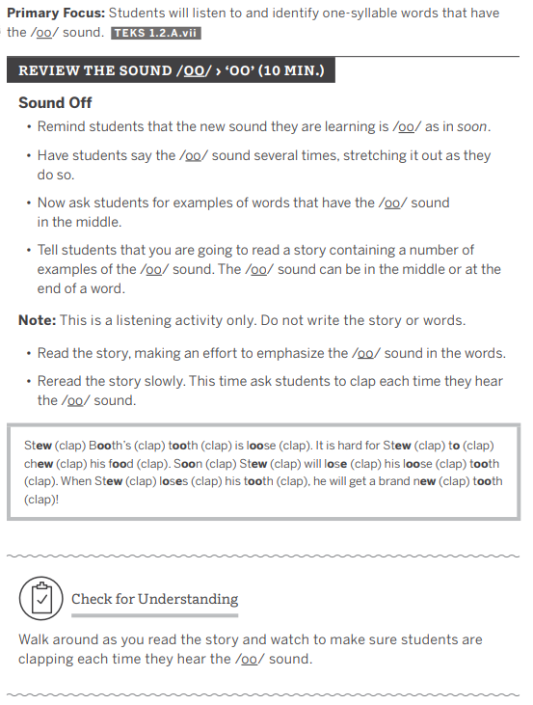  T: What are students practicing in this lesson?  S: Identifying one-syllable words with the /oo/ sound.  T: How are students practicing that?  S: Students say the /oo/ sound by stretching it out. Students provide examples of words with the /oo/ sound. Students listen for words with the /oo/ sound as the teacher reads a story. Students clap each time they head the /oo/ sound.  T: Now, we want to consider how that practice builds. What do students have to do first?  S: First students have to say the /oo/ sound by stretching it out.  T: What do student do next?  S: They must share words that have the /oo/ sound.  T: Then what?  S: They listen for words with the /oo/ sound as the teacher reads a book.  T: What do you notice about the progression of the practice?  S: Students move from more simplistic to more complex skills.  T: Yes – How does this help build students understanding of the learning goal?  S: Students practice and build their confidence with simpler skills before moving into more difficult skills.  T: How does this connect to the Science of Learning?  S: The working memory has limited capacity that can be overwhelmed when tasks are too cognitively demanding or when students are presented with too much information at once.  T: Yes – the sequencing of the practice, just like the sequencing of content, can help students avoid overload. It also helps students build on their prior knowledge to make connections and deepen understanding.  T: How did the practice align to the objectives and assessment?  S: The student practice directly addresses the objective for the lesson and students are assessed on the exact skill they are practiced and that was modeled at the beginning of the activity.  T: Why is it important for the practice to align to the standards and objectives?  S: Students need to practice the most important content at the level of rigor expected for the grade level. If not, students may not learn the content they need to learn for that grade-level, which could leave gaps for future learning. | Student Guide  PPT
  Learning Goal: Students will listen to and identify one-syllable words that have the /oo/ sound.
  What are students practicing? | How are they practicing? | How does the practice build upon itself?
  Identifying one-syllable words with the /oo/ sound | Students say the /oo/ sound by stretching it out.  Students provide examples of words with the /oo/ sound.  Students listen for words with the /oo/ sound as the teacher reads a story. Students clap each time they head the /oo/ sound. | The practice starts with a more simplistic skill of saying the /oo/ sound. Students then have to produce words with the /oo/ sound and then listen for words with the /oo/ sound as the teacher reads a book. The skills progress from hearing the sound in isolation to hearing the sound in words.
  How is the student practice within the lesson aligned with the objectives and assessments?
  The student practice directly addresses the objective for the lesson and students are assessed on the exact skill they are practiced and that was modeled at the beginning of the activity.
10 mins | Practice #2: Nonexample  T: Now, you are going to examine a nonexample of deliberate practice using the same process. (Share via PPT.)  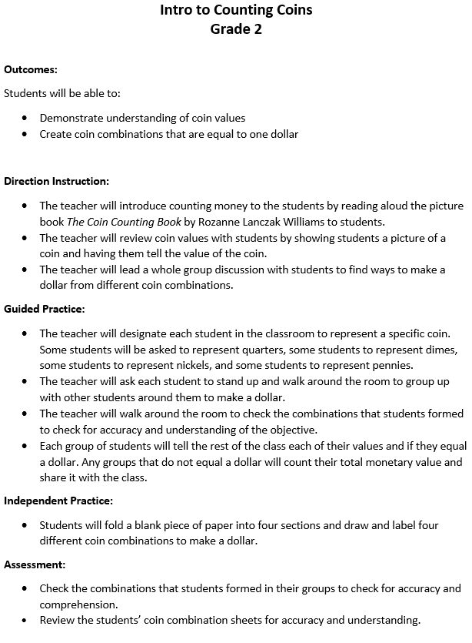  T: With a partner, read the lesson plan and complete the chart in your student guide by determining what students are practicing, how they are practicing, and how that practice builds upon itself. Then, consider how the student practice aligns with the objectives and assessments within the lesson.  T: (Provide time for students to read the lesson plan and take notes in the student guide. After a about 8 minutes, bring students back to discuss.)  T: What are students practicing?  S: Students are creating coin combinations to make a dollar.  T: How does the practice build upon itself?  S: The practice does not build. Students are assigned a specific coin value and they must work with a group to make a dollar. Then, students draw and label four different coin combinations to make a dollar.  T: How did the student practice align with the objectives and assessments within the lesson?  S: The practice aligned with the objective, which was to create coin combinations to make a dollar. The only assessments are observations of the guided practice and independent practice activity.  T: Why is this a nonexample of deliberate practice?  S: The practice does not allow opportunities for students to build on their understanding.  T: How could the practice be improved to build student understanding?  S: Students could have first practiced how to add the total value of a set number of the same coin, such as 3 nickels = 15 cents. Students could have used their prior knowledge of addition or skip counting to find the value and repeated the practice with dimes and quarters.  T: Yes – students then could have moved into counting mixed groups of coins starting with the largest value coin and practiced ways to count mixed groups of coins by making ten. Both strategies along with skip counting would have been helpful skills for students to practice before moving into the activity where they had to work with a group to make a dollar. | Student Guide  PPT
5 mins | Debrief  T: Why is it important for practice activities to build on one another?  S: It helps ensure that students have the prior knowledge they need to master new ideas and complete more difficult tasks independently. The more a learner spends time practicing and thinking about the content in the working memory, the more likely they will learn the content.  T: Why is deliberate practice important?  S: Students need to practice skills that align to the expectations set by the standards and objectives. Students need multiple opportunities to practice refining and strengthen their understanding without the pressure of being graded. Students also need timely and specific feedback to ensure they are on the right track and adjust if needed. This process helps students move their learning from the short-term memory to the long-term memory.
5 mins | (Students complete exit ticket) | Exit Ticket

