Unit 6: Instructional Alignment

Lesson 6.01: High Quality Curricula

Lesson at Glance
Warm-Up (5 mins)  - Bell Ringer | Instruction (20 mins)  - Introduction to High Quality Instructional Materials  - Introduction to the Components of a Curriculum | Application (20 mins)  - Practice #1  - Debrief  - Exit Ticket

TEKS | 3 | The student explores the teaching and training profession. The student is expected to:  - summarize and apply acquired pedagogical knowledge and skills needed by teaching and training professionals;
 | 6 | The student plans and develops effective instruction. The student is expected to:  - explain the role of the Texas Essential Knowledge and Skills in planning and evaluating instruction;  - explain the rationale for and process of instructional planning components such as vertical alignment and scope and sequence;  - demonstrate lesson planning to meet instructional goals.
Objectives | - Identify and describe the purpose and value of a high-quality curriculum.  - Identify the components of a high-quality curriculum.
Rationale/  Summary | We are emphasizing the use of high-quality curricula for several reasons:  - Research shows that when implemented with fidelity, a high-quality curriculum has a significant positive impact on student learning.  - The use of a curriculum varies by district, campus, and teaching assignment. Not all teachers will have a curriculum. Future educators should learn how to differentiate between materials that are research-based, rigorous, and differentiated, and those that are not.  - The course is primarily focused on instructional practices—how to teach lessons rather than how to write them
Formative Assessment and Exemplar Response | Students will response to the following questions:  1. What are the features of a high-quality curriculum?  2. What are the benefits of using a high-quality curriculum?  Students will match the component of a curriculum with the description.  (See exemplar response in Exit Ticket – Answer Key)
Vocabulary | Curriculum |  | A curriculum is a sequenced collection of instructional materials such as lesson plans, learning tasks, and assessments. Teachers use it to guide students toward proficiency in content knowledge and skills
Vocabulary | High-Quality Instructional Materials (HQIM) |  | Materials that are research-based, closely aligned to rigorous standards, differentiated to meet the needs of all students, and have been rated as high-quality by a team of reviewers
Vocabulary | Scope & Sequence |  | Outlines the learning plan for the year. Shows when certain standards are taught and how long it will take to teach them.
Vocabulary | Units |  | Groups of learning standards are taught in units or modules. A unit is a collection of daily lessons and assessments around a broad topic. Each unit has goals or essential questions and a summative assessment
Vocabulary | Unit Plan |  | An instructional framework to guide teachers in meeting learning goals, aligning instruction, and completing assessments to address the most important content for a topic of study
Vocabulary | Standards |  | Learning goals or expectations for what students should know and be able to do at each grade level
Vocabulary | Texas Essential Knowledge and Skills (TEKS) |  | The Texas state learning standards. The TEKS outline what students in Texas should know and be able to do at each grade level.
Vocabulary | English Language Proficiency Standards (ELPS) |  | These standards outline the instruction that must be provided to allow English language learners the full opportunity to learn English and succeed academically
Vocabulary | Vertical Alignment |  | Shows the standards that are taught at each grade level.
Vocabulary | Objectives |  | Statements that describe what students will be expected to know and be able to do by the end of the lesson
Vocabulary | Assessment |  | Any tool used to collect, analyze, and respond to information about student understanding of learning targets
Vocabulary | Lesson Plan |  | Daily lesson plans target specific objectives that support achievement of unit goals and standards. Lesson plans include targeted objectives, learning activities and formative assessments.

Est Time | Instructional Activities (including formative assessments) | Materials
 | Prior to this lesson, determine how you will share the Kindergarten Scope and Sequence, Weather Module Map, and Survival Unit Overview. These items can be found with the other supplemental materials for lesson 6.01.
4 mins | Bellringer: (Read the directions for the anticipatory set and clarify any questions) Students complete the anticipatory set.
1 min | T: (Review and discuss the answers to the anticipatory set) | Student Guide
5 mins | Introduction to High-Quality Instructional Materials  T: A highly qualified teacher is the most important factor influencing student achievement. High-quality instructional materials (HQIM) organized within a curriculum also have a significant positive impact on student learning.  T: (Share PPT.) A curriculum is a sequenced collection of instructional materials such as lesson plans, learning tasks, and assessments. Teachers use it to guide students toward proficiency in content knowledge and skills.  High-quality instructional materials (HQIM) are research-based, closely aligned to rigorous standards, differentiated to meet the needs of all students, and reviewed by a team of experts. A high-quality curriculum is a tool that, when used properly by a well-prepared teacher, can have a significant positive impact on student learning.  (Guide students through the examples and nonexamples table)  The examples are high-quality. They have been thoroughly reviewed and rated by educators.  The materials in the nonexample column may not be of high quality. A teacher would need to inspect the materials to see if they are aligned, differentiated, and research based.  S: (Take notes in student guide.)  T: Let’s look at what some of the research says about HQIM. (Show images via PPT).  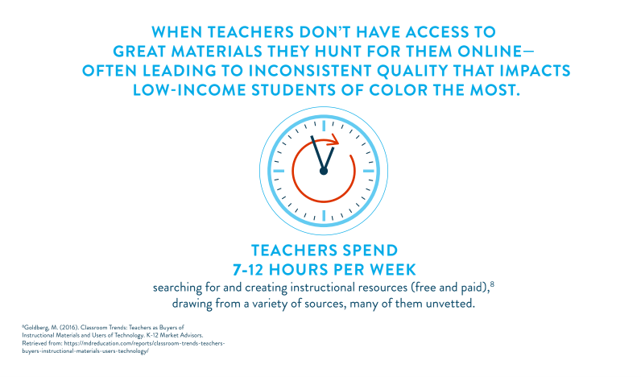  T: For materials to be unvetted means that they have not been reviewed by experts for quality or consistency. What might be the impact on learning if teachers are creating their own instructional materials from a variety of sources?  S: The information may be incorrect. There will be inconsistencies in what students in different classrooms or schools are learning.  T: Yes – when teachers create their own materials using content that hasn’t been identified as high-quality, it leads to issues of access to quality instruction. A student in one school could be provided with high-quality, rigorous materials, whereas a student at another school may be receiving something completely different.    T: What may be the impact of students spending 581 of 720 hours on assignments that are not high-quality?  S: Students may not be learning the most important content. Students may not be learning what they are supposed to learn for the grade-level, which could lead to lower performance on state tests.  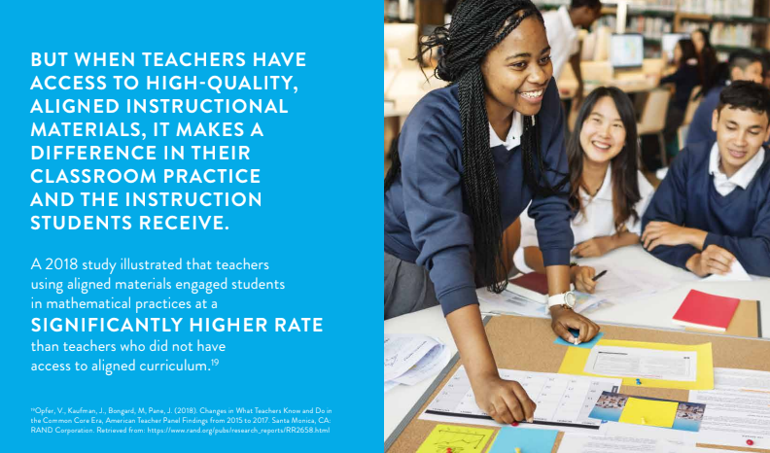  Images source: EdReports.org  T: Without a high-quality curriculum, teachers spend their own time and money on materials that may not lead to gains in student learning. What else could teachers do with this time that would help their students learn?  S: (turn and talk)  T: (Guide students to ideas such as, providing written feedback on student work, conferencing with individual students, preparing for instruction, planning for student misconceptions, thoughtfully preparing student groups, building content knowledge, observing other teachers, reflecting on teaching, grading, communicating with families, etc.)  A high-quality curriculum is not a substitute for a qualified teacher. It is a tool that supports the teacher to do a better job of helping all students learn. | Student Guide  PPT
15 mins | Introduction to High-Quality Components of a Curriculum  S: Answer these questions in the student guide: How do teachers know what to teach or what should be in a curriculum?  S: (Answers will vary or students may not know)  T: To know what to teach at each grade level, we use standards. Standards guide the development and organization of high-quality curriculum.  Standards are the expectations for what students should know and be able to do by the end of each grade level. They guide teachers to know what to teach. In Texas, these standards are the Texas Essential Knowledge and Skills, or the TEKS.  Texas also uses the English Language Proficiency Standards or ELPS. These standards outline the instruction that must be provided to allow English language learners the full opportunity to learn English and succeed academically.  S: Add definition of standards, TEKS, and ELPS to the student guide.  T: The TEKS and ELPS guide what gets included in a high-quality curriculum. Let’s dive into how a curriculum is organized to support teaching and learning.  T: (Share PPT.) A curriculum is a sequenced collection of instructional materials such as lesson plans, learning tasks, and assessments. Teachers use it to guide students toward proficiency in content knowledge and skills.  T: (Share unit graphic on PPT and direct students to the graphic organizer in the student guide). This chart shows how a typical curriculum is organized. A curriculum must include the following to effectively support instruction and learning:  Vertical Alignment  Scope and Sequence  Units and Unit Plans  Lesson plans  T: A helpful part of many high-quality curricula is a vertical alignment chart. This chart shows what standards are taught at each grade level.  S: (Add definition of vertical alignment chart to graphic organizer in student guide)  T: (Show example of vertical alignment chart). How can this chart help teachers plan instruction from year to year?  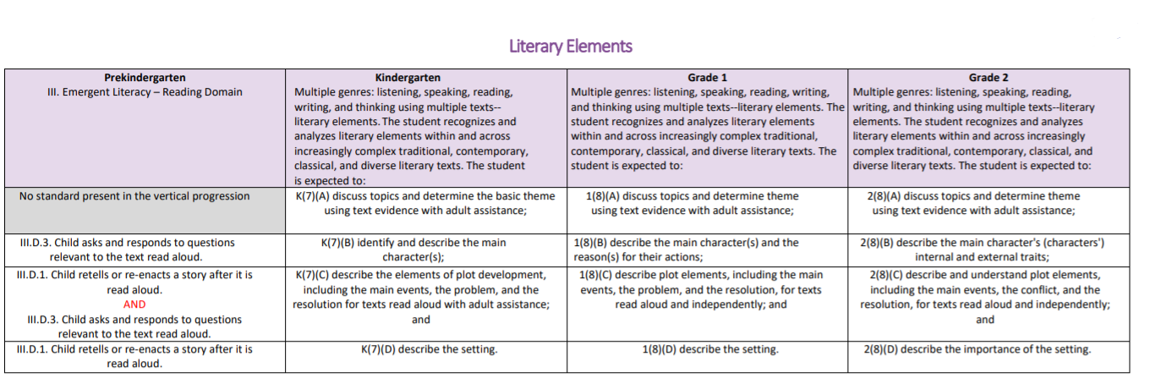  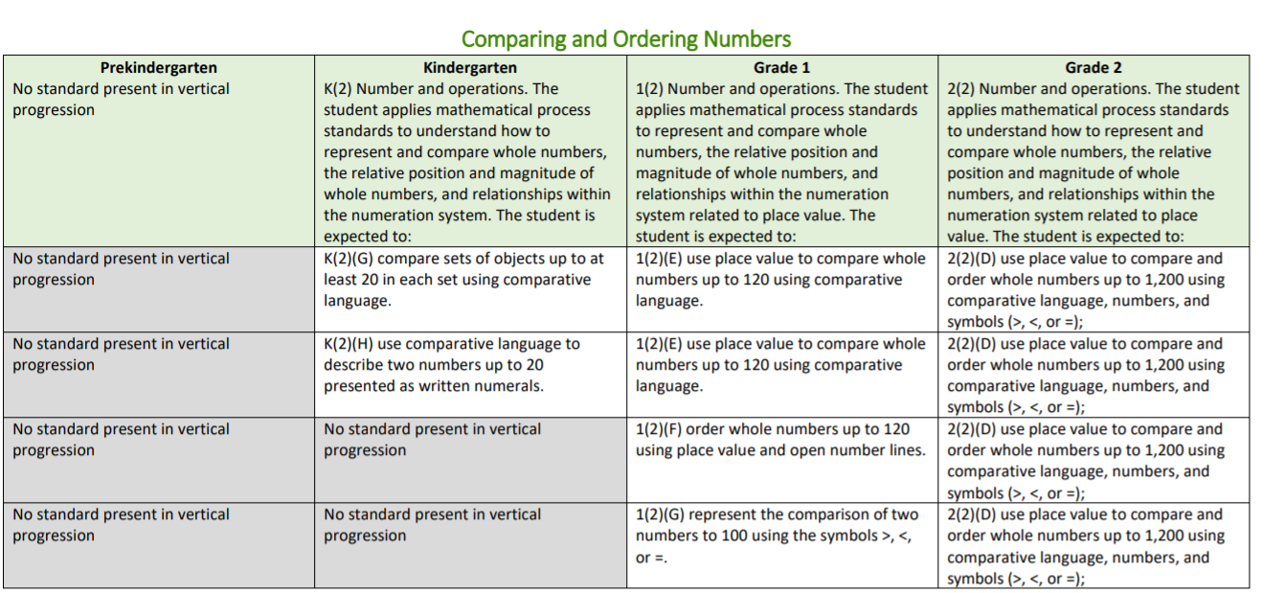  S: They can see what students have already learned and what they will need to learn before entering the next grade.  T: To plan learning for the year, a teacher uses a scope & sequence. This shows when certain standards are taught and how long it will take to teach them.  S: (Add definition of scope and sequence to the graphic organizer).  T: Here is an example of a Kindergarten Science Scope and Sequence. (Show via PPT or provide copies from 6.01 resources.)  The document shows how the curriculum is divided into units or modules. For each module, the document shows the topics covered, the number of days it will take to teach each topic, and the standards addressed.  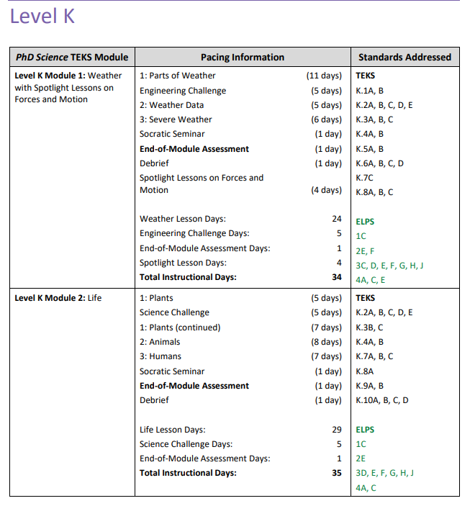  T: In a curriculum, related standards are grouped together in units or modules. In this curriculum they are called modules.  S: (Add this information to their graphic organizer)  Groups of standards are taught in units or modules.  - Groups of learning standards are taught in units or modules.  - A unit is a collection of daily lessons and assessments around a broad topic.  - Each unit has goals or essential questions and a summative assessment.  T: Look at the scope and sequence. What are the two modules about?  S: One is about weather with spotlight lessons on forces and motion, and the other is about life.  T: These are broad topics that take longer to teach. According to the scope and sequence, how many days will the Weather module take?  S: 34 days  T: The module identifies for the teacher how many days are for lessons, engineering challenges, spotlight lessons, and assessment.  How many of those days are lesson days?  S: 24  T: Why is it important for a teacher to know how many days to plan for the module?  S: It helps the teacher know how much time to spend on each topic and how long it should take for students to master the content.  T: Unit/module plans include goals or essential questions for what students should know and be able to do by the end of the unit. The essential question is a broad question that guides the learning throughout the module.  T: Here is the Level K Module 1: Weather Unit. (Show via PPT or provide copies from 6.01 resources).  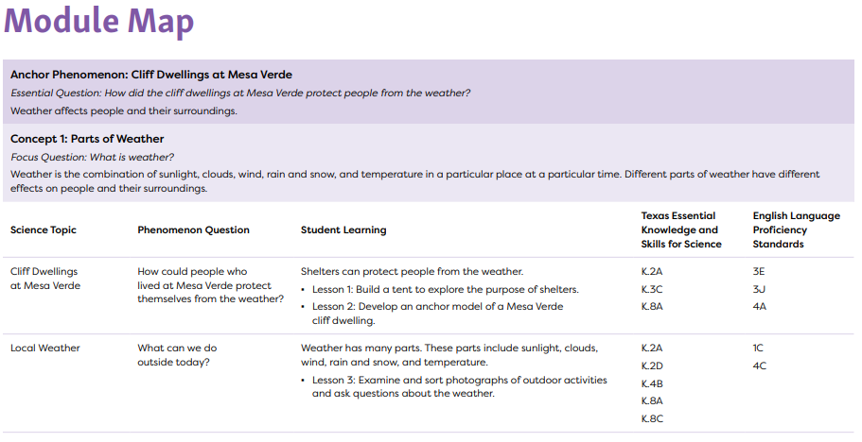  T: What is the essential question for this module?  S: How did the cliff dwellings at Mesa Verde protect people from the weather?  T: Yes. In this unit students will need to know about the cliff dwellings at Mesa Verde, how they were used as shelters, and why people need shelter from the weather.  A high-quality curriculum will be divided into daily lessons that help students use their learning to answer this question.  S: (Add these notes to the graphic organizer)  - Units are divided into daily lesson plans.  - Daily lesson plans target specific objectives that support achievement of unit goals and standards.  - Lesson plans include targeted objectives, learning activities and formative assessments that align with the unit goals.  T: Each daily lesson has at least one objective. An objective is a statement, based on the standards, for what a student should know and be able to do by the end of the lesson.  In this module map, objectives are listed under Student Learning. The objective for Lesson 1 is, “Build a tent to explore the purpose of shelters.”  What should students know and be able to do at the end of the lesson?  S: Students will need to show that they can build a tent. They will need to know that a tent is a shelter. They will need to know why people need shelters.  T: (Direct students to turn and talk to answer the next questions in their student guide)  S: (Work together to answer the questions in the student guide)  T: (Call on students to discuss responses from the student guide questions.)  T: Each unit or module will also include at least one summative unit assessment. You’ll remember that assessments are used to measure how well students learned the content.  T: Here in the Level K Module 1: Weather Unit, we can see the end of unit (module) assessment.  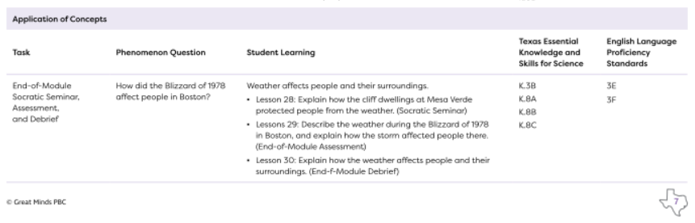  T: (Lead the discussion as students add notes to the student guide) Look at the Task column. This assessment is completed in three parts. What are the parts?  S: Socratic Seminar, Assessment, and Debrief.  T: Where can you find what students are expected to know and do at the end of each lesson, the lesson objectives?  S: The Student Learning column  T: How are the objectives aligned with the Unit Essential Question?  S: The students must explain how the cliff dwellings protected the people of Mesa Verde from the weather in Lesson 28. In Lesson 29, they apply what they learned in the unit about how weather affects peoples’ lives to another scenario. In Lesson 30, they explain how weather affects people and their surroundings.  T: The curriculum gives them multiple ways to synthesize and demonstrate all that they’ve learned. A high-quality curriculum will have a clear connection between the standards, essential questions or unit goals, lesson objectives, and assessments. It is a tool that helps a qualified teacher do their work.
10 mins | Practice 1: Curriculum Analysis  T: Now, you are going to work with a partner to analyze a module from a science curriculum. You will read the overview document for the module and answer the questions for Practice 1 in your student guide.  T: (Break students into groups. Students will use the Survival Unit Overview to answer the questions in Practice 1.)  S: (Students read overview document and answer questions in the student guide) | Student Guide  Survival Unit Overview
5 mins | Debrief  T: Why is it helpful for a teacher to use a high-quality curriculum?  S: (Answers will vary but students should understand that it provides a consistent plan to teach all the standards).  T: Starting with the Vertical Alignment, how is a curriculum usually organized?  S: The Vertical Alignment shows what standards are taught at different grade levels. The scope and sequence shows what standards are taught throughout the year. The curriculum is divided into units, and units are divided into lessons. Units and lessons have goals or objectives and assessments. Everything is aligned to the standards.
5 mins | (Students complete the exit ticket.) | Exit Ticket

