Student Guide – Answer Key

Lesson 7.01: High Leverage Teaching Practices | Introduction
Name:
Date:

Bellringer: Read each of the following practices below used by a teacher. Based on what you know, rate each as an effective practice or not an effective practice and share your reasoning.
Teacher Practice | Is this an effective teaching practice? (Yes/No/Not Sure) | Explain your reasoning
At the beginning of a lesson, at teacher shares lesson objectives. | Yes | Sharing lesson objectives helps students focus on what they must learn.
After delivering the lesson, the teacher provides examples and non-examples of the content the students need to learn | Yes | Examples and non-examples help students to better understand a new concept
The teacher returns the work one week after it’s completed. | No | When students are practicing a skill, it is important to receive feedback in a timely manner.
The teacher models how to complete a word problem with a clear, step by step explanation | Yes | Yes, demonstrating the steps of a process while explaining the rationale behind the steps is an effective practice.
The teacher groups students to discuss the theme of a poem they read in class. | Yes/Maybe | Group learning is an effective practice if it is structured appropriately.

Notes: High Leverage Practices

High Leverage Teaching Practice | Evidence based practices that reliably increase student learning whenever they are applied.
Evidence based practice | A practice that is not just based on theory but has been rigorously tested and has shown to make a positive, statistically significant difference in learning outcomes.

Exploration: High Leverage Practices

High Leverage Practice | What is it? /Key Points | How can teachers demonstrate this practice?
- Focus on Instructional Outcomes | - Set & communicate clear goals & success criteria  - Provide appropriate mix of success and challenge  - Helps students to understand what is required  - Learning goals should provide challenge for students to set high expectations  - Learning goals should be achievable for varying students & abilities | - Access prior knowledge  - Set differentiated goals for groups of students based on need  - Demonstrate a purpose for learning  - Provide challenging goals and recognize effort toward achieving them
- Structuring Lessons | - Teachers plan lessons which have clear steps & transitions  - Reinforce routines and build on learning  - Optimize time on task and smooth transitions  - Attend to the sequence to maintain engagement by linking lesson & unit learning | - Explains the steps in the lesson (learning goals, new learning, opportunities for practice, questioning techniques and assessment)  - Make connections between learning goals, activities & assessments  - Identifies clear transitions between steps in the lesson
- Explicit Teaching | - Clearly show students what to do and how to do it  - Teacher makes learning intentions clear to students along with success criteria & demonstrates them through modeling  - Checks for understanding & ties all the concepts together at the end of the lesson | - Explains what students need to know and will be able to do at the end of the lesson  - Shows worked examples to show students how to do something  - Allows time for student practice  - Reinforces main points at the end of the lesson
- Worked Examples | - Worked examples are demonstration of the steps required to complete a task  - By scaffolding the learning, worked examples reduce the cognitive load for students | - Scaffolds learning and skills by providing clear, step by step example  - Designs worked examples accessible to students & unpacks learning  - Monitors student learning to move toward independent practice
- Collaborative Learning | - Students work together and everyone participates in learning task  - Uses strategies to establish cooperation and collaboration  - Relies on students actively participating in roles, responsibilities & outcomes | - Sets group tasks & establishes rules about how groups operate  - Explicitly teaches students to work as team (roles/responsibilities)  - Designs tasks that require sharing of expertise & structured participation by all
- Multiple Exposures | - Providing multiple opportunities to encounter, engage with and elaborate on new knowledge  - Learning developed over time with multiple and spaced interactions with new concepts  - Distribute practice across several day & vary interactions that learners have w/knowledge | - Links multiple exposures to the learning goals  - Uses variety of learning and assessment tasks that vary interaction with knowledge
- Questioning | - Teachers use questioning for many purposes: to engage students, stimulate thinking and make links to student lives.  - Provides opportunities for students to talk with each other  - Can provide feedback to teachers on student understanding | - Utilizes protocols for structuring conversations  - Targets questions/responses to acknowledge individual student needs  - Engages students in dialogue & pushes their thinking  - Asks students to justify thinking  - Provides feedback & opportunities for students to provide feedback to others
- Metacognitive Strategies | - Thinking about your own thinking  - Being aware of learning helps to learn better  - Can help regulate motivation  - Can include planning how to approach learning tasks, evaluating progress & monitoring comprehension | - Provides students practice setting, monitor & evaluating goals  - Helps students use strategies to achieve goals  - Uses variety of learning & assessment strategies to scaffold and personalize learning
- Differentiated Instruction | - Use methods to extend knowledge & skills of every student in every class regardless of starting point  - Provides appropriate challenge for all students  - Responds to student readiness, interests & learning profile  - Plan lessons that incorporate adjustments to content process and product | - Use pre-assessment to determine student readiness, interest & learning profile for needs & strengths  - Provides realistic & challenging goals & recognize student effort  - Uses range of strategies to allow students to demonstrate thinking in different ways  - Assesses student work against prior achievements rather than other students work

The following passages about each of the high leverage practices have been excerpted from High Impact Teaching Strategies: Excellence in Teaching and Learning, State of Victoria (Department of Education and Training)- https://www.education.vic.gov.au/Documents/school/teachers/support/high-impact-teaching-strategies.pdf
- Focus on Instructional Outcomes (referred to as “Setting Goals” in the original document)
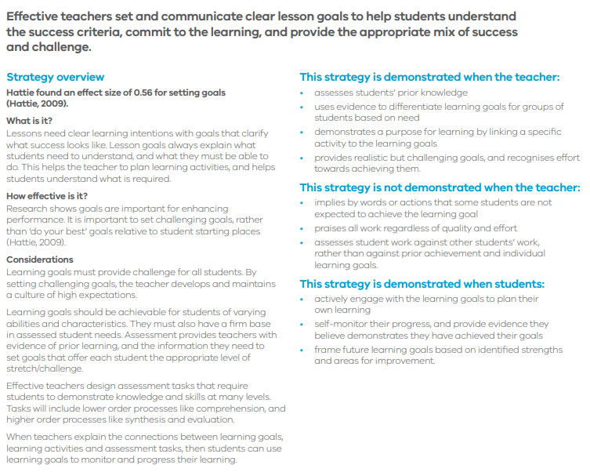

- Structuring Lessons
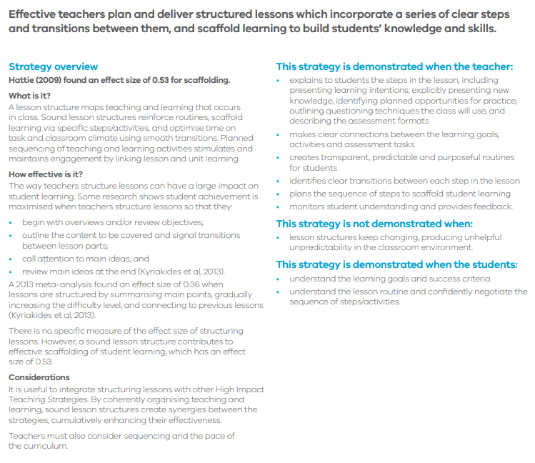

- Explicit Teaching 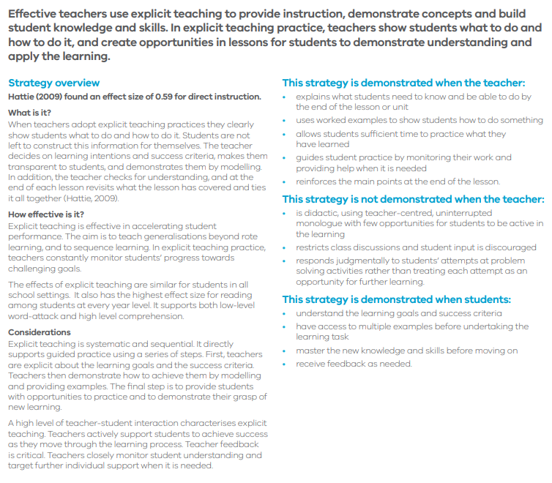

- Worked Examples
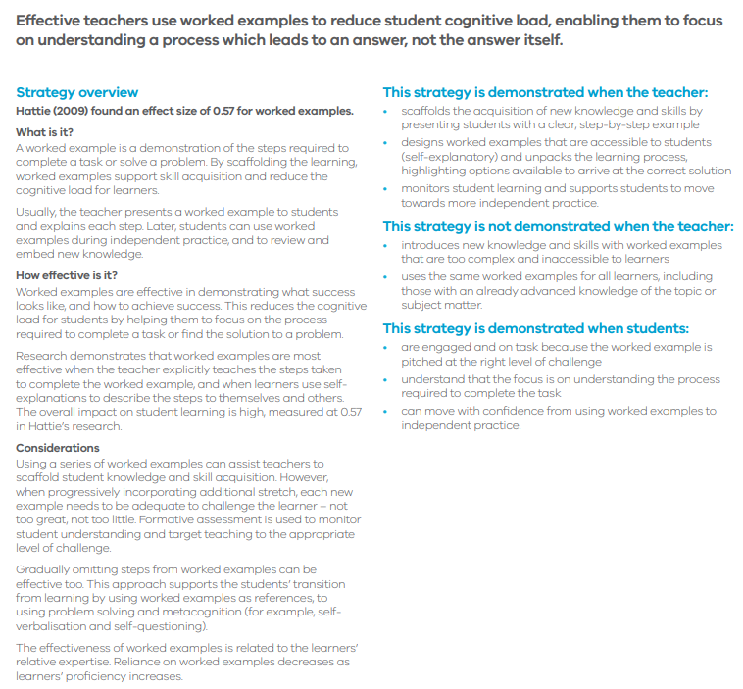

- Collaborative Learning
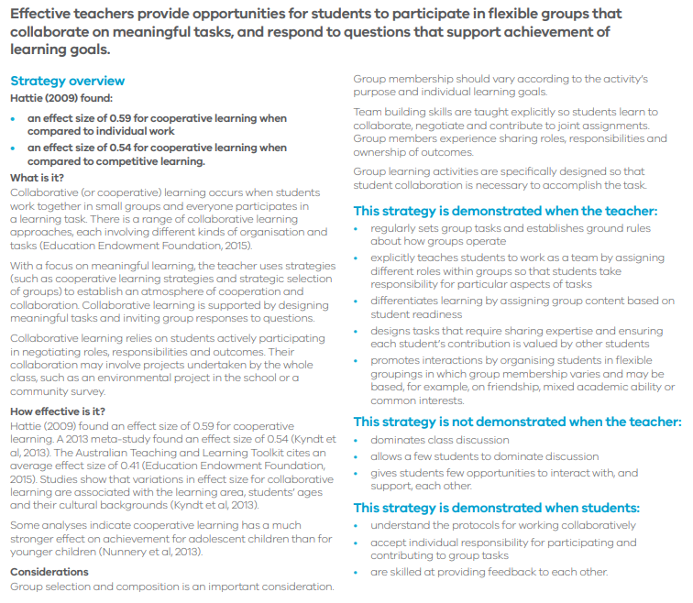

- Multiple Exposures
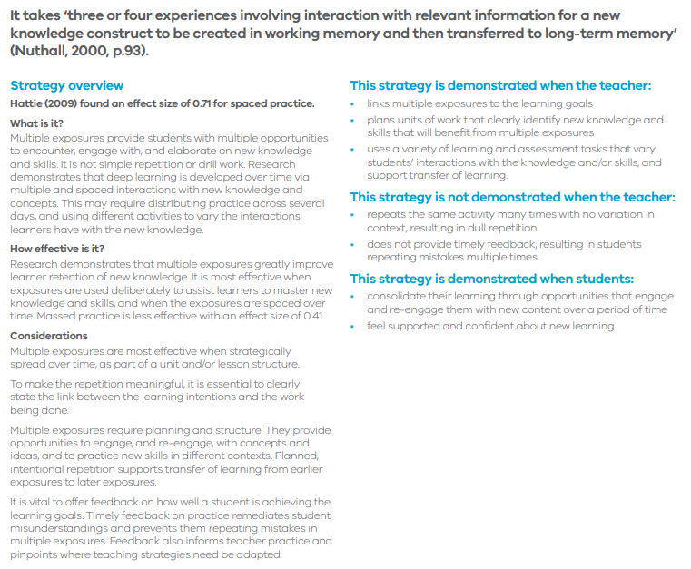

- Questioning
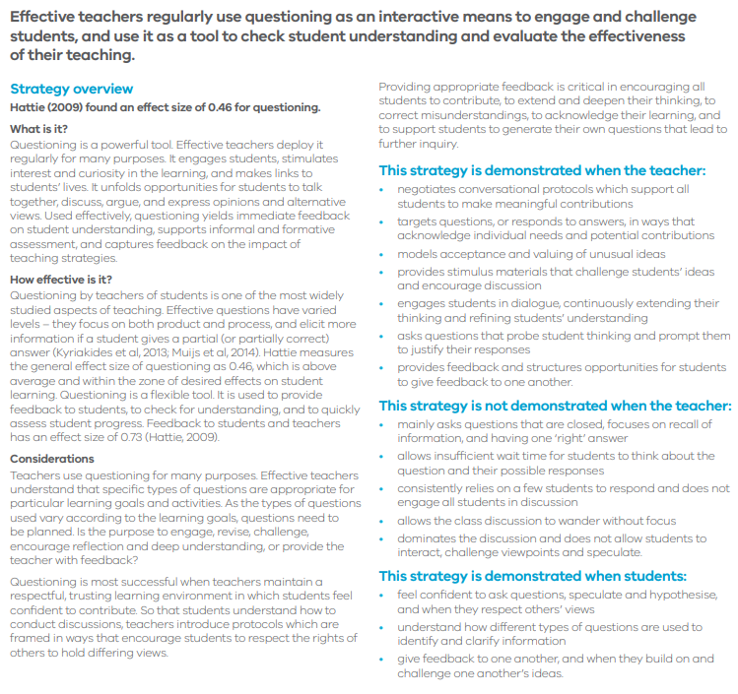

- Metacognitive Strategies
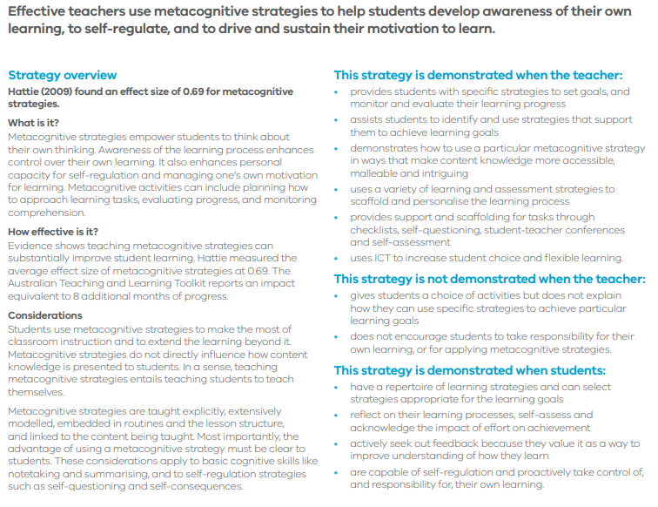

- Differentiated Instruction (Called “Differentiated Teaching” in the original document)
