Student Guide

Lesson 7.03: Structuring Lessons
Name:
Date:

Bellringer: In past units we have discussed the importance of classroom management and considerations for effective sequencing of instruction. Write down all that you remember about these two topics.
Classroom management (Unit 2)
Sequencing Lessons (Unit 6)

Notes: Structuring Lessons

Sequencing | The effective ordering of academic content to support students' understanding of a topic; sequencing also relies on building on prior knowledge to ensure that there are not gaps in student learning
Scaffolding | Structured supports offered to students by the teacher to help students attain a strong command of a new skill and/or concept
Double Plan | Instructional strategy where teachers plan what students will be doing each step of the way to intentionally leverage opportunities for student learning and engagement.

The high leverage teaching strategy of Structuring lessons brings together the concepts of:

3 Key Considerations for Implementing HQIM with structure and intentionality:

Video Viewing Guide: TLAC Double Planning
What are the benefits of double planning?

Double Planning
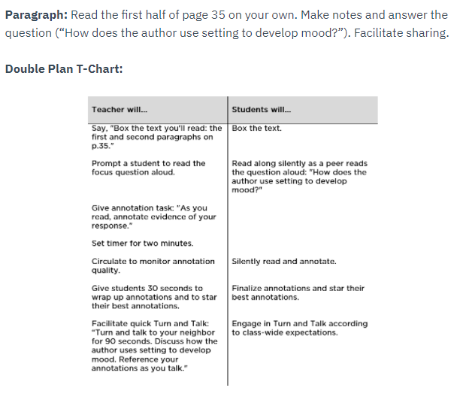

How does the double plan for the partner reading activity above address the following?
- Clarity of student expectations

- Student engagement

- Effective transitions

Practice: Double Planning
Lesson Description: Students will read a text titled “What is light?” with a partner. After reading the text, the students will provide evidence from the text to answer questions.
Teacher Will.. | Student Will…
Say “We are going to read the text “What is light” with a partner and answer some questions. Can everyone hold up their text to show me you are ready?”
Say “We will complete this reading with our shoulder buddy’s today. Make eye contact & point to your shoulder buddy that you worked with in the last activity.”
Say” In this partner reading activity, partner 1 will read the first 2 paragraphs aloud, and partner 2 will read the next two paragraphs aloud. Turn to page 1 of your text, find the first 4 paragraphs and number them in the margin 1-4”
Say “Now turn to your shoulder buddy and decide who will be partner 1 and who will be partner 2. Hold up 1 finger if you will be partner 1, and two fingers if you will be partner 2 once you have decided”
Give students 30 seconds to decide who will be partner 1 and partner 2.
Say “You will have 10 minutes to complete your reading. As your partner is reading you should be following along in the text. If you complete the reading before the 10 minutes are up, you may begin to quietly work on your questions.”
Set a timer for 10 minutes
Circulate to monitor the partner reading.
Say “At this time, you should all begin working on your reading questions with a partner. Be sure to write down the paragraph number where you found the answer. You will have 5 minutes to answer your questions.”
Set timer for 5 minutes
Circulate to monitor partner discussions and work.

How does the double plan for the partner reading activity above address the following?
- Clarity of student expectations
- Student engagement
- Effective transitions

