Student Guide – Answer Key

Lesson 7.03: Structuring Lessons
Name:
Date:

Bellringer: In past units we have discussed the importance of classroom management and considerations for effective sequencing of instruction. Write down all that you remember about these two topics.
Classroom management (Unit 2)
Being proactive is important. Building relationships with students, setting high expectations, creating safety, and establishing clear and consistent routines help teachers to manage the classroom effectively.
Sequencing Lessons (Unit 6)
It is important for teachers to break content down into small chunks for students to learn and to make sure that they build from less complex to more complex skills.

Notes: Structuring Lessons

Sequencing | The effective ordering of academic content to support students' understanding of a topic; sequencing also relies on building on prior knowledge to ensure that there are not gaps in student learning
Scaffolding | Structured supports offered to students by the teacher to help students attain a strong command of a new skill and/or concept
Double Plan | Instructional strategy where teachers plan what students will be doing each step of the way to intentionally leverage opportunities for student learning and engagement.

The high leverage teaching strategy of Structuring lessons brings together the concepts of:
Classroom management and Sequencing of lessons
3 Key Considerations for Implementing HQIM with structure and intentionality:
- Clarity of Student Expectations: Begin with overview/review prior content. This helps to activate student thinking and make connections between past learning and current learning as well as clarify expectations and student success criteria.
- Effective Transitions: Teachers must maximize the time available for learning. This includes ensuring that transitions between activities are smooth and the teacher structures instructional activities to maximize time on task.
- Student Engagement: Students should be actively thinking, reading, writing, and talking about their learning throughout the lesson.
Video Viewing Guide: TLAC Double Planning
What are the benefits of double planning?
Double planning can help teachers to clarify their expectations for students (what success looks like). It also could be helpful for teachers to think about how they will give instructions clearly and structure effective transitions to maximize time on task as well as to ensure effective student engagement.

Double Planning
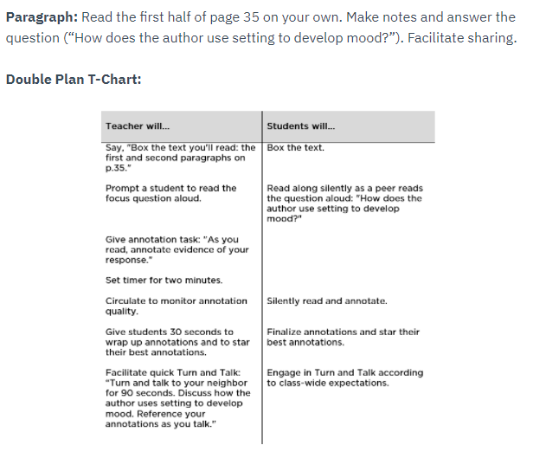

How does the double plan for the partner reading activity above address the following?
- Clarity of student expectations
The description mentions making notes while the double plan clarifies that students should be annotating and then staring their best annotations. Also, during the section of sharing, the teacher clarifies that students should “reference your annotations as you talk”. That clarifies to students that they should be working from the text as they are discussing the prompt.
- Student engagement
Students engage by boxing the text, read along silently, ask a student to read the focus prompt, actively annotate the passage, turn, and talk during a discussion.
- Effective transitions
The double plan shows how much time to be spent on each step. It also reminds the teacher to set a timer to maximize time on task. Without these reminders the teacher may let an activity go too long or too little of time and the students may not be clear about how much time they have on a particular task.

Practice: Double Planning
Lesson Description: Students will read a text titled “What is light?” with a partner. After reading the text, the students will provide evidence from the text to answer questions.
Teacher Will.. | Student Will…
Say “We are going to read the text “What is light” with a partner and answer some questions. Can everyone hold up their text to show me you are ready?” | Hold up the text “What is light?”
Say “We will complete this reading with our shoulder buddy’s today. Make eye contact & point to your shoulder buddy that you worked with in the last activity.” | Make eye contact & point to shoulder partner
Say” In this partner reading activity, partner 1 will read the first 2 paragraphs aloud, and partner 2 will read the next two paragraphs aloud. Turn to page 1 of your text, find the first 4 paragraphs and number them in the margin 1-4” | Number paragraphs on page 1 from 1-4
Say “Now turn to your shoulder buddy and decide who will be partner 1 and who will be partner 2. Hold up 1 finger if you will be partner 1, and two fingers if you will be partner 2 once you have decided” | Discuss partner assignment, hold up finger indicating partner 1 or 2
Give students 30 seconds to decide who will be partner 1 and partner 2.
Say “You will have 10 minutes to complete your reading. As your partner is reading you should be following along in the text. If you complete the reading before the 10 minutes are up, you may begin to quietly work on your questions.” | Students begin reading their assigned paragraphs aloud to their partners
Set a timer for 10 minutes
Circulate to monitor the partner reading.
Say “At this time, you should all begin working on your reading questions with a partner. Be sure to write down the paragraph number where you found the answer. You will have 5 minutes to answer your questions.” | Students discuss answers to questions citing the paragraph where the answer was found in the text
Set timer for 5 minutes
Circulate to monitor partner discussions and work.

How does the double plan for the partner reading activity above address the following?
- Clarity of student expectations
Students are prompted to assign a reading passage to read aloud, clarifies what students should do if they finish reading early, citing answers
- Student engagement
Students are prompted to engage physically to show they are prepared (show book, make eye contact/point to partner, show fingers of which part they will read).
- Effective transitions
Utilize familiar routines (shoulder buddy), timers used to maximize time on task, clear instructions provided for students to follow

