Exit Ticket - Answer Key

Lesson 7.04: Explicit Teaching | Part I
Name:
Date:

- What is explicit teaching? How does it help students to learn more effectively?
When something is explicitly taught, a teacher guides students through the learning process, step by step, with clear explanations, procedures, and success criteria. Students would have a clear example of what they are supposed to do, and explanation of why it is important and how to do it successfully. They could replicate the example.

- Below is a script for modeling how to generate and organize data. Analyze the script and provide evidence of where you found the key modeling practices demonstrated in this example.
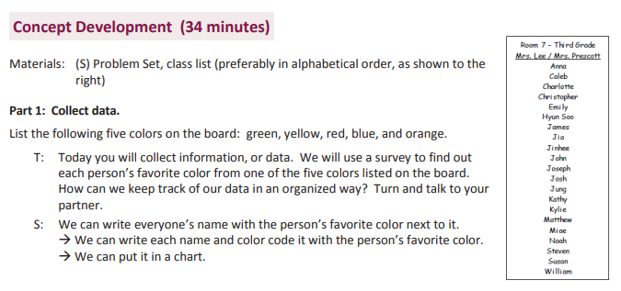
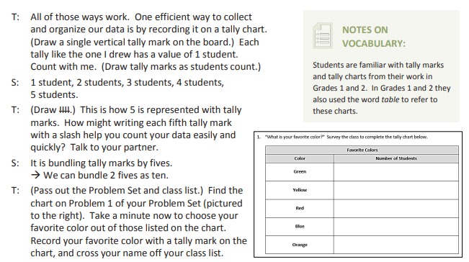

Key Modeling Practices | Evidence
Small, Learnable Steps | The teacher starts first with generating data by creating a list of students and their favorite colors. Then they move to how they might be able to organize and make sense of the data by collecting it in a chart with tally marks.
Visual Demonstration | The teacher demonstrated visually the process of making tally charts and representing the numbers in each category by making slashes. Also, how to group the tally marks bundles of 5.
Verbal Explanation | The teacher explained each step. “Each tally like the one I drew has a value of one student. Count with me”
Connect the Steps | Makes connection with prior vocabulary and moves from intro to tally marks to how to draw them to represent data. There is a purpose for each action that is explained.
Check for Understanding | The teacher checks for understanding with questioning (How can we keep track of our data in an organized way? How might writing each 5th tally mark with a slash help you count your data easily?)

