Exit Ticket

Lesson 7.04: Explicit Teaching | Part I
Name:
Date:
- What is explicit teaching? How does it help students to learn more effectively?

- Below is a script for modeling how to generate and organize data. Analyze the script and provide evidence of where you found the key modeling practices demonstrated in this example.
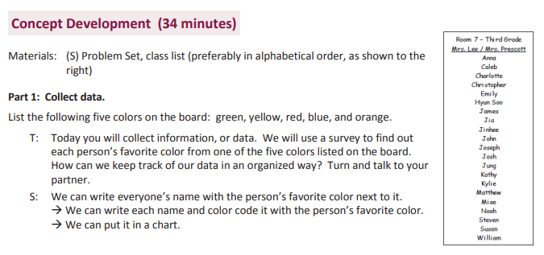
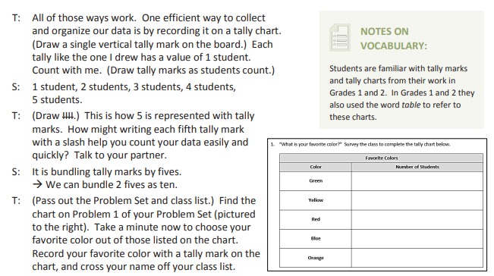

Key Modeling Practices | Evidence

Small, Learnable Steps

Visual Demonstration

Verbal Explanation

Connect the Steps

Check for Understanding

