Student Guide

Lesson 7.04: Explicit Teaching | Part I
Name:
Date:

Bellringer: If you had to learn a new skill, would it be easier for you to learn it by reading about it in a book or watching a video about how to do it on YouTube? Explain your rationale.

Introduction to Explicit Teaching

Explicit Teaching
Modeling

Benefits of Modeling as a Strategy:

Key Practices for Effective Modeling:

Example: Modeling
Objectives:
- TEKS 1.2.A. vii Students will listen to and orally produce the /ee/ sound at the beginning, middle and end of words.
Instructional Outcome:
- I can recognize words that have the /ee/ sound in middle.
- I can repeat words that use the /ee/ sound.

Key Modeling Practices | Evidence

Small, Learnable Steps

Visual Demonstration

Verbal Explanation

Connect the Steps

Check for Understanding

Non-Example: Modeling
Students in a 1st grade science class are learning to classify animals by their different characteristics.
Objective: Students will identify distinguishing characteristics of animal families.
Instructional outcome: I can identify specific characteristics of animal families
Prior learning: Animals can be classified according to:
- physical characteristics such as body covering (fur, scales, hair, feathers, shells, etc.),
- body shape (two main features, three main features)
- appendages (arms, legs, wings, fins, tails) a
- method of movement (walking, crawling, flying, swimming).
- whether they live in water or land (habitat)
- whether they are wild or domestic.
In the model below the teacher is demonstrating to students how to classify g a group of animals based on their characteristics. After the teacher models the process of classifying, the students will be given pictures of different animals and asked to find examples that fit each of the different categories above.
Script for Modeling the Classification of Animals
T: Today class we are going to work on classifying different animals based on their characteristics. I am going to demonstrate to you how to think about how we can group these animals based on different characteristics.
T: (Holds up a picture of a tiger.) This is a picture of an animal called a tiger. What do you notice about this animal?
S: He has stripes.
T: Yes, he has stripes. What else do you notice?
S: He has a tail, and he looks mean.
T: Yes, the tiger has a tail. The tail is a part of physical characteristics that we will examine. What other physical characteristics do you notice?
S: The tiger is orange and has 4 legs.
T: Yes, good the legs are an important physical characteristic. What do we know about animals that have legs?
S: They walk?
T: Yes, walking is a type of movement that we can use to classify animals.
T: Now, you are going to look for examples of different animals that exhibit different physical characteristics. I have given each of you several pictures to look at an examine and a chart of the different physical characteristics to look at. You will work to find examples of each of those characteristics and put the pictures of animals that fit each of the categories under it. Go ahead and get started now.
Key Modeling Practices | Evidence of Non-Example

Small, Learnable Steps

Visual Demonstration

Verbal Explanation

Connect the Steps

Check for Understanding

How could this non-example of modeling be revised to better exhibit the key practices for effective modeling?

Student Practice: Modeling
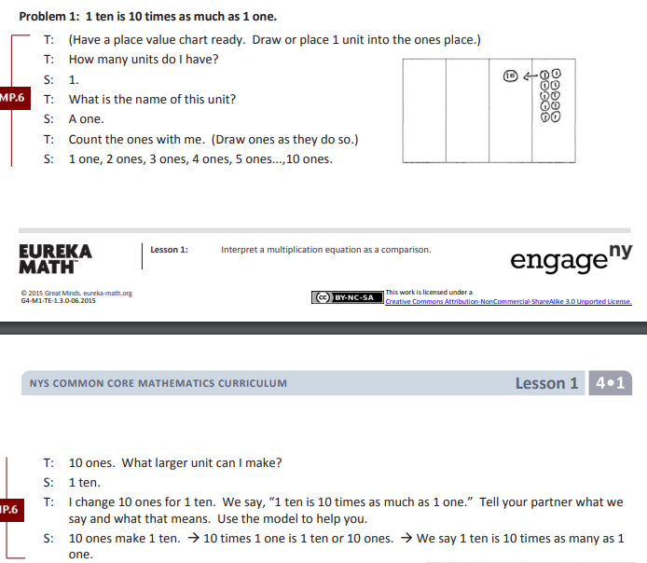

Key Modeling Practices | Evidence

Small, Learnable Steps

Visual Demonstration

Verbal Explanation

Connect the Steps

Check for Understanding

