Student Guide – Answer Key

Lesson 7.04: Explicit Teaching | Part I
Name:
Date:

Bellringer: If you had to learn a new skill, would it be easier for you to learn it by reading about it in a book or watching a video about how to do it on YouTube? Explain your rationale.
Answers will vary.

Introduction to Explicit Teaching

Explicit Teaching | Guides students through the learning process, step by step, with clear explanations, procedures, and success criteria.
Modeling | A strategy where teachers visually show students a process while describing each step with a rationale.

Benefits of Modeling as a Strategy:
- Communicates to students what success looks like
- Demonstrates the process for achieving success.
- Communicates to students the importance of what is being taught,
- Decreases student errors
- Helps to build early student confidence.
Key Practices for Effective Modeling:
- Small, learnable steps: Small, manageable chunks prevent cognitive overload.
- Visual demonstration: demonstrate each step as students watch.
- Verbal explanation: explain each step as you demonstrate them. Provide a rationale for why that step is important and key details for that step. Keep explanations short and direct.
- Connect the steps. This is important to understand the sequence to the process as well as looking for ways to connect to prior learning.
- Pause & check for student understanding along the way. Allow opportunities for students to ask questions and get clarification. Re-model steps as necessary.

Example: Modeling
Objectives:
- TEKS 1.2.A. vii Students will listen to and orally produce the /ee/ sound at the beginning, middle and end of words.
Instructional Outcome:
- I can recognize words that have the /ee/ sound in middle.
- I can repeat words that use the /ee/ sound.

Key Modeling Practices | Evidence
Small, Learnable Steps | The sound was introduced first, then they practiced saying the sound, then they practiced different words with the sound, before they had to recognize words with the sound and without.
Visual Demonstration | The teacher held up a picture of the words when they said the words.
Verbal Explanation | As the teacher said the words with /ee/, she helped to explain what it sounds like, and provided examples of words with the sound at the beginning, middle and ends.
Connect the Steps | After introducing the sounds, the teacher then provided examples of words with the sounds at the beginning middle and end. The visual demonstration of the words helped to connect words to sound. Connected to prior knowledge of vowel vs consonant sounds.
Check for Understanding | Students were asked to close their eyes and raise their hand in the last part of the lesson when they heard words with the /ee/ sound. Question about vowel vs. consonant sounds.

Non-Example: Modeling
Students in a 1st grade science class are learning to classify animals by their different characteristics.
Objective: Students will identify distinguishing characteristics of animal families.
Instructional outcome: I can identify specific characteristics of animal families
Prior learning: Animals can be classified according to:
- physical characteristics such as body covering (fur, scales, hair, feathers, shells, etc.),
- body shape (two main features, three main features)
- appendages (arms, legs, wings, fins, tails) a
- method of movement (walking, crawling, flying, swimming).
- whether they live in water or land (habitat)
- whether they are wild or domestic.
In the model below the teacher is demonstrating to students how to classify g a group of animals based on their characteristics. After the teacher models the process of classifying, the students will be given pictures of different animals and asked to find examples that fit each of the different categories above.
Script for Modeling the Classification of Animals
T: Today class we are going to work on classifying different animals based on their characteristics. I am going to demonstrate to you how to think about how we can group these animals based on different characteristics.
T: (Holds up a picture of a tiger.) This is a picture of an animal called a tiger. What do you notice about this animal?
S: He has stripes.
T: Yes, he has stripes. What else do you notice?
S: He has a tail, and he looks mean.
T: Yes, the tiger has a tail. The tail is a part of physical characteristics that we will examine. What other physical characteristics do you notice?
S: The tiger is orange and has 4 legs.
T: Yes, good the legs are an important physical characteristic. What do we know about animals that have legs?
S: They walk?
T: Yes, walking is a type of movement that we can use to classify animals.
T: Now, you are going to look for examples of different animals that exhibit different physical characteristics. I have given each of you several pictures to look at an examine and a chart of the different physical characteristics to look at. You will work to find examples of each of those characteristics and put the pictures of animals that fit each of the categories under it. Go ahead and get started now.

Key Modeling Practices | Evidence of Non-Example
Small, Learnable Steps | The teacher didn’t break this into parts. She was vague in asking for characteristics, so students didn’t know what to provide as answers.
Visual Demonstration | The teacher showed the picture, but it doesn’t indicate or highlight visually the important characteristics that are noted by the student.
Verbal Explanation | The teacher didn’t explain how to identify the different characteristics.
Connect the Steps | The teacher didn’t connect the model to the prior learning of the students.
Check for Understanding | The teacher did not stop to check for understanding of the key information throughout the model. The teacher did not provide opportunities for students to ask questions.

How could this non-example of modeling be revised to better exhibit the key practices for effective modeling?
The teacher could have showed a chart with the different characteristics across the top. The teacher could have reviewed/questioned students about each of the characteristics before showing a picture. When showing the picture, the teacher could have asked more specific questions about what student’s notice about the different categories of characteristics. As students identify characteristics, the teacher could point and explain how each met/didn’t meet the characteristics. The teacher could have paused to see if student’s had questions about how the animal was classified or about the task before releasing them to work.
Student Practice: Modeling
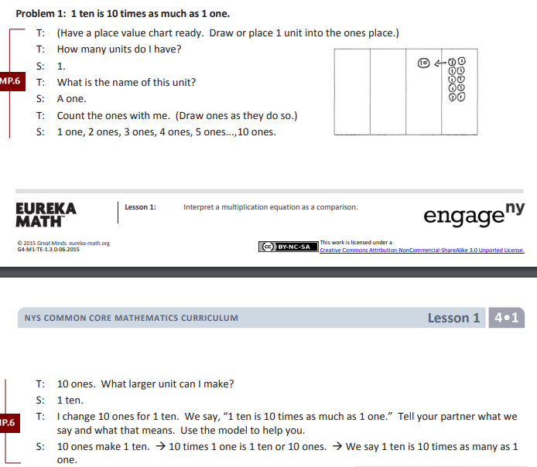

Key Modeling Practices | Evidence
Small, Learnable Steps | Showed the 1’s first. Counted & drew to show the 1s. Then drew the 10.
Visual Demonstration | Chart with the 1’s and the 10’s, each circle showed either a 1 or a 10, draw the ones as they counted.
Verbal Explanation | Explained each step, counted out loud as the picture was drawn
Connect the Steps | “1 ten is 10 times as much as 1 one”
Check for Understanding | Explained it to a partner, repeated it at the end of the model. Asked questions units and names

