Student Guide – Answer Key

Lesson 7.05: Explicit Teaching | Part II
Name:
Date:

Bellringer: Describe the high leverage practice of explicit teaching. How is modeling an example of explicit teaching?
Explicit teaching guides students through the learning process, step by step, with clear explanations, procedures, and success criteria. In an effective model, teachers break skills down into small learnable steps, provide a visual and verbal description of the process, connect the steps to each other and to prior learning and check for understanding. In these processes, the teacher is demonstrating the learning process and showing students what success looks like and how to achieve it.

Review of Key Practices of Effective Modeling

Explicit Teaching
Modeling | A strategy where teachers visually show students a process while describing each step with a rationale.

Key Practices for Effective Modeling:
- Small, learnable steps: Small, manageable chunks prevent cognitive overload.
- Visual demonstration: demonstrate each step as students watch.
- Verbal explanation: explain each step as you demonstrate them. Provide a rationale for why that step is important and key details for that step. Keep explanations short and direct.
- Connect the steps. This is important to understand the sequence to the process as well as looking for ways to connect to prior learning.
- Pause & check for student understanding along the way. Allow opportunities for students to ask questions and get clarification. Re-model steps as necessary.

Practice: Modeling
Select one of the scenarios below to model to a partner. You will draft a modeling script including any visuals/images to use in the model.
Scenario 1: A Kindergarten class is being introduced to a new sound /b/. Below is a description of how the teacher will model the new sound.
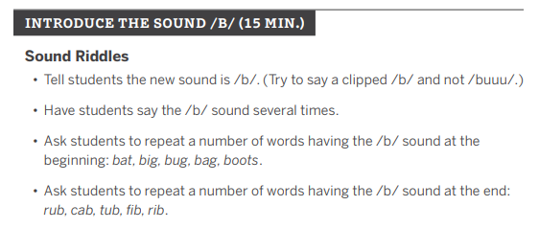
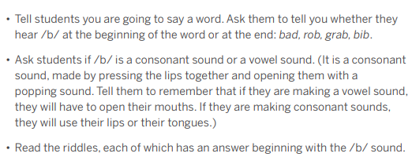

Scenario 2: A 1st grade class is learning how to write the vowel sound /er/.
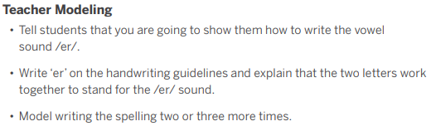
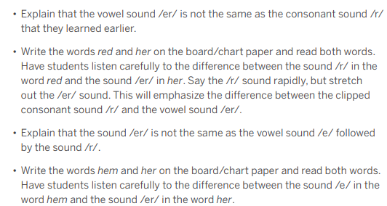

Craft a script for your model. Include any visuals/images you will use during the model you present.
Answers will vary.

Feedback from your partner:
Key Modeling Practices | Feedback
Small, Learnable Steps | Answers will vary.
Visual Demonstration | Answers will vary.
Verbal Explanation | Answers will vary.
Connect the Steps | Answers will vary.
Check for Understanding | Answers will vary.

Notes from Partner Model:
Answers will vary.

Feedback for your partner about their model:
Key Modeling Practices | Feedback
Small, Learnable Steps | Answers will vary.
Visual Demonstration | Answers will vary.
Verbal Explanation | Answers will vary.
Connect the Steps | Answers will vary.
Check for Understanding | Answers will vary.

