Student Guide – Answer Key

Lesson 7.05: Explicit Teaching | Part II
Name:
Date:

Bellringer: Describe the high leverage practice of explicit teaching. How is modeling an example of explicit teaching?

Review of Key Practices of Effective Modeling

Explicit Teaching
Modeling

Key Practices for Effective Modeling:

Practice: Modeling
Select one of the scenarios below to model to a partner. You will draft a modeling script including any visuals/images to use in the model.
Scenario 1: A Kindergarten class is being introduced to a new sound /b/. Below is a description of how the teacher will model the new sound.
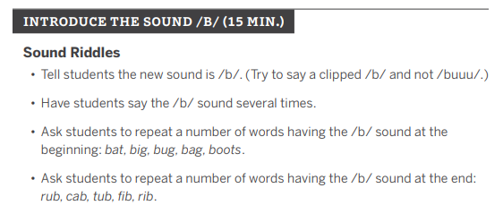
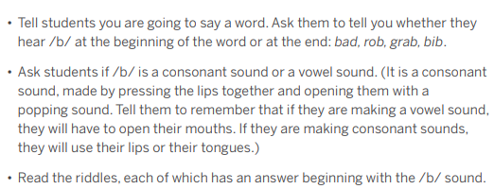
Scenario 2: A 1st grade class is learning how to write the vowel sound /er/.
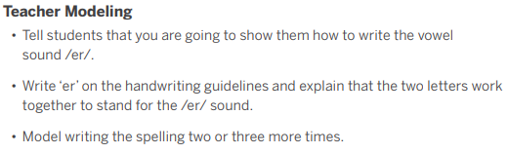
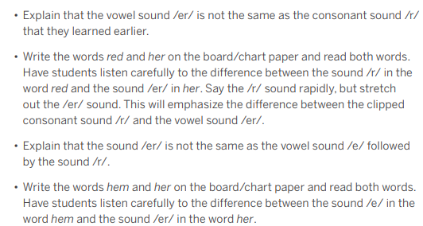

Craft a script for your model. Include any visuals/images you will use during the model you present.

Feedback from your partner:
Key Modeling Practices | Feedback

Small, Learnable Steps

Visual Demonstration

Verbal Explanation

Connect the Steps

Check for Understanding

Notes from Partner Model:

Feedback for your partner about their model:
Key Modeling Practices | Feedback

Small, Learnable Steps

Visual Demonstration

Verbal Explanation

Connect the Steps

Check for Understanding

