Student Guide

Lesson 7.06: Worked Examples
Name:
Date:

Bellringer: Describe each of the key practices in an effective model and explain why they help learning.

Key Modeling Practices | Description | How does it help learning?

Small, Learnable Steps

Visual Demonstration

Verbal Explanation

Connect the Steps

Check for Understanding

Introduction to Worked Examples

Worked Examples

Benefits of Worked Examples:

Criteria for effective worked examples
Criteria | Description
Focus on Process
Provides steps & rationale
Increasing complexity

Example: Worked Example
Mr. Brooks, a high school algebra teacher is teaching students how to solve for an unknown variable. He began by using the example below. He walked the students through the example providing the explanations of each step listed.
8x + 3 = 17 + x | The goal is to figure out what x must be.
8x + 3 – (x) = 17 + x – (x)  7x + 3 = 17 | Subtract x from both sides to remove x from the right side. The goal is to get the x’s on only one side of the equation.
7x + 3 – (3) = 17 – (3)  7x = 14 | Subtract 3 from both sides to further isolate the x. We need to get x by itself on one side of the equation.
7x /7 = 14/7  X = 2 | Divide both sides by 7 to solve for the value of x

He then moved to a practice set where he walked the students through the examples below as a class before asking the students to solve the last problem independently.
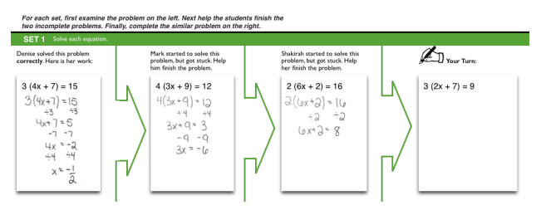
Resource: Booth, J. L., McGinn, K. M., Young, L. K., & Barbieri, C. (2015). Simple Practice Doesn’t Always Make Perfect Evidence from the Worked Example Effect. Policy Insights from the Behavioral and Brain Sciences, 2(1), 24-32.

What evidence supports that this is an example of an effective worked example?
Criteria | Evidence
Focus on Process
Provides steps & rationale
Increasing complexity

Non-Example:
Mr. Jones, a science teacher, is teaching students how to convert one unit of measure to another in the metric system. The students are new to the concept of converting units. He stared by demonstrating how to convert kilograms to grams using the problem below:
4.8 kilograms | The goal is to convert kilograms to grams
4.8 kg x 1000 g  1 1 kg | To convert kg to grams multiply by 1000.
4.8 x 1000 = 4800 | You get 4,800 g

He then gave the students time to practice their conversions by completing the following practice problems:
Express the following mass in units of grams.
- 5.89 kg = _______ g
- 3 kg = _______ g
- 0.18 kg = ______ g
- 4.20 kg = _______ g
- 6.5 kg = ______ g
Express the following mass in units of kg.
- 12,240 g = _______ kg
- 15 g = _______ kg
- 565 g = _______ kg
- 4,000 g = ______ kg
- 3, 920 g = ______kg

What evidence supports that this is a non-example of an effective worked example?
Criteria | Evidence that makes it a Non-Example
Focus on Process
Provides steps & rationale
Increasing complexity

Student Practice: Worked Examples
Read each of the scenarios below. Determine if the scenario meets the criteria to be considered an effective worked example. Provide your rationale in the chart below each scenario.
Scenario 1: A 5th grade math teacher is teaching students how to find the prime factors of a number. Students have already learned that a prime number is one that can only be divided by 1 and itself. Below is the picture of her example and description of the process.
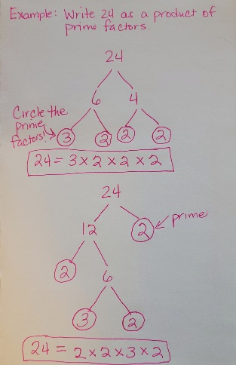 | - Select two whole numbers that multiply to give 24 (except 1 and 24). In this case I chose 6 and 4.  - Next identify if the factors are prime. Remember prime means it can be divided only by 1 and itself. In this case, neither 6 or 4 is prime.  - Determine factors for the number 6. This can be any two whole numbers that multiply to give 6. In this case, I chose 3 and 2.  - Now determine if these factors are prime. If they are, circle them to indicate that you can stop looking for factors. Both 3 and 2 are prime so I circled them.  - Now determine factors for the number 4. In this case I chose 2 and 2.  - Again, check to see if they are prime. We previously determined that 2 is prime, so we will circle them as well to know we can stop looking for factors.  - Now we need to check our work. We will check to make sure that when we multiply all the prime factors we get the original number. In this case 3 x 2 x 2 x 2 equals 24 which is our original number so we are good.

After doing the first example, she had a student help with the second example where they started with 24 again but used the factors of 12 and 2. The students from the class helped worked together to solve the problem a different way. Once they completed the 2nd example, the teacher asked the students to find the prime factors of 65 and 100 independently showing their work by creating a factor tree as she demonstrated.
Criteria | Does it meet the criteria to be effective? (Yes/No) | Rationale
Focus on Process
Provides steps & rationale
Increasing complexity

Scenario 2: A math teacher is teaching students to classify two dimensional shapes based on their characteristics. Students have been introduced to the definition of a polygon, which is a closed, two-dimensional figure formed by three or more line segments that intersect at only their endpoints. After identifying if the shapes are polygons, the students will further classify them by their names.
 | - Our goal is to determine if this shape is considered a polygon.  - Is this shape closed and 2D (plane figure)?  - Does it have three or more line segments?  - Do the line segments only intersect at the endpoints?  - If this shape meets all these criteria, it is a polygon.
 | - Here is another example. Based on the criteria for a polygon this is not a polygon.
 | - Based on the criteria this is considered a polygon.

After doing the worked example, the teacher asked the students to classify the following shapes below independently.
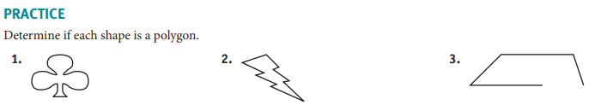
Criteria | Does it meet the criteria to be effective? (Yes/No) | Rationale
Focus on Process
Provides steps & rationale
Increasing complexity

