Student Guide – Answer Key

Lesson 7.06: Worked Examples
Name:
Date:

Bellringer: Describe each of the key practices in an effective model and explain why they help learning.

Key Modeling Practices | Description | How does it help learning?
Small, Learnable Steps | Content to be learned is broken down into steps taught one at a time | Prevents cognitive overload
Visual Demonstration | Visual image or object used to demonstrate the process | Provides a way for someone to “see” the process
Verbal Explanation | Description of the steps as they are done | Explanation includes not just the how but the why steps are important
Connect the Steps | Steps are connected to each other and prior learning | Helps students to understand the sequence and extend and revise knowledge
Check for Understanding | Teacher pauses and checks to make sure students understand. Provides room for questions and re-modeling of steps as needed | Ensures that everyone knows the process and is doing it correctly

Introduction to Worked Examples

Worked Examples | Step-by-step demonstration of how to perform a task or solve a problem

Benefits of Worked Examples:
- Helpful when students have little to no prior knowledge of the skill to be learned - demonstrates the process to students step-by-step so students learn what they need to do and what success looks like.
- They focus on the process rather than the answer. This allows the brain to utilize all the power of the working memory to applying information, thus reducing the cognitive load.
Criteria for effective worked examples
Criteria | Description
Focus on Process | Allows the brain to utilize all the power of the working memory to applying information, thus reducing the cognitive load.
Provides steps & rationale | Models expert thinking; highlights importance of each step
Increasing complexity | Examples move from basic to more challenge. This helps the learner to transition from using the example as a reference to mimic to deeper thinking and understanding of the process.

Example: Worked Example
Mr. Brooks, a high school algebra teacher is teaching students how to solve for an unknown variable. He began by using the example below. He walked the students through the example providing the explanations of each step listed.
8x + 3 = 17 + x | The goal is to figure out what x must be.
8x + 3 – (x) = 17 + x – (x)  7x + 3 = 17 | Subtract x from both sides to remove x from the right side. The goal is to get the x’s on only one side of the equation.
7x + 3 – (3) = 17 – (3)  7x = 14 | Subtract 3 from both sides to further isolate the x. We need to get x by itself on one side of the equation.
7x /7 = 14/7  X = 2 | Divide both sides by 7 to solve for the value of x

He then moved to a practice set where he walked the students through the examples below as a class before asking the students to solve the last problem independently.
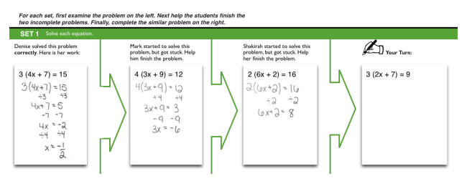
Resource: Booth, J. L., McGinn, K. M., Young, L. K., & Barbieri, C. (2015). Simple Practice Doesn’t Always Make Perfect Evidence from the Worked Example Effect. Policy Insights from the Behavioral and Brain Sciences, 2(1), 24-32.

What evidence supports that this is an example of an effective worked example?
Criteria | Evidence
Focus on Process | After modeling the process initially, students were provided examples that were worked, showing the step. Language focused on the process rather than solution.
Provides steps & rationale | Mr. Brooks first shows an example of a problem step-by-step and explains what he is doing at each step.
Increasing complexity | I do, we do, you do. Full process modeled, then students increasingly had steps removed until they worked out the problem independently. It is important the examples are appropriately challenging for students.

Non-Example:
Mr. Jones, a science teacher, is teaching students how to convert one unit of measure to another in the metric system. The students are new to the concept of converting units. He stared by demonstrating how to convert kilograms to grams using the problem below:
4.8 kilograms | The goal is to convert kilograms to grams
4.8 kg x 1000 g  1 1 kg | To convert kg to grams multiply by 1000.
4.8 x 1000 = 4800 | You get 4,800 g

He then gave the students time to practice their conversions by completing the following practice problems:
Express the following mass in units of grams.
- 5.89 kg = _______ g
- 3 kg = _______ g
- 0.18 kg = ______ g
- 4.20 kg = _______ g
- 6.5 kg = ______ g
Express the following mass in units of kg.
- 12,240 g = _______ kg
- 15 g = _______ kg
- 565 g = _______ kg
- 4,000 g = ______ kg
- 3, 920 g = ______kg

What evidence supports that this is a non-example of an effective worked example?
Criteria | Evidence that makes it a Non-Example
Focus on Process | In the student practice, the problems are about finding the solution. There is not any language that focuses on the process.
Provides steps & rationale | The steps for solution are provided but there is no explanation of why the steps are important or how they help to solve the problem.
Increasing complexity | Mr. Jones does a problem and then releases the students to work independently. He asks them to convert kg to g and g to kg. He doesn’t show them how to calculate g to kg.

Student Practice: Worked Examples
Read each of the scenarios below. Determine if the scenario meets the criteria to be considered an effective worked example. Provide your rationale in the chart below each scenario.
Scenario 1: A 5th grade math teacher is teaching students how to find the prime factors of a number. Students have already learned that a prime number is one that can only be divided by 1 and itself. Below is the picture of her example and description of the process.
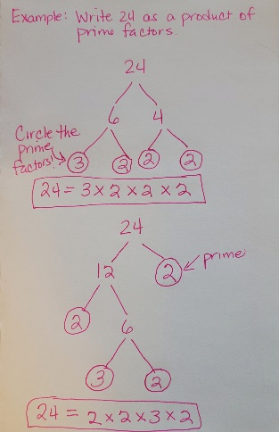 | - Select two whole numbers that multiply to give 24 (except 1 and 24). In this case I chose 6 and 4.  - Next identify if the factors are prime. Remember prime means it can be divided only by 1 and itself. In this case, neither 6 or 4 is prime.  - Determine factors for the number 6. This can be any two whole numbers that multiply to give 6. In this case, I chose 3 and 2.  - Now determine if these factors are prime. If they are, circle them to indicate that you can stop looking for factors. Both 3 and 2 are prime so I circled them.  - Now determine factors for the number 4. In this case I chose 2 and 2.  - Again, check to see if they are prime. We previously determined that 2 is prime, so we will circle them as well to know we can stop looking for factors.  - Now we need to check our work. We will check to make sure that when we multiply all the prime factors we get the original number. In this case 3 x 2 x 2 x 2 equals 24 which is our original number so we are good.

After doing the first example, she had a student help with the second example where they started with 24 again but used the factors of 12 and 2. The students from the class helped worked together to solve the problem a different way. Once they completed the 2nd example, the teacher asked the students to find the prime factors of 65 and 100 independently showing their work by creating a factor tree as she demonstrated.
Criteria | Does it meet the criteria to be effective? (Yes/No) | Rationale
Focus on Process | Yes | The teacher demonstrated the process for finding prime factors. The steps were highlighted and we asked to be replicated in the independent practice.
Provides steps & rationale | Yes | Each step was clear and a rationale was provided.
Increasing complexity | Yes | The teacher demonstrated the first factor tree, then the students worked as a class, then students were asked to do it independently with larger numbers.
Scenario 2: A math teacher is teaching students to classify two dimensional shapes based on their characteristics. Students have been introduced to the definition of a polygon, which is a closed, two-dimensional figure formed by three or more line segments that intersect at only their endpoints. After identifying if the shapes are polygons, the students will further classify them by their names.
 | - Our goal is to determine if this shape is considered a polygon.  - Is this shape closed and 2D (plane figure)?  - Does it have three or more line segments?  - Do the line segments only intersect at the endpoints?  - If this shape meets all these criteria, it is a polygon.
 | - Here is another example. Based on the criteria for a polygon this is not a polygon.
 | - Based on the criteria this is considered a polygon.

After doing the worked example, the teacher asked the students to classify the following shapes below independently.
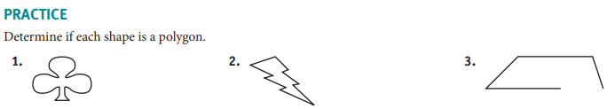
Criteria | Does it meet the criteria to be effective? (Yes/No) | Rationale
Focus on Process | No | While the teacher provided some steps, in subsequent steps they did not emphasize the steps to classify. The practice doesn’t ask students to justify using the process.
Provides steps & rationale | No | The teacher provided steps but didn’t provide a rationale in the 2nd and 3rd examples.
Increasing complexity | No | The teacher modeled the first classification, then went on to classify two more shapes. There is no increasing difficulty with the examples provided and students do not have to justify thinking.

