Student Guide – Answer Key

Lesson 7.08: Collaborative Learning | Part II
Name:
Date:
Bellringer: Consider the following scenario: Ms. N is a 7^{th-}grade teacher. She put students in groups of three to discuss a reading passage they read together in class. As she walks around, she notices some students are off task. In several groups, one student is doing all the talking, and in another group, students are arguing.
What strategies might Ms. N use to prevent these issues from happening?

Answers Vary

Notes: Introduction to Protocols
Protocol | A protocol is a well-defined set of actions used in a classroom for a specific academic purpose.
Roles for Protocols | - Protocols enhance the structure or clarity of an open-ended task such as brainstorming or generating ideas.  - Protocols promote equal participation by encouraging students to take turns between listening and speaking.  - Protocols assign clear roles and tasks so opportunities for collaborative work are maximized.
Protocol similarities | - Protocols are organized and have identified what participants will do.  - Protocols have timeframes for each step and specify how long participants must complete each step.  - Protocols include a description of what the protocol will do to structure learning.

Practice 1 - Examining Protocols

Save the Last Word Protocol
Purpose
This discussion technique encourages meaningful classroom conversations by eliciting differing opinions and interpretations of a text. The discussion time also allows students to process the reading more deeply and allows students time to practice reflecting on things they read. You can use this protocol:
- After reading a thought-provoking article or story
- After watching a thought-provoking video (with transcript)
- After listening to a thought-provoking podcast (with transcript)

Directions
1. Read
Assign a section of text and ask students to find two to five quotes or ideas from the text. The quotes may be something they agree or disagree with, something they find interesting, something they didn’t know, , etc.

2. Write
Pass out index cards or slips of paper to each student, one card for each quote they have found. On one side of the card, ask students to write down the statements from the text. On the other side, instruct them to write any comments or feelings about their statements.
3. Group and Share
Divide the class into groups of 3-5 students. All students in the group are allowed to share one of their quote cards. The first student reads one of their quotes to the group and shows where to locate it in the text. However, the student may not comment about his or her quote until the other members of the group give their reactions. Therefore, the student gets the last word in the discussion of the statement. This process continues until everyone in the group has shared at least one quote and has provided the last word in the discussion.

 | How does Save the Last Word align to characteristics of effective protocols?
Protocols enhance the structure or clarity of an open-ended task such as brainstorming or generating ideas. | It provides a specific process for discussing the text in a particular order. The protocol will help students process the reading more deeply and to encourage meaningful classroom conversations.
Protocols promote equal participation by encouraging students to take turns between listening and speaking. | Each student has a turn to share their own quote/passage as well as the opportunity to respond to other students’ selections. Every student in the group participates equally
Protocols assign clear roles and tasks so opportunities for collaborative work are maximized. | A protocol such as this would give students specific roles to help them stay on task.

Practice 2: Protocol Analysis
Review the protocols below and complete the graphic organizer to analyze their alignment to elements of effective protocols.
 | Jigsaw | List/Group/Label | Clock Partners
Protocols enhance the structure or clarity of an open-ended task such as brainstorming or generating ideas. | Learning is structured in chunks. Each learner becomes an expert in one chunk and then shares learning with others. | The activity is divided into a step-by-step process to help students generate ideas and then narrow them into categories and revise. | This protocol enhances the clarity of who students should be working with. It allows the students to quickly find their groups for a task, but the teacher would need to give additional instructions for the task.
Protocols promote equal participation by encouraging students to take turns between listening and speaking. | Each person in a learning or home group is responsible for teaching one piece of the learning. No one can sit out. | All students can contribute vocabulary words to the original list. Students work together in small groups to come to consensus on labels. | Students can be placed in pairs. Smaller groups are likely to lead to more equal participation, but this protocol isn’t structured to require equal participation. The teacher would have to add parameters to the activities students do with their pairs to ensure equal participation.
Protocols assign clear roles and tasks so opportunities for collaborative work are maximized. | Experts have a clear assignment to become an expert on one piece of the learning. This task becomes their role. | The step-by-step process provides specific instruction for each part of the task, but there are no specific roles in this protocol. | Students are assigned specific tasks when they are told to find different partners. Teacher can assign roles for each partnership if desired.

Jigsaw Protocol
Purpose
This protocol allows small groups to engage in an effective, time-efficient comprehension of a longer text or large amount of information. Students divide up the text or information needed about a topic and become an expert. Then students share information with their group members.

Directions
1. Divide the text/topic into manageable sections.
2. Arrange the students into groups so there are the same number of people in each group as sections to read or topics to understand. Assign the sections/topics to each member.
3. Students read their section independently looking for key points OR students research their topic independently.
4. Students return to their small group and each member in turn shares their important points or summaries of the text or information about their topic.
5. Students independently write/reflect on their own understanding after the discussion

List/Group/Label
Purpose
The List/Group/Label strategy offers a simple three-step process for students to organize a vocabulary list from a reading selection. This strategy stresses relationships between words and the critical thinking skills required to recognize these relationships.

Directions
- Select a main topic or concept in a reading selection.
- Students will list all words they think relate to this concept. Write student responses on the chalkboard. Note: Since the concept is presented without a specific context, many of the student suggestions will not reflect the meaning of the concept in the reading selection.
- Divide the class into groups of 3 or 4 students. Have these teams join related terms from the larger list. Have the teams provide “evidence” for this grouping—that is, require the students to articulate the common features or properties of the words collected in a group.
- Ask the student groups to suggest a descriptive title or label for the collections of related terms. These labels should reflect the rationale behind collecting the terms in a group.
- Finally, have students read the text selection carefully and then review both the general list of terms and their collections of related terms. Students should eliminate terms or groups that do not match the concept’s meaning in the context of the selection. New terms from the reading should be added, when appropriate. Terms should be “sharpened,” and the groupings and their labels revised, when necessary.

Clock Partners Protocol
Purpose
Clock Partners allows educators to quickly move students into partner groups. This protocol gives the teacher many options for organizing students into partner groups.

Directions
- Give each student a copy of the Clock Partners chart.
- Give students time to find a classmate to be their partner for each time slot on their clock. Students will write their name on the designated line to sign up for that timeslot.
- When teachers want to pair students up, they will tell them to find a particular clock partner. For example, “Find your 3 o-clock partner.”

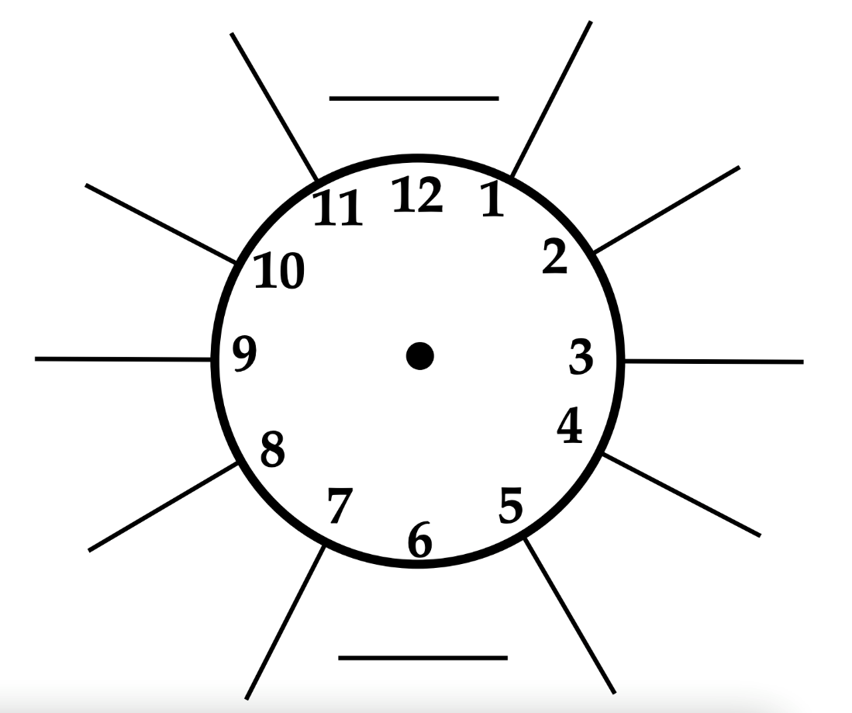

Save the Last Word Protocol
Purpose
This discussion technique encourages meaningful classroom conversations by eliciting differing opinions and interpretations of a text. The discussion time also allows students to process the reading more deeply and allows students time to practice reflecting on things they read. You can use this protocol:
- After reading a thought-provoking article or story
- After watching a thought-provoking video (with transcript)
- After listening to a thought-provoking podcast (with transcript)

Directions
1. Read
Assign a section of text and ask students to find three to five quotes from the text that they think are particularly interesting. The quotes may be something they agree or disagree with, something they find interesting, something they didn’t know, something they would like to tell someone about, etc.
* For elementary students, only have them prepare one quote.
2. Write
Pass out index cards or slips of paper to each student, one card for each quote they have found. On one side of the card, ask students to write down the statements from the text. On the other side, instruct them to write any comments or feelings about their statements.
3. Group and Share
Divide the class into groups of 3-5 students. All students in the group are allowed to share one of their quote cards. The first student reads one of their quotes to the group and shows where to locate it in the text. However, the student isn’t allowed to make any comments about his or her quote until the other members of the group give their reactions. Therefore, the student gets the last word in the discussion of the statement. This process continues until everyone in the group has shared at least one quote and has provided the last word in the discussion.

