Student Guide

Lesson 7.09: Questioning | Using Questioning Strategies to Support Student Learning
Name:
Date:
Bellringer: Bellringer: How does the use of meaningful questions lead to cognitive engagement and student understanding?

Intro to Questioning
Questioning is an important part of the classroom because it:

Bloom’s Taxonomy

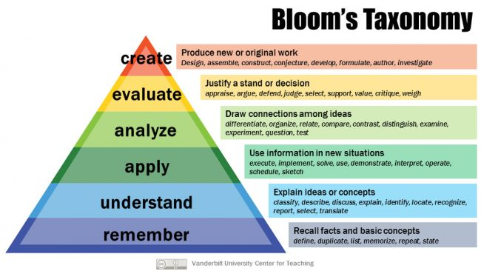

Types of Questioning
Type of Question | Level of Bloom’s Taxonomy | Purpose | Examples | Nonexamples
Lower-Level Questioning

Higher-Level Questioning

Closed Questions

Open Questions

Practice #1: Guided Practice
Record notes at the teacher goes through the model.
Question | Higher/Lower Level | Open or Closed | Purpose of Question
What is this an example of?
Is this an example of land?
How did you decide which parts of the globe were land?
What information do you think a globe gives us about land?
Why is it difficult to describe land using only a globe?
What other tools could you use to help you describe land?
How would you describe land?

Practice #2
Read the following scenario and examine the questions the teacher plans to use for an upcoming lesson. Identify if the questions are higher-level or lower level, if the questions are open or closed, and explain the teacher’s purpose for using each question.

Scenario:
Ms. Green is planning a lesson on solving word problems to determine perimeter with given side lengths. Her goal is to use questions to quickly assess student understanding of the concept and ask questions that will require students to thinking more deeply and apply their learning to different situations. Below is the problem Ms. Green plans to walk students through and the questions she plans to ask students with possible student responses in parentheses.

Mrs. Kozlow put a border around a 5-foot by 6-foot rectangular bulletin board. How many feet of border did Mrs. Kozlow use?

Question | Higher/Lower Level | Open or Closed | Purpose of Question
What can you draw to help you solve this problem?
What is the width and the length? (5 feet for the width and 6 feet for the length)
Why is this a question about perimeter and not area?
Can you find the perimeter of the bulletin board with the information in your picture? (Yes, we can use what we know about rectangles to label the unknown sides)
Look at your number sentence. What strategy did you use or could you use to find the perimeter? (add 5 and 6 and then double the sum to get 22 or multiple each side length by 2 and then add the products)

