Student Guide – Answer Key

Lesson 7.09: Questioning | Using Questioning Strategies to Support Student Learning
Name:
Date:
Bellringer: Bellringer: How does the use of meaningful questions lead to cognitive engagement and student understanding?
It forces students to think critically and elaborate as opposed to providing a one-word response. It pushes students to make connections and draw on their prior knowledge and learning.

Intro to Questioning
Questioning is an important part of the classroom because it:
- Encourages extended student response
- Engages students in effective class discussions
- Fosters student involvement
- Facilitates a positive, active learning environment
- Helps teachers to challenge students and learn more about how they think.
- Helps teachers to understand what students know/don’t know

Bloom’s Taxonomy | Model used to classify thinking into levels of rigor. Helps a teacher consider the level of thinking, action or knowledge a student must use to answer a question or accomplish a task.

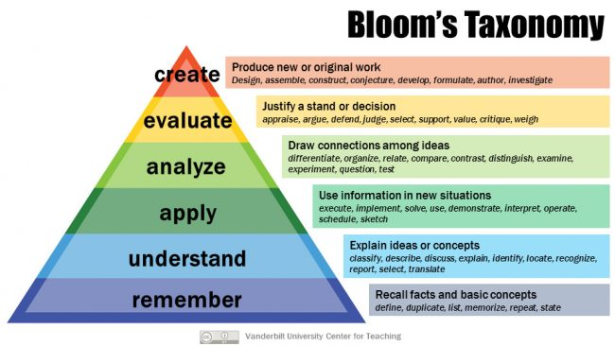
Types of Questioning
Type of Question | Level of Bloom’s Taxonomy | Purpose | Examples | Nonexamples
Lower-Level Questioning  Questions that require students to recall or restate information that is relatively easy to give | Remember, Understand, Apply | - Review or  - summarize content  - Assess comprehension  - Check student understanding  - Determine student strengths & weaknesses | - Define theme.  - What are the three branches of government? | - What second theme could be added to this story, and how would you change the story to support the additional theme?  - What is the function of each of the three branches of government and how do they compare?
Higher-Level Questioning  Questions that require students to go beyond simple information and think deeply and critically about a topic | Analyze, Evaluate, Create | - Encourages students to think more deeply and critically about the content  - Develops & engages students in problem solving  - Encourages discussions  - Requires students to apply, not just recall prior knowledge and understanding to respond | - Do you agree with the theme of this story? Why or why not?  - Think of a time in history when the system of checks and balances was challenged the most. What was the result? | - What is theme of the story?  - What are the three branches of government?
Closed Questions  Questions that have a limited number of acceptable answers and are useful to check students’ understanding | Can be used at both lower & higher-level questioning | - Questions where there is a limited number of acceptable answers  - Doesn’t require students to elaborate on their responses  - Beneficial in helping to retrieve core knowledge & facts | - Who was the first person to walk on the moon?  - How do the hairs on a gecko’s toes work together to help it carry so much weight?  - What is the meaning of “tear” as it is used in the text? (higher level) | - What benefits have come from space exploration?  - Why do you think the pilot was/wasn’t fit to do the job?
Open Questions  Questions that have many acceptable answers and that promote deeper thinking and building of connections | Can be used at both lower & higher-level questioning | - Questions where there are many acceptable answers, many of which might not be anticipated by teacher  - Promotes deeper thinking and building of connections | - How are the main character’s actions important to the plot of the story?  - How can we use the features of a gecko to help us develop modern medicine practices?  - How would you describe a metamorphic rock? (lower-level) | - What is the main character’s name in the story?  - What does a gecko have on its toes to help it carry up to 200 pounds?

Practice #1: Guided Practice
Record notes at the teacher goes through the model.
Question | Higher/Lower Level | Open or Closed | Purpose of Question
What is this an example of? | Lower Level  Reasoning: The question simply asks students to recall information. It allows the teacher to assess basic understanding of land vs water. | Closed  Reasoning: The question requires a simple response with a limited number of responses | To assess student’s basic understanding of land vs water
Is this an example of land? | Lower Level  Reasoning: The question simply asks students to recall information. It allows the teacher to assess basic understanding of land vs water. | Closed  Reasoning: The question requires a simple response with a yes/no response. | To assess student’s basic understanding of land vs water. Use a check for understanding.
How did you decide which parts of the globe were land? | Higher Level  Reasoning: Students must explain how they decided which parts of the globe were land and justify their response with evidence. | Open  Reasoning: Open because it allows for a variety of acceptable answers and allows students space to build connections. | To force students to elaborate on why they said a certain place on the globe was land.
What information do you think a globe gives us about land? | Higher Level  Reasoning: The question forces students to think about the different features of the globe and what those different features represent. | Open  Reasoning: Open-ended because the answer isn’t limited. | To encourage students to think more deeply and critically about the purpose of a globe and what useful information they can gather from a globe. It could encourage discussion between peers.
Why is it difficult to describe land using only a globe? | Higher Level  Reasoning: The question requires students to differentiate between the information they can get from a globe versus the information they can get from somewhere else. | Open  Reasoning: Open because students can respond in a variety of ways. The question also promotes deeper thinking and building of connections. | To encourage students to think more deeply and critically about the features of the land and think about whether a globe can help them better understand the different features. It requires students to use prior knowledge and understanding to respond
What other tools could you use to help you describe land? | High level  Reasoning: students must think about what other tools they could use to help them describe land. | Closed  Reasoning: there are a limited number of tools students can use to describe land. | To encourage students to think about what other tools could help them describe land. It requires students to use prior knowledge and understanding to respond.
How would you describe land? | Low level  Reasoning: Students recall the characteristics of land | Open  Reasoning: Students can describe land in different ways | To check students understanding of the characteristics of land.

Practice #2
Read the following scenario and examine the questions the teacher plans to use for an upcoming lesson. Identify if the questions are higher-level or lower level, if the questions are open or closed, and explain the teacher’s purpose for using each question.

Scenario:
Ms. Green is planning a lesson on solving word problems to determine perimeter with given side lengths. Her goal is to use questions to quickly assess student understanding of the concept and ask questions that will require students to thinking more deeply and apply their learning to different situations. Below is the problem Ms. Green plans to walk students through and the questions she plans to ask students with possible student responses in parentheses.

Mrs. Kozlow put a border around a 5-foot by 6-foot rectangular bulletin board. How many feet of border did Mrs. Kozlow use?

Question | Higher/Lower Level | Open or Closed | Purpose of Question
What can you draw to help you solve this problem? | High level  Reasoning: The question simply asks students to recall information, such as the shape of the bulletin board. Students only need a basic understanding of how to use a drawing to solve a word problem. | Closed  Reasoning: The question has a limited number of acceptable answers and doesn’t require students to think deeply. | To assess students’ basic understanding of how to use a drawing to solve a word problem.
What is the width and the length? (5 feet for the width and 6 feet for the length) | Low level  Reasoning: The question only requires students to have a basic understanding of the characteristics of a rectangle and length vs width. | Closed  Reasoning: The question has a limited number of acceptable answers and doesn’t require students to think deeply. | To assess students’ basic understanding of the characteristics of a rectangle and understanding of length verses width.
Why is this a question about perimeter and not area? | High level  Reasoning: The question asks students to compare perimeter and area and apply their understanding of the comparison to the word problem. | Closed  Reasoning: The question has a limited number of acceptable answers. | To assess the students’ understanding of the difference between perimeter and area.
Can you find the perimeter of the bulletin board with the information in your picture? (Yes, we can use what we know about rectangles to label the unknown sides) | Low Level  Reasoning: This question requires students to use what they know about a rectangle. | Closed  Reasoning: This question only requires a yes/no response. | To assess if students understand the characteristics of a rectangle, such as opposite sides are equal.
Look at your number sentence. What strategy did you use or could you use to find the perimeter? (add 5 and 6 and then double the sum to get 22 or multiple each side length by 2 and then add the products) | High-level  Reasoning: The question encourages students to consider various ways to solve the same problem. | Open  Reasoning: Students can respond in a variety of ways. The question promotes deeper thinking and building of connections. | To encourage students to think more deeply and critically about all the possible ways to solve a problem.

