Exit Ticket - Answer Key

Lesson 7.10: Questioning | Engaging Students in the Questioning Process
Name:
Date:
Read the following passage and examine the corresponding questions to determine if each question is Right There, Think and Search, Author and Me or On My Own.
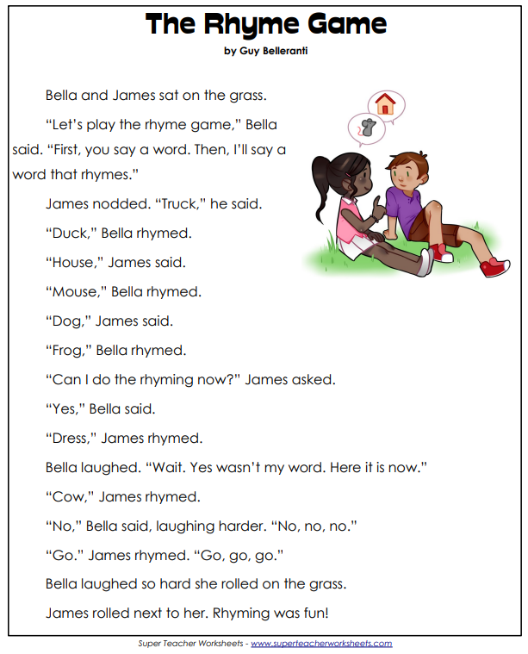

Question | Question Type
Where does the story take place? | Author and Me
Whose idea was it to play the rhyme game? | Right There
What words did Bella have to create rhymes with? | Think and Search
Why did Bella keep laughing at James’ rhymes? | Author and Me
In the story, “The Rhyme Game,” Bella and James think of rhyming words. What are three words you can think of that rhyme with dog? | On My Own

How did the QAR strategy help you to develop deeper questions?
The QAR strategy helped me to understand the relationship between a question and its answer. The strategy helped me see that in order to generate quality questions, a student must make connections between the question, the text, and their own background knowledge.

