Exit Ticket

Lesson 7.10: Questioning | Engaging Students in the Questioning Process
Name:
Date:
Read the following passage and examine the corresponding questions to determine if each question is Right There, Think and Search, Author and Me, or On My Own.
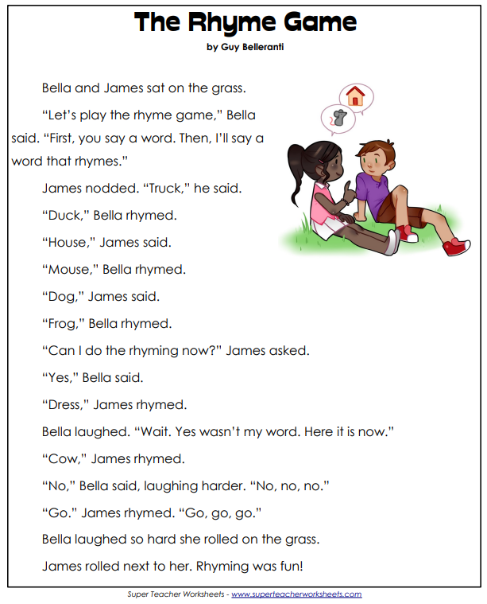

Question | Question Type
Where does the story take place?
Whose idea was it to play the rhyme game?
What words did Bella have to create rhymes with?
Why did Bella keep laughing at James’ rhymes?
In the story, “The Rhyme Game,” Bella and James think of rhyming words. What are three words you can think of that rhyme with dog?

How did the QAR strategy help you to develop deeper questions?

