Student Guide - Answer Key

Lesson 7.10: Questioning | Engaging Students in the Questioning Process
Name:
Date:
Bellringer: Studies have shown that 4-year-olds ask as many as 200-300 questions a day. Between the ages of 2-5, kids ask on average 40,000 questions! Why do you think it is important for students to ask questions?

Introduction to QAR
A teacher can help students develop questions by:
- Modeling explicitly how to ask good questions
- Providing structured ways for students to ask questions
- Setting expectations that asking questions is the norm in the classroom.

QAR (One-Pager)
Question-Answer-Relationship (QAR) is a strategy that helps students understand different types of questions they may encounter during various tasks and helps them learn to generate their own questions. It is used when students are reading texts.

Why use QAR?

QAR helps students to identify connections between the question, the text, and their own background knowledge. Better understanding these connections and understanding different question types helps students know how to answer different questions. QAR also helps students to generate their own questions. When students are able to generate their own questions, they become more curious and they are better able to guide and monitor their own learning.

How to use QAR:

- Present the four question types.
- Teach students to analyze questions to identify question type. Teach them how identifying question type can help them to answer questions.
- Teach students to generate their own questions using the question types.
- Use QAR to ask students to identify question type when they are having a hard time answering a question. Ask them how knowing the question type can help them figure out how to answer the question.
- Use QAR to ask students to generate their own questions as they read texts when you want to build curiosity and motivation for discussing a text.
Sample Text
Some people are afraid of bugs such as spiders or beetles. But there is one bug that just about everybody likes – pill bugs. If you ever pick one up, you know why its nickname is “roly-poly.” A pill bug rolls up into a tight little ball to protect itself. This bug is scared of you, not the other way around!

Sample Questions
What kind of bug does just about everybody like? (Right there)
Compare the relationship between humans and roly-polys and the relationship between humans and bugs like spiders or beetles? (Think and Search)
Do you agree with the author’s assessment of how people feel about roly-polys? (Author and Me)
Are you afraid of bugs? Why or why not? (On My Own)

Question Type | Definition | Question Starts With… | Example | High or Low Level | Open or Closed
Right There | Explicit questions whose answers can be found in the text. Often the words used in the question are the same words found in the text. | - Who  - What  - When  - Where  - How | Where did the story take place? | Low level | Closed
Think and Search | Explicit questions whose answers are gathered from several parts of the text and put together to make meaning. | - How did…?  - Summarize  - Describe  - Compare  - What caused…? | Why was Baby Bear upset? | Low level | Closed
Author & Me | The answer to the question cannot be found directly in the text. The learner must combine information provided in the text with their own prior knowledge to create a response. | - Predict what will happen  - Why did the author…?  - What is the main idea? | What kind of person is Goldilocks? | High Level | Open
On My Own | The answer to the question cannot be found directly in the text. These questions require the learner to use their background or prior knowledge to answer the question. | - What is your opinion about…?  - How would you feel…?  - What would you do…? | Goldilocks sat in Baby Bear’s chair and broke it. Write about a time you broke or damaged something that did not belong to you. | High Level | Open

Teacher Model of QAR Strategy
Independently read “Roly-Poly Pill Bugs” by Cynthia Sherwood. After you read, we will then look at a few questions to determine the question type.
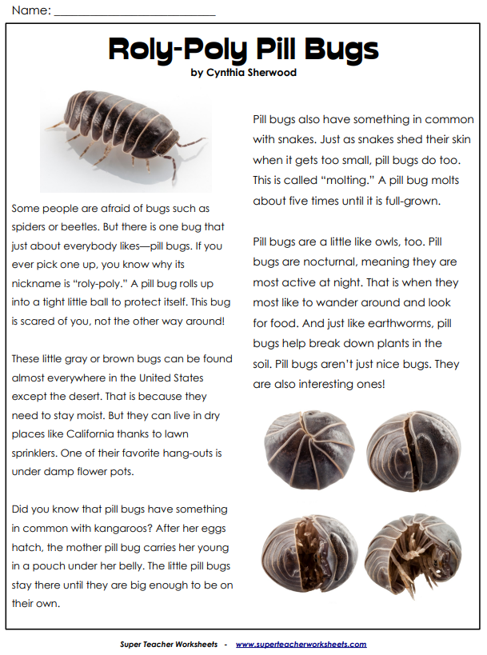
Question | Type of Question | Reasoning
Why are pill bugs nicknamed “roly-poly”? | Right there | The answer can be found directly in the text.
Which statement from the article is an opinion?  a. This bug is scared of you, not the other way around.  b. A pill bug molts about five times until it is full-grown.  c. Pill bugs aren't just nice bugs; they are interesting ones.  d. One of their favorite hang-outs is under damp flower pots | On My Own | The answer cannot be found directly in the text. Students must use their own prior knowledge to answer the question.
In what ways is the pill bug similar to other creatures? | Think and Search | The answers are found directly in the text but are gathered from several parts of the text and put together to make meaning.
Where would you be least likely to find a pill bug? | Author and Me | These questions are based on information provided in the text, but the student is required to relate it to their own experience. Although the answer does not lie directly in the text, the student must have read it to answer the question.

Practice
Independently read “Spitting to Survive” by Liana Mahoney. Working in groups of 4, each student will focus on one question type. Draft two questions for your assigned question type as it relates to the passage you read. After everyone in your group has read and drafted a set of questions, each member will share their drafted questions with the group. Each person should take no more than 2 minutes to share their questions.

Question Type | Questions
Right There | - List 3 ways spit helps humans.  - Which animal creates a forceful stream of water to capture insects?
Think & Search | - How are the archer fish and spitting cobra similar?  - Describe the different ways an animal might use spitting to survive.
Author & Me | - What is the author’s purpose for writing this passage?  - What is the main idea of this passage?
On My Own | - Write a story about a time you encountered a spitting animal.  - What would you do if an animal spit on you?
