Student Guide

Lesson 7.10: Questioning | Engaging Students in the Questioning Process
Name:
Date:
Bellringer: Studies have shown that 4-year-olds ask as many as 200-300 questions a day. Between the ages of 2-5, kids ask on average 40,000 questions! Why do you think it is important for students to ask questions?

Introduction to QAR
A teacher can help students develop questions by:
- Modeling explicitly how to ask good questions
- Providing structured ways for students to ask questions
- Setting expectations that asking questions is the norm in the classroom.

QAR (One-Pager)
Question-Answer-Relationship (QAR) is a strategy that helps students understand different types of questions they may encounter during various tasks and helps them learn to generate their own questions. It is used when students are reading texts.

Why use QAR?
QAR helps students to identify connections between the question, the text, and their own background knowledge. Better understanding these connections and understanding different question types helps students know how to answer different questions. QAR also helps students to generate their own questions. When students are able to generate their own questions, they become more curious and they are better able to guide and monitor their own learning.

How to use QAR:

- Present the four question types.
- Teach students to analyze questions to identify question type. Teach them how identifying question type can help them to answer questions.
- Teach students to generate their own questions using the question types.
- Use QAR to ask students to identify question type when they are having a hard time answering a question. Ask them how knowing the question type can help them figure out how to answer the question.
- Use QAR to ask students to generate their own questions as they read texts when you want to build curiosity and motivation for discussing a text.
Sample Text
Some people are afraid of bugs such as spiders or beetles. But there is one bug that just about everybody likes – pill bugs. If you ever pick one up, you know why its nickname is “roly-poly.” A pill bug rolls up into a tight little ball to protect itself. This bug is scared of you, not the other way around!
Sample Questions
What kind of bug does just about everybody like? (Right there)
Compare the relationship between humans and roly-polys and the relationship between humans and bugs like spiders or beetles? (Think and Search)
Do you agree with the author’s assessment of how people feel about roly-polys? (Author and Me)
Are you afraid of bugs? Why or why not? (On My Own)

Question Type | Definition | Question Starts With… | Example | High or Low Level | Open or Closed
Right There
Think and Search
Author & Me
On My Own

Teacher Model of QAR Strategy
Independently read “Roly-Poly Pill Bugs” by Cynthia Sherwood. After you read, we will then look at a few questions to determine the question type.
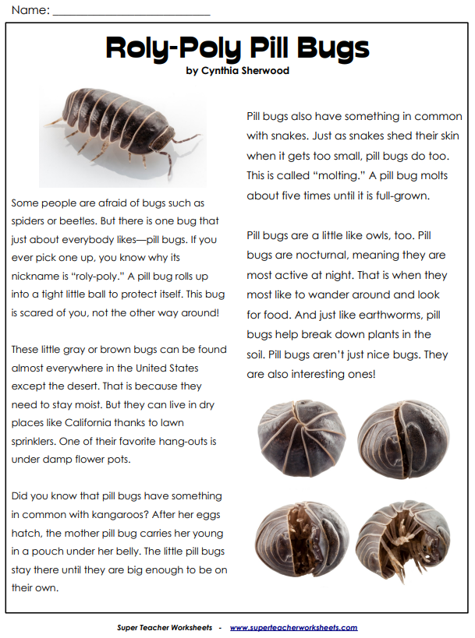
Question | Type of Question | Reasoning
Why are pill bugs nicknamed “roly-poly”?
Which statement from the article is an opinion?

a. This bug is scared of you, not the other way around.
b. A pill bug molts about five times until it is full-grown.
c. Pill bugs aren't just nice bugs; they are interesting ones.
d. One of their favorite hang-outs is under damp flowerpots
In what ways is the pill bug similar to other creatures?
Where would you be least likely to find a pill bug?

Practice
Independently read “Spitting to Survive” by Liana Mahoney. Working in groups of 4, each student will focus on one question type. Draft two questions for your assigned question type as it relates to the passage you read. After everyone in your group has read and drafted a set of questions, each member will share their drafted questions with the group. Each person should take no more than 2 minutes to share their questions.

Question Type | Questions
Right There
Think & Search
Author & Me
On My Own
