Exit Ticket

Lesson 7.11: Metacognition
Name:
Date:
- Define metacognition.

- Review the image below and record at least three things you would identify in a think-aloud. Identify each in terms of a specific metacognitive strategy.

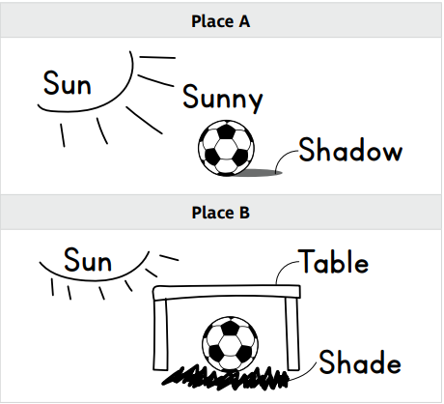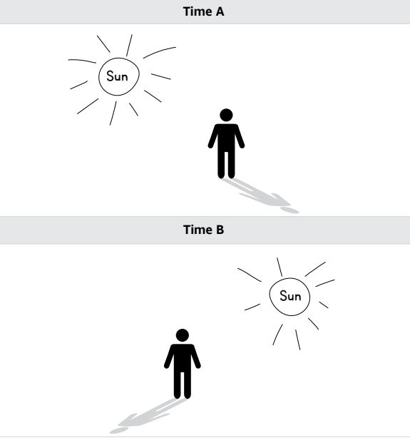

Three things I would identify in a think-aloud | Metacognitive strategy used

