Unit 7: High Leverage Strategies

Lesson 7.11: Metacognition

Lesson at Glance
Warm-Up (5 mins)  - Bellringer | Instruction (20 mins)  - Introduction to Metacognition (8 mins)  - Making Thinking Visible: Teacher Model (12 mins) | Application (15 mins)  - Partner Practice (10 mins)  - Exit Ticket (5 mins)

TEKS | 3 | The student explores the teaching and training profession. The student is expected to:  - Summarize and apply acquired pedagogical knowledge and skills needed by teaching and training professionals;
Objectives | - Define metacognition and explain how metacognitive strategies support student learning.  - Identify and describe the impact of metacognitive strategies.  - Practice think-alouds to make thinking visible.
Rationale/  Summary | Awareness of our own thinking processes enhances student understanding, increases control over learning and enhances personal ability to self-regulate thinking and motivation. Metacognition is a powerful tool in instruction and learning and should be explicitly taught. In this lesson, students will learn to recognize and practice metacognitive strategies.
Formative Assessment and Exemplar Response | - Define metacognition. How does metacognition support learning?  - Reflect on your experience practicing the read aloud. Was it easy or difficult to make your thinking visible? How does making your thinking visible help you or your partner to better understand the content?  See Exit Ticket Answer Key for exemplar response.
Vocabulary | Metacognition |  | Thinking about your thinking
 | Think-aloud |  | A strategy used to verbalize one’s thinking in order to make it explicit

Est Time | Instructional Activities (including formative assessments) | Materials
3 mins | Bellringer: Have you ever talked to yourself as you were working through a problem? Why might it be beneficial for someone to verbalize their thinking as they are solving problems? | Student Guide  PPT
2 mins | T: Raise your hand if you answered yes to the first question.  S: (Raise hands to respond.)  T: Why do you think you did that?  S: Because it helped me to solve the problem. It helped me to focus on the problem. It helped me to figure out what the problem was. (Answers will vary.) | Student Guide
8 mins | Introduction to Metacognition  T: Today, we are going to talk about metacognition – thinking about your own thinking. (Use the PowerPoint to define metacognition.) Metacognition increases your own awareness and understanding of your thought process.  T: Why do you think it might be important to understand your own thought process?  S: (Answers will vary.)  T: Let’s learn a little more about metacognitive strategies. (Use PPT to review notes.)  - Metacognitive strategies can include:  - planning how to approach new tasks or new information (What’s my purpose or goal? Where should I start? What obstacles might I encounter and how can I plan to avoid them?)  - identifying and planning for challenges (What might be hard for me? What are some strategies for moving forward?)  - consulting prior knowledge (What do I know about this already? How can I use what I know to make predictions?  - evaluating your progress (Where am I in the process? How am I doing? Am I on track?)  - monitoring comprehension (Am I understanding? Where might I be getting stuck? What do I need to do to get unstuck?)  - using images (What does this image add to my understanding of the text? How might I visualize what is being said?)  T: Evidence shows that teaching metacognitive strategies is a high leverage teaching practice because it substantially improves student learning. Based on what you know so far, why do you think that might be?  S: (Answers will vary but should align to information provided so far.) If students know how they are understanding or making sense of something, they can repeat that strategy when they are stuck another time.  T: Yes. Awareness of our own thinking processes also enhances:  - control over learning and  - personal ability to self-regulate our thinking and motivation.  T: I’m going to use a think-aloud to model for you what metacognition looks like. Before I start, what do you remember about modeling from earlier in the unit?  S: (Answers will vary.) Requires someone to say out loud what they are thinking. Teachers can use modeling to help students see how “expert thinkers” solve a problem.  T: Yes, that’s right. Modeling can help students see how expert thinkers solve problems. Teachers use modeling to help students see how expert thinkers manage their comprehension & solve problems. A think-aloud is a way for a teacher to model a thought process for students and make thinking explicit.  T: Teachers can also ask students to “think aloud.” When students practice thinking aloud, they help to make their thinking explicit to themselves and others. Keep in mind that not all modeling needs to focus on metacognitive thinking. Sometimes think-alouds focus on a process or a skill instead of thinking about thinking. | PPT  Student Guide
12 mins | Making Thinking Visible: Teacher Model  T: Today, I will use a think-aloud as I make sense of an image. As I think-aloud, please take note of any strategies you notice me using to make sense of the image and complete the graphic organizer in your student guide. (Display the image on an overhead or document camera. Annotate as you think aloud.)  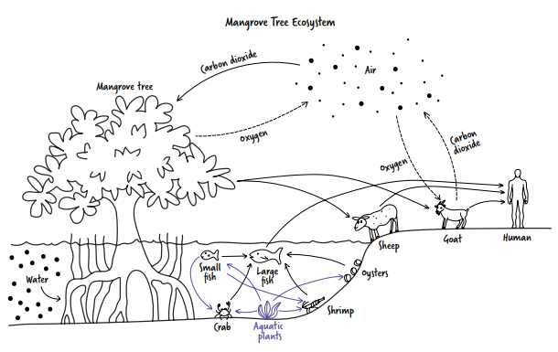  Image from: https://digital.greatminds.org/insync/teacher/resources/phdteks.g5.m2/file/6155c4ad68b3c20041537844 (Lesson 9)  T: This looks like a complicated image. It might take me some time to figure it out. Where should I start to make sense of it? Well, I see there is a title. The title would probably give me a good understanding of the overall image. It says Mangrove Tree Ecosystem. (Underline the title.) I don’t know the word mangrove, but I do know what an ecosystem is – a community of organisms living together. I guess mangrove it is a type of tree. This image must show the ecosystem that builds around this type of tree.  T: Before I continue my think aloud, let’s talk about any strategies you noticed and complete some of the graphic organizer together. I’ll do the first one for you.  T: The first thing that I noticed myself doing is identifying and planning for challenges. I acknowledged to myself that the image was complicated and might take some time to figure out. This helped me because I was able to prevent myself from becoming frustrated by the work and time it took me to make sense of the image. I was able to plan for a challenge. (Model how to complete the graphic organizer for students.)  S: (Complete the graphic organizer based on the teacher’s model.)  T: What other strategies did you notice?  S: You planned how to approach the task. You underlined the title and used it to get a big picture of what the image was about.  T: Yes. Because I knew that the title would help point me in the right direction, I started there. What else did you notice?  S: (Answers will vary but should include items in the 7.13 Student Guide – Answer Key.)  T: I’ll continue with my think-aloud now. When you hear me use a metacognitive strategy, raise your hand. We’ll pause when anyone raises their hand to discuss the metacognitive strategy that was used.  T: I notice a tree in the image and see the label mangrove tree. This gives me more information about the type of tree it is. If I look at the picture, I notice that it is growing in the water. This is different than most trees I’m familiar with and brings up some questions for me: How does the tree grow in water? How is the tree different than other trees that don’t grow in water? These would be good questions for me to record and come back to later. (Record questions on the image.)  S: (Listen and raise hands when they hear a metacognitive strategy.)  T: What strategies did you hear? What did it sound like and how did it support my understanding?  S: You used an image to confirm a guess about the word mangrove. You used comparison to identify unique features of the tree and create questions for further learning. (Continue to complete the graphic organizer by identifying and analyzing strategies.)  T: Let me see what else I can figure out from the image. I see a lot of arrows. I wonder what they mean. I think I’ll start in the bottom left corner of the page. I notice the word water with an arrow pointing at the roots of the mango tree. The water has dots in it. I wonder if those might be nutrients going into the mango tree roots. The mango tree must get water and nutrients through its roots. This makes sense because that’s what other trees do as well. I’ll put a check mark next to the image here because I feel like I understand it.  S: (Listen and raise hands when they hear a metacognitive strategy.)  T: What strategies did you hear? What did it sound like and how did it support my understanding?  S: You thought about a process – a specific place to start and then analyzed the image. You asked yourself questions and confirmed your thinking. (Continue to complete the graphic organizer by identifying and analyzing strategies.)  T: (Continue the think-aloud as scripted below.)  S: (Raise hands when they hear a metacognitive strategy.)  T: (Pause to discuss the strategy/strategies used, what they sounded like, and how they impacted understanding.)  T: I also understand this area in the top middle portion of the page. (Circle the carbon dioxide/oxygen cycle.) Last year, we learned about how trees take in carbon dioxide from the air and give off oxygen. I also see the other half of this process. The goat is taking in oxygen and giving off carbon dioxide. The goat must represent all land animals that do that. I’ll put a check mark here because I understand the overall process. (Place a check next to the circle drawn around the carbon dioxide/oxygen cycle.) I notice that some of the lines are dotted, though. I’m not sure why. Maybe this is something I should remember from last year, too, but I don’t so I’ll record that question to come back to later. (Record question about why some lines are dotted in the carbon dioxide/oxygen cycle.)  T: Now let me look at the arrows at the bottom of the image - starting in the middle and moving out to the right corner. There are a lot of arrows here and it feels a little overwhelming. Let me start by asking myself what I can make sense of. I can think about what still confuses me later.  T: I see a small fish and a large fish with an arrow pointing from the small fish to the large fish. I think this means that the large fish will eat the small fish. Let me test my thinking to see if the other arrows pointing from one element to another might indicate the same thing. If my thinking is correct, the large fish also eats crabs, shrimp, and oysters. It also means that the sheep and goat eat the mango leaves and that the human eats the goat, the sheep, and the large fish. I didn’t know that fish ate crabs, shrimp, and oysters, but the rest of the story makes sense so maybe this is something new I learned. (Annotate while thinking. Write: large fish eats small fish, crab, shrimp, oysters; sheep and goat eat leaves; human eats sheep, goat, fish.)  T: Now, let me see if I can make sense of the remaining arrows. I notice that all the remaining arrows are purple instead of black. I wonder if there is a reason for this. It’s confusing but I’m making good progress on my understanding. I’m going to see if I can figure it out on my own before I ask for help.  T: If I use the same test as before, the arrows here would mean that the crab eats the small fish and the aquatic plants, the small fish eats the aquatic plants, the shrimp eats the small fish and the aquatic plants, and the oysters eat the aquatic plants. I don’t know for sure if all of this is true, but it does seem to make sense. Hmmm. It doesn’t explain to me why these arrows are in purple though, so let me record that question to ask later. (Record question.)  T: How did using metacognitive strategies help me to make sense of the image?  S: You were able to identify and plan for challenges, use prior knowledge and images to make sense of new information, and monitor progress and comprehension to stay on track. | Student Guide  PPT
8 mins | Practice 1: Partner Think-Aloud  T: Now it’s your turn to practice thinking aloud as you make sense of an image. You will work with a partner, and each have a turn making sense of a different image. (Pair students up.)  T: I will pass out two images to each pair. (Pass out two images to each pair. Be sure to put them face down.) Before you practice, take two minutes to review the image and plan what you will say. (Set 2-minute timer.)  T: Decide who will go first.  S: (Decide who will go first.)  T: If you are speaking first, be sure to share your thinking with your partner as you make sense of your image. Your partner will listen and identify metacognitive strategies you use. If you are listening first, note strategies your partner uses in your student guide.  T: Once partner 1 has finished talking through the image, partner 2 will share the strategies they heard. You will have 3 minutes for round 1.  T: You may turn over one image now. (Set timer for 3 minutes.)  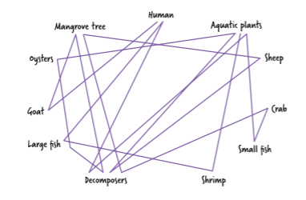  From: https://digital.greatminds.org/insync/teacher/resources/phdteks.g5.m2/file/6155c4ad68b3c20041537844 (Lesson 23)  S: (. Partner 1 engages in a think-aloud to make sense of the image. Partner 2 takes notes. Partners debrief the activity together with partner 2 sharing strategies heard.)  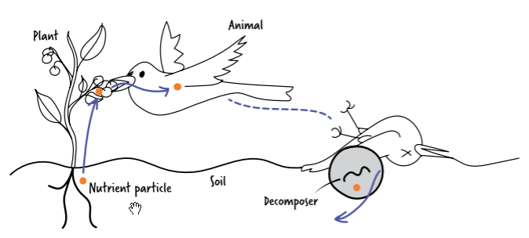  T: (After 3 minutes, help students switch roles.) It is time to switch roles. If you just completed the think-aloud, you will now listen to your partner and note strategies you hear.  S: (Partner 2 engages in a think-aloud to make sense of the image. Partner 1 takes notes. Partners debrief the activity together with partner 1 sharing strategies heard.) | Student Guide  PPT
2 mins | Debrief  T: What strategies did you or your partner use to make sense of your image?  S: (Answers will vary but should reflect strategies introduced in the lesson.)  T: How did the strategies help you or your partner think more deeply about the image?  S: (Answers will vary.)  T: How did listening to someone else’s thinking expand your own?  S: (Answers will vary.)  T: What was easy or difficult about the process of making your thinking visible?  S: (Answers will vary.) | Student Guide
5 mins | S: (Complete the exit ticket.) | Exit Ticket

