Unit 8: Planning for Diverse Learners

Lesson 8.02: Intro to Universal Design for Learning | Part II

Lesson at Glance
Warm-Up (10 mins)  - Bellringer | Instruction (10 mins)  Introduction to UDL  UDL Guidelines | Application (30 mins)  UDL Guidelines Jigsaw - Expert Groups  UDL Guidelines Jigsaw - Learning Groups  Debrief  Exit Ticket

TEKS | 3 | The student explores the teaching and training profession. The student is expected to:  - summarize and apply pedagogical knowledge and skills needed by teaching and training professionals;
 | 7 | The student creates an effective learning environment. The student is expected to:  - describe and implement a safe and an effective learning environment that incorporates the principles of universal design;  - evaluate materials and equipment to determine age and grade level appropriateness and to meet the needs of diverse learners;
 | 10 | The student develops technology skills. The student is expected to:  - describe the role of technology in the instructional process;  - use technology applications appropriate for specific subject matter and student needs;
Objectives | Name and describe UDL’s guiding principles: multiple means of engagement, multiple means of representation, and multiple means of action and expression
Rationale/  Summary | A knowledge of the Universal Design for Learning Guidelines will provide a framework to guide teaching and instructional decision-making.  - Engagement – stimulate interest and motivation for learning  - Representation – present information and content in different ways  - Action & Expression – differentiate the ways that students can express what they know  In this lesson, students will learn about each of the three UDL Guidelines through a Jigsaw activity.
Formative Assessment and Exemplar Response | Match the following terms to the correct definition.  - Universal Design for Learning (UDL)  - UDL Guidelines  - Multiple Means of Engagement  - Multiple Means of Representation  - Multiple Means of Action & Expression  See Exit Ticket – Answer Key for exemplar response.
Vocabulary | Universal Design for Learning (UDL) |  | An educational framework to guide the development of flexible learning environments that can accommodate individual learning differences through engagement, representation, and expression. UDL minimizes barriers and maximizes learning for all students.
Vocabulary | UDL Guidelines |  | A set of strategies that can be applied to any subject or grade level to ensure that all learners can access and participate in meaningful, challenging learning opportunities. (CAST, 2022)
Vocabulary | Multiple Means of Engagement |  | Providing various ways of engaging with material to stimulate interest and motivation for learning
Vocabulary | Multiple Means of Representation |  | Presenting information and content in different ways to support learning for all students
Vocabulary | Multiple Means of Action & Expression |  | Offering options for ways students can demonstrate their learning and express what they know
Vocabulary | Assistive Technologies |  | Any form of device, technology, or equipment that helps students with disabilities participate, communicate, and learn.

Est Time | Instructional Activities (including formative assessments) | Materials
 | Prior to the lesson, preview the learner sketch tool. Access https://learnersketch.org/ to create your class in the tool. To begin, you may search for your school or sign up your facility, or have students take the assessment as a guest (this option is located below the sign in bar to the right.)
5 mins | Bellringer: Complete the Learner Sketch Tool learning profile self-assessment. Make a list of your strengths and challenges based on the results.  S: (Complete the Learner Sketch Tool.) | Learner Sketch Tool: https://learnersketch.org/  Student Guide
5 mins | T: (Access the group’s composite self-reported strengths and challenges.)  T: Let’s look at our class composite. What are some the strengths in this group?  S: (Responses will vary.)  T: What are some of the group’s challenges?  S: (Responses will vary.)  T: What does this tell us about our learning?  S: We all have different strengths and challenges when it comes to learning. What may be a strength for one person could be a weakness for someone else.  T: How should this understanding transfer to the way we teach?  S: Teachers must use strategies that support every learner.
5 mins | Introduction to UDL  T: Let’s look at a picture of a Rubik’s Cube.  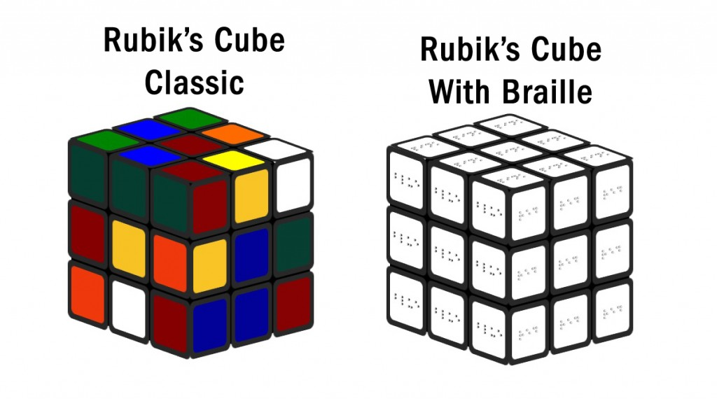  T: Who has tried to solve a Rubik’s Cube before?  S: (Responses will vary.)  T: What if someone is color blind or has another visual impairment? Would they be able to solve the Rubik’s Cube?  S: No because they would not be able to see the colors to align them correctly.  T: Let’s look at a Rubik’s Cube with Braille.  T: This is accessible to a blind student, but who wouldn’t be able to solve this?  S: Anyone who can’t read Braille.  T: What if you wanted a version that would allow blind students, color blinded students, and sighted students accessibility?  S: You would need a cube that included both Braille and colors.  T: Let’s see what that might look like.  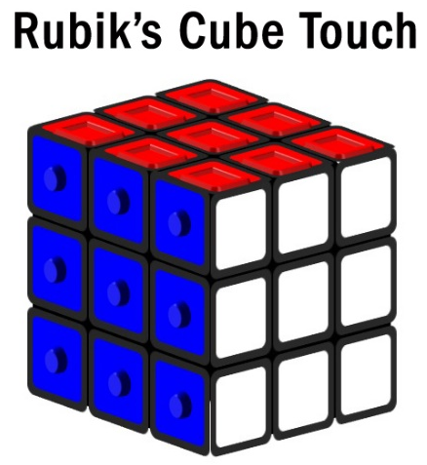  T: How does this Rubik’s cube make it possible for more people to attempt it?  S: This cube has both colors and textures.  T: Just like this Rubik’s Cube, a teacher must consider how they can make learning accessible to all students. This can be accomplished by applying Universal Design for Learning (UDL).  T: Define UDL based on what you remember from our previous lesson.  S: UDL is an educational framework to guide the development of flexible learning environments that can accommodate individual learning differences through engagement, representation, and expression. UDL minimizes barriers and maximizes learning for all students.  T: Yes - research shows that students learn best through the use of multiple methods that encourages active cognitive processing and promotes meaningful learning (Mayer 2003). Because of this, it is important to utilize multiple strategies and techniques to maximize learning for all students.  T: Before we move forward, let’s make a clear distinction between UDL and learning styles. The concept of learning styles is often misinterpreted to mean that individuals have fixed and rigid ways of learning. UDL, on the other hand, supports the understanding that all learners benefit from multiple means of engagement, representation, and expression, which are the key guidelines for UDL.  S: (Take notes on the different between learning styles and UDL in student guide.) | Student Guide  PPT
5 mins | UDL Guidelines  T: The UDL Guidelines provide a set of strategies that can be applied to any subject or grade level to ensure that all learners can access and participate in meaningful, challenging learning opportunities (CAST, 2022).  T: The guidelines are:  - Multiple Means of Engagement  - Multiple Means of Representation  - Multiple Means of Action and expression  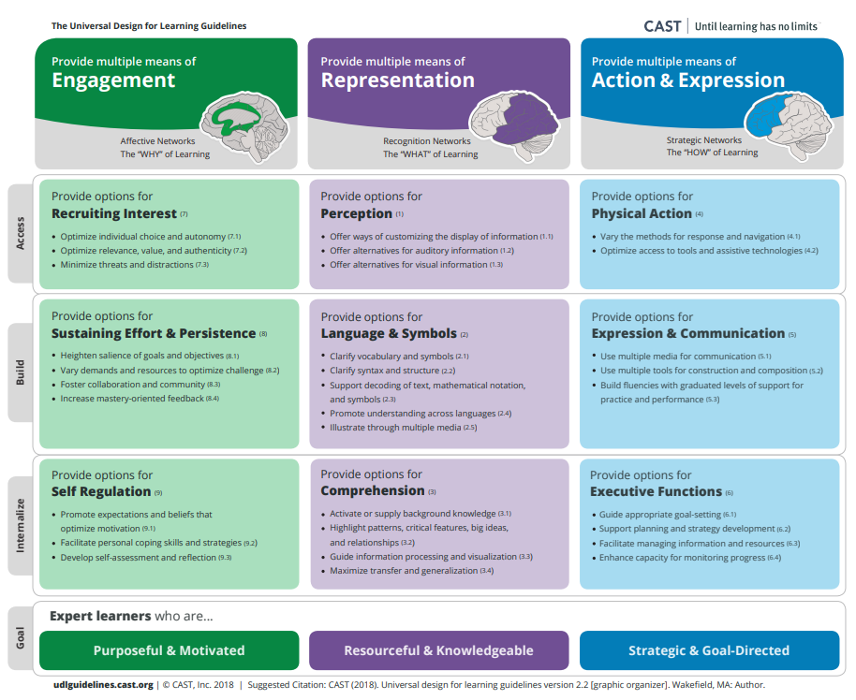  T: These guidelines, when used effectively, help students learn and can help us understand how to best teach so students can learn most effectively.  T: To learn this new material today, we are going to engage in a Jigsaw. You will start in groups where you will learn to be an “expert” around a topic – in this case one of the three UDL guidelines.  T: After you work with your “expert” group, you will work with a “learning” group with members from each of the three expert groups to share your learning. In your learning groups, you will teach each other what you learned.  T: Finally, we will share with the whole group about what we learned to check for understanding.  T: First we will establish our “learning” groups.  T: (Direct students to create groups of 6 with students sitting close to them.)
10 mins | UDL Guidelines Jigsaw - Expert Groups  T: Within your learning group, count off by threes.  S: (Students count off by threes within learning groups.)  T: (Direct students into 3 expert groups around the room, one for each of the three guidelines, ones going with engagement, twos with representation, and threes going with action and expressions. If there is a larger class, consider creating two groups for each guideline expert group, such as two groups working on engagement, two groups working on representation, etc.)  S: (Students move to their “expert” groups with their student guides.)  T: Turn to your student guide and read the descriptions and examples of your assigned guideline.  S: (Students read the materials in the student guide for their guideline – this will likely take 3 or 4 minutes.)  T: Now use the graphic organizer to discuss the guideline and prepare to teach your “learning” group. You want to become an expert. Use the questions in your student guide to guide your discussion and preparation and use the chart to write down what you will share with your “learning” group.  - What are the most important ideas to understand about this guideline?  - Why is it important for teaching and learning?  S: (Students discuss the guideline and prepare to teach their learning group by discussing the questions and filling out the table in their student guide.)  T: (Circulate to “expert” groups to support their discussion and preparation.) | Student Guide
10 mins | UDL Guidelines Jigsaw – Learning Groups  T: Now that each of you have prepared, we are going to return to our “learning” groups and teach each other what we’ve learned. Please return quickly to your learning group.  S: (Return to their original learning groups.)  T: Starting with Guideline 1 – Engagement, experts will share what they learned. Learners should listen and take notes on each guideline in their student guide.  T: Each “expert” presenter will have 2 minutes to share what they learned. If there are two experts on the same topic, share the duties of teaching your fellow “learning” team members.  T: (Display a two-minute timer for the Guideline 1 expert, then two minutes for Guideline 2 expert, and so on).  S: (Experts teach and learners listen and take notes.)
5 mins | Debrief  T: Let’s collectively review what we learned.  T: (Going guideline by guideline, have students explain what they understand about each guideline, correcting and reinforcing the big ideas.)  T: (Display the guidelines slides as students explain the guidelines to the whole class).  S: (Students share their learning about each guideline.)  T: These three guidelines will frame this unit as concrete ways to ensure all learners can access and participate in the learning. Today was an introduction to each guideline. In future lessons, we will spend time learning more about each individual guideline.
5 mins | (Students complete the exit ticket.)

