Unit 8: Planning for Diverse Learners

Lesson 8.03: Multiple Means of Engagement

Lesson at Glance
Warm-Up (5 mins)  - Bell Ringer (5) | Instruction (21 mins)  - Intro to Engagement (8)  - Guideline - Recruiting Interest (8)  - Model of Practice Activity (5) | Application (25 mins)  - Practice – Engagement in the Classroom (17)  - Debrief (3)  - Exit Ticket (5)

TEKS | 3 | The student explores the teaching and training profession. The student is expected to:  - summarize and apply pedagogical knowledge and skills needed by teaching and training professionals;
 | 7 | The student creates an effective learning environment. The student is expected to:  - describe and implement a safe and an effective learning environment that incorporates the principles of universal design;  - evaluate materials and equipment to determine age and grade level appropriateness and to meet the needs of diverse learners;
Rationale/  Summary | Learners differ in what engages their interests, in what motivates them to learn, and in what attracts their attention. This lesson begins with an overview of Multiple Means of Engagement and then dives more deeply into the first guideline – options for recruiting interest. Students will explain why engagement matters and why it is necessary to have multiple means of engagement. Additionally, they will choose between two different lessons to look for evidence of recruiting interest.
Formative Assessment and Exemplar Response | Reflect on the learning goal: Identify ways a teacher can spark excitement and curiosity for learning and explain how those specific strategies can be used in the classroom.  - What parts of today’s lesson were most engaging to you?  - What parts of today’s lesson most impacted your learning?  Read the following scenarios and determine which is more likely to foster student engagement. Explain your reasoning and tell why the use of multiple forms of engagement is important to student learning.  Scenario 1: Ms. C. is about to begin a unit on animals and their life cycles. She asks students to vote on which animal they would like to learn more about. The top 3 votes in the room were frogs, horses, and snakes. Ms. C. begins preparing a unit on animal life cycles focusing on frogs, horses, and snakes. She plans to take her students on a field trip to the local children’s museum where they can learn more about these different animals. Afterwards, she has students create a class book to explain what they learned about each animal and its life cycle. At the end of the project, Ms. C. ask students to share one important thing they learned.  Scenario 2: Mrs. H. is also beginning a unit on animals and their life cycles. She asks students to choose an animal they would like to learn more about during this unit and decide if they would like to work individually or with a partner. Mrs. H. provides students with a playlist of tools and resources on various levels that they can use to learn more about their chosen animal, such as books, videos, photographs, podcasts, etc. Mrs. H. plans to give students a choice in how they present their learning on their animal, either through a brochure, video presentation, poster, PowerPoint or model. At the end of the project, Mrs. H. ask students to reflect on their learning through an “I use to think… Now I think…” prompt to share how their understanding of life cycles progressed from the beginning of the unit to now.  Which scenario is more likely to foster student engagement and why? Explain your reasoning.  Why is the use of multiple forms of engagement important to student learning?  See Exit Ticket – Answer Key for exemplar response.
Vocabulary | Student Engagement |  | The level of attention, interest, and motivation students exhibit in the learning process
Vocabulary | Multiple Means of Engagement |  | Providing various ways of engaging with material to stimulate interest and motivation for learning
Vocabulary | Learning Menu |  | A type of graphic organizer that allows students a menu or choice of learning activities

Est Time | Instructional Activities (including formative assessments) | Materials
 | Prior to this lesson, please have handouts of “The Art of Invention” available for students.
3 mins | Bellringer: Complete the following true/false statements and be ready to explain the reasoning for your choice.  - Every student should complete the same work.  - There is one form of engagement that will work for every student.  - Culture, personal relevance, and background knowledge influences a student’s engagement.  - All students should have the same resources and tools to complete a task.  - Students need a safe and supportive environment where they feel safe to learn and take risks.  - All students like working in groups. | Student Guide  PPT
2 mins | T: Take a minute to compare your bellringer answers with a partner. If you are in an odd row, turn to the person behind you to find your partner. See if you can come to consensus on whether each statement is true or false.  S: (Compare and discuss answers.)
8 mins | Introduction to Engagement  T: Set your bellringer questions aside for the moment. We will return to them later, but first we are going to engage in an activity to get you up and moving.  T: I am going to give you a series of prompts. If you agree with the statement, you will move to this side of the room (point to one side of the room) and if you disagree you will move to this side of the room (point to the opposite side of the room). Be prepared to share your reason for your choice.  T: (Share the prompts below one at a time. Allow time for students to move. Call on a couple of students from each side to give their reasoning for their choice before moving to the next prompt.)  - I work best in groups.  - I like having a choice in what I learn.  - I prefer activities that allow me to actively participate and explore.  - I shut down if the task is too easy or too hard for me to complete.  - I frequently self-reflect on my own personal goals.  T: Was this activity engaging? Why or why not?  S: (Student responses will vary.)  T: Why did I limit the activity to only 5 prompts?  S: So we wouldn’t get bored with the activity. To help us stay engaged.  T: Student engagement is the level of attention, interest, and motivation students exhibit in the learning process. A learner’s engagement can be influenced by many factors, such as their culture, personal relevance, and background knowledge. (Share via PPT while students record definition in student guide).  T: What does this activity show about what people find engaging?  S: Everyone is different and prefers different things.  T: Yes - Learners differ in what engages their interests, in what motivates them to learn, and in what attracts their attention. There isn’t one means of engagement that will work for every learner in every context.  T: How can a teacher use this same principle when designing lessons and instructional activities for students?  S: The teacher must think about what is going to be interesting and engaging to all students, not just a few.  T: As we learned in the Science of Learning, if a student isn’t attending to the content, they cannot cognitively engage, which makes the learning inaccessible.  T: For this reason, it is important that teachers provide multiple means of engagement, which means providing various ways of engaging with material to stimulate interest and motivation for learning.  T: Let’s look at the three guidelines for multiple means of engagement. These guidelines define what multiple means of engagement should look like in the classroom.  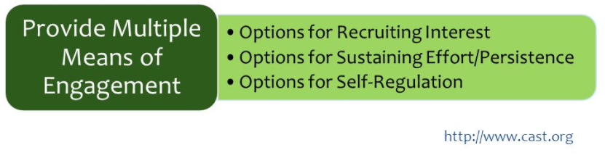  T: Today, we will focus on the first guideline: Options for Recruiting Interest. What do you think is meant by recruiting interest?  S: A teacher should get students interested in a topic at the beginning of a lesson. The beginning of a lesson should spark excitement and curiosity for learning.  T: Yes, before moving into the core instruction, a teacher should first get students interested and curious. Your learning goal for today is to identify ways a teacher can spark excitement and curiosity for learning and explain how those specific strategies can be used in the classroom.  T: What did we do at the beginning of the lesson today that may have been intended to spark interest?  S: We had the opportunity to “test” our current knowledge and share our thinking with our partners. If we had different answers it increased curiosity about the correct answer. You also got us up and moving and thinking about our own preferences so the learning was relevant to us. We were able to compare our preferences to our peers.  T: Yes, all of those things were intended to get you interested in the content of today’s lesson. | Student Guide  PPT
10 mins | Guideline - Recruiting Interests  T: Let’s see what recruiting interest might look like in the classroom. (Share via PPT and walk students through each guideline as student record notes in student guide).  T: Why do you think choice helps a teacher recruit interest?  S: (Answers will vary.) If a teacher’s examples are related to a student’s hobbies, they are more likely to be interested in the content.  T: One thing to note about incorporating a variety of materials and resources is that a teacher must ensure the cultural relevance is genuine and not based on a teacher’s assumption of what is culturally relevant.  T: Can you give an example of a time you didn’t understand why you had to learn something?  S: (Answers will vary.)  T: How about a time you understood the purpose of the learning?  S: (Answers will vary.)  T: How did understanding the purpose of the learning impact your motivation?  S: I was more motivated when I knew why I was learning something and how it might help me in life after school.  T: What does a safe and supportive environment have to do with motivation for learning?  S: Students feel more motivated by teachers who don’t yell at them when they make mistakes. If a student is afraid of making a mistake because of the consequences, they will be less motivated to try.  T: And what about sequence and pacing? Have you ever been in a class that went too fast or too slow for you?  S: Yes.  T: How did that impact your motivation?  S: If it is too slow, I am bored. If it is too fast, I get overwhelmed and quit.  T: Having a choice to move at your own speed is more motivating than having to keep up with a speed set by the teacher.  Adapted from CAST (2018). Universal Design for Learning Guidelines version 2.2. Retrieved from http://udlguidelines.cast.org | Student Guide  PPT
  Recruiting Interest
  Guideline | Examples | Nonexamples
  Allow students choice in how they might reach a learning target | - Provide choice boards (also called menu options and playlists)  - Offer choice in how students work  - Use examples aligned to student hobbies | - Ask all students to complete a research project on the same topic  - Require all students to work independently on a task
  Provide opportunities for students to engage in learning experiences that are relevant and valuable to their goals and individual interests | - Connect content to something relatable to students.  - Incorporate a variety of materials and resources.  - Provide a clear purpose for why the content matters in the real-world. | - Provide materials that are not personalized to students’ lives  - Give assignments with no clear purpose
  Create a supportive environment where students feel safe to learn and take risks. | - Set clear expectations and class routines.  - Use timers, cues, etc. for activities and transitions  - Provide choice in the sequence or pace for completing tasks. | - Allow a chaotic and unorganized learning environment  - Require all students to work at the same pace and complete assignments in the same order
5 mins | Model of Practice Activity  T: In just a few moments, you are going to look for evidence of recruiting interest in an example lesson plan. Before I let you explore a lesson on your own, let’s look at a small portion of a 4th grade ELA lesson together to identify evidence of recruiting interest.  T: (Show the first 1:40 minutes of 4th grade Bilingual ELA Lesson)  T: What evidence of recruiting interest did you see in this short video clip?  S: The teacher used a scenario that was relatable to students.  T: Yes – the teacher told students about a real-life problem she was having that was likely interesting to students and asked the students to help her solve it. I’m going to add that to my graphic organizer beside evidence of -provide opportunities for students to engage in learning experiences that are relevant and valuable to their goals and individual interests.  T: You are going to go through this same process in the practice activity. | Video Example
  Guideline | Evidence from Video Example
  Allow students choice in how they might reach a learning target
  Provide opportunities for students to engage in learning experiences that are relevant and valuable to their goals and individual interests | The teacher told students about a real-life problem she was having that was likely interesting to students and asked the students to help her solve it.
  Create a supportive environment where students feel safe to learn and take risks.
17 mins | Practice – Engagement in the Classroom  T: You are going to look for evidence of recruiting interest in an example lesson. For this activity, you are going to use a Learning Menu. A learning menu is a type of graphic organizer that allows students a menu or choice of learning activities. Here is an example:  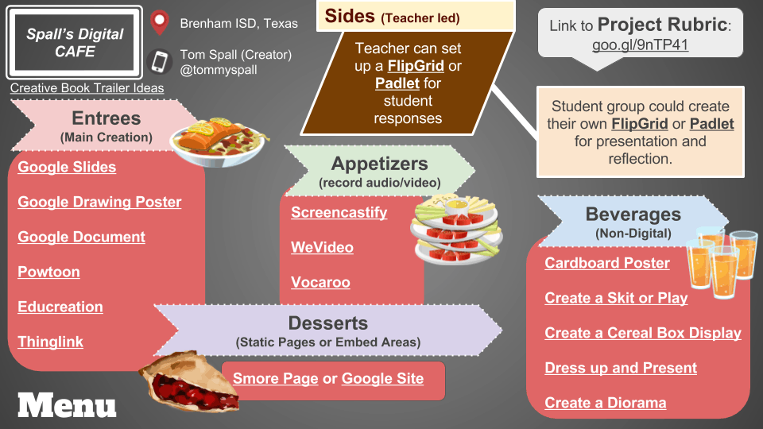  T: You are going to use this learning menu to choose how you will work, the lesson you will analyze, and how you will share your evidence. | Video Example  Grade 4 Unit 2 – The Art of Invention (Handout)
  Appetizer
  Choose how you want to work.
  Alone
  With a partner
  Main Course
  Choose which lesson you want to analyze.
  Video Example: Pre-K Math Lesson
  (Cut video to include just these parts)
  :13-3:57
  5:30-11:29
  19:40-21:53
  Lesson Plan: Grade 4 Unit 2 – The Art of Invention (Handout)
  Dessert
  Choose how you want to share your evidence.
  Graphic Organizer
  Poster
  Video
3 mins | Debrief  T: What were some of the ways the teacher supported student interest and motivation through multiple means of engagement?  S: (Share evidence from student guide.)  T: How did these activities spark excitement and create relevance for students?  S: Students had choice in how they could reach the learning target, opportunities to engage in learning experiences that were relevant and valuable to their individual interests, and a supportive environment where they could feel safe to learn and take risks.  T: How did the menu activity for the lesson analysis provide you with multiple means of engagement?  S: We were able to choose whether we wanted a partner, we were able to choose which lesson format was better for us – written or video, and we were able to choose how we wanted to share our evidence.  T: Let’s return to your bellringer. What are the correct answers?  S: (Share correct bellringer responses.)  T: Why is it important to provide multiple means of engagement?  S: Students differ in what engages their interests, in what motivates them to learn, and in what attracts their attention. There isn’t one means of engagement that will work for every learner in every context.  T: Why does it matter if students are engaged?  S: If a student isn’t attending to the content, they cannot cognitively engage, which means they aren’t going to learn.  T: In our next lesson, we will explore strategies to sustain effort and persistence and self-regulate.
5 mins | (Students complete the exit ticket.) | Exit Ticket

