Exit Ticket

Lesson 8.06: Putting it All Together | Multiple Means of Engagement
Name:
Date:
Examine the lesson plan provided below to evaluate its use of multiple means of engagement. Complete the graphic organizer to record evidence and make suggestions for ways the teacher can include multiple means of engagement through options for recruiting interest, sustaining effort and persistence, and self-regulation.

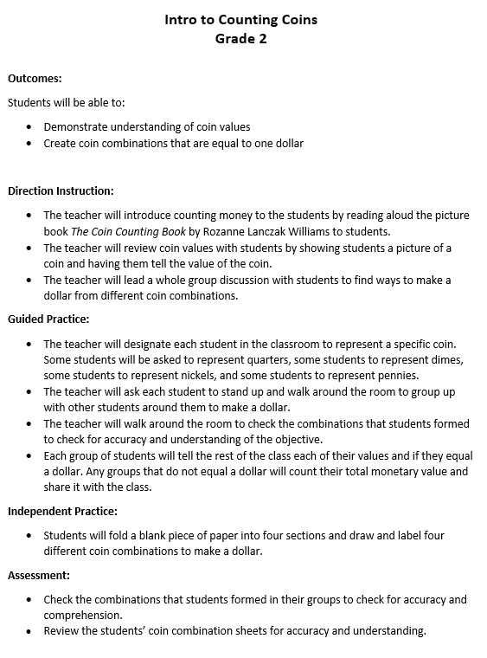

Guideline | Evidence | Suggestions for improvement
Recruiting Interest
Allow students choice in how they might reach a learning target
Provide opportunities for students to engage in learning experiences that are relevant and valuable to their goals and individual interests
Create a supportive environment where students feel safe to learn and take risks.
Sustaining Effort/Persistence
Explain the important of goals and objectives
Provide flexibility with tools and resources to challenge and motivate learners
Foster collaboration and community through flexible grouping
Provide feedback that guides students toward mastery
Self-Regulation
Support learners in setting personal goals that are attainable and that motivate them to take ownership of their learning.
Provide models, scaffolds, and feedback to help learners develop personal coping skills and strategies.
Support learners in developing an awareness of their progress toward goals and how to learn from their mistakes.

