Exit Ticket - Answer Key

Lesson 8.06: Putting it All Together | Multiple Means of Engagement
Name:
Date:
Examine the lesson plan provided below to evaluate its use of multiple means of engagement. Complete the graphic organizer to record evidence and make suggestions for ways the teacher can include multiple means of engagement through options for recruiting interest, sustaining effort and persistence, and self-regulation.

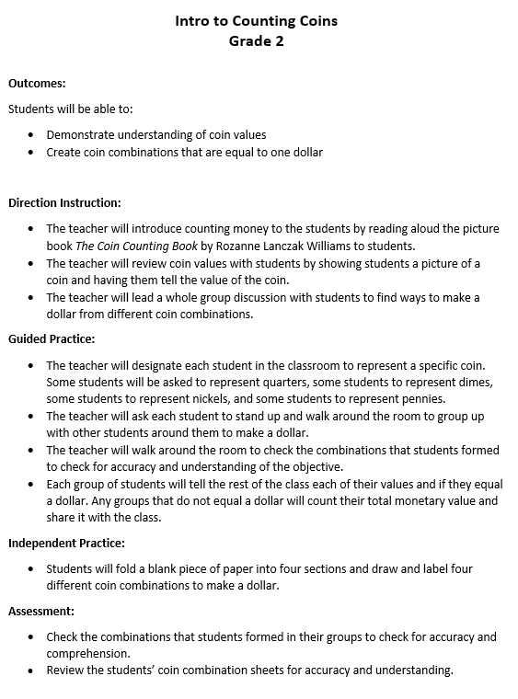

Guideline | Evidence | Suggestions for improvement
Recruiting Interest
Allow students choice in how they might reach a learning target | - Students had a choice in the coin combinations created to make a dollar | - Students had a choice in the coin combinations created to make a dollar
Provide opportunities for students to engage in learning experiences that are relevant and valuable to their goals and individual interests |  | - Ask students to think about where they’ve seen coins used and how they’ve been used.  - Have students share what they know about the different coin values
Create a supportive environment where students feel safe to learn and take risks. |  | - The teacher could remind students of the expectations and class norms as they moved into the guided practice activity.
Sustaining Effort/Persistence
Explain the important of goals and objectives |  | - The teacher could explain why being able to count money and create different coin combinations to make a certain amount is important
Provide flexibility with tools and resources to challenge and motivate learners |  | - The teacher could provide various tools and resources for students to use to practice making coin combinations that are equal to one dollar, such as a grocery store station, digital money app, etc.
Foster collaboration and community through flexible grouping | - The teacher allowed students to group up with others around the room to create a dollar
Provide feedback that guides students toward mastery | - The teacher walked around the room to check the combinations students formed | - The teacher could provide specific feedback to students to guide their progress toward the learning goal.
Self-Regulation
Support learners in setting personal goals that are attainable and that motivate them to take ownership of their learning. |  | - The teacher could allow students to set their own personal goals related to the overall objective.
Provide models, scaffolds, and feedback to help learners develop personal coping skills and strategies. |  | - The teacher could model what to do during the guided practice or independent activity if they were unable to create a dollar using their different coin values. The teacher could provide scaffolds and supports in case students got stuck, such as a money flip book or poster in the room.
Support learners in developing an awareness of their progress toward goals and how to learn from their mistakes. |  | - The teacher could offer opportunities for students to self-assess and reflect on their own learning after the lesson.

