Unit 8: Planning for Diverse Learners

Lesson 8.07: Multiple Means of Representation and Options for Perception

Lesson at Glance
Warm-Up (5 mins)  - Bell Ringer (5) | Instruction (16 mins)  - Introduction to Multiple Means of Representation (8)  - Introduction to Options for Perception (8) | Application (24 mins)  - Video Viewing (8)  - Practice: Application of Multiple Modalities (10)  - Debrief (3 mins)  - Exit Ticket (3)

TEKS | 3 | The student explores the teaching and training profession. The student is expected to:  - summarize and apply pedagogical knowledge and skills needed by teaching and training professionals;
 | 7 | The student creates an effective learning environment. The student is expected to:  - describe and implement a safe and an effective learning environment that incorporates the principles of universal design;  - evaluate materials and equipment to determine age and grade level appropriateness and to meet the needs of diverse learners;
 | 10 | The student develops technology skills. The student is expected to:  - describe the role of technology in the instructional process;  - use technology applications appropriate for specific subject matter and student needs;
Objectives | - Identify strategies for providing multiple means of representation  - Brainstorm options for providing multiple means of representation
Rationale/  Summary | Learners perceive and comprehend information that is presented to them in different ways; therefore, there isn’t one means of representation that will work for every learner. In this lesson, students will define multiple means of representation and learn about strategies to provide options for perception, which is the first of the UDL guidelines for representation. Students will practice brainstorming options for adding multiple means of perception to lesson plan activities.
Formative Assessment and Exemplar Response | Students will examine a nonexample lesson plan to evaluate its use of multiple modes of representation. Students will make suggestions for ways the teacher might include multiple options for perception.  See Exit Ticket – Answer Key for exemplar response.
Vocabulary | Multiple Means of Representation |  | Presenting information and content in different ways to support learning for all students.
Vocabulary | Perception |  | A way of understanding or interpreting information
Vocabulary | Modality |  | A form of sensory perception

Est Time | Instructional Activities (including formative assessments) | Materials
4 mins | Bellringer: A second-grade science teacher uses pictures and music to introduce new vocabulary related to the learning objective. She reads each word aloud and has the students practice their pronunciation. During the lesson, students watch a video, read or listen to an article on their iPads, and play a game that matches pictures, vocabulary, and real-world scenarios related to the objective.  How might this approach to introducing new vocabulary benefit students? | Student Guide
1 min | T: How do you think this teacher’s approach to new vocabulary helped students learn?  S: Through this approach, students can visualize and hear the new vocabulary in different ways. Students have various options for engaging in activities around the learning objective. This increases their motivation because they can choose an option that interests them. The activities also allow students to apply the new vocabulary in different contents, which leads to deeper understanding.  T: Why do you think it is important for students to see new vocabulary and concepts in different ways?  S: Students process information in different ways, so it helps to see it in different forms.  T: Yes, students process information – that is, they perceive it and come to understand it – in different ways, so it is important to use a variety of strategies to represent information.
8 mins | Intro to Multiple Means of Representation  T: We can use an understanding of modalities to help us brainstorm options for perception within a lesson.  T: (Use PPT to review definition of modality.) Please take notes in your student guide. A modality is a form of sensory perception – a way that you perceive information through your senses.  S: (Take notes in student guide.)  T: There are multiple modalities. We will focus on audio, visual, verbal (reading/writing), and kinesthetic/sensory (movement/touch). To be clear, these are not the same as learning styles. When people think about learning styles, they mistakenly think that each student has a fixed way of learning that works best for them. Unlike fixed learning styles, the idea of using multiple modalities is about showing the same information in multiple ways to allow various options for processing. Presenting information using multiple modalities helps ensure that students have multiple ways to perceive and think about the information. Let’s look at an example.  T: Let’s say you want to visit The Alamo. You ask your neighbor for directions. Your neighbor says to take I-37 to Commerce Street, then turn on Alamo Plaza. The Alamo will be about a quarter mile down the road.  (Modality: Verbal directions with an image of destination)    T: (Share and define modalities via PPT as each is presented). If you live in the area or have a good sense of direction, those directions could be useful to you. You may need to accompany those verbal directions with specific exit numbers or landmarks to help you determine whether you are going in the right direction. You may also benefit from having a printed map to help you visually see where your destination is in relationship to where you started. You may even choose to use a GPS app on your phone to have verbal cues and an interactive map.  (Modality: Map and printed directions with exit numbers)    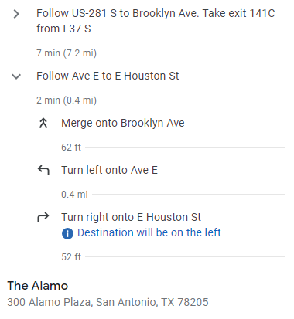  (Modality: GPS app that had an interactive map and verbal directions)  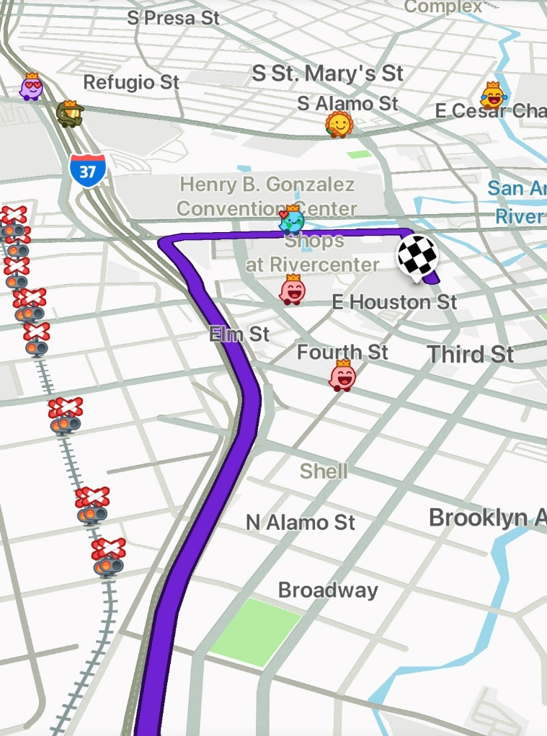  T: Why are these different modalities helpful?  S: People process information in different ways. Some people do better when they have verbal cues instead of having to read a map. If someone wants to get to the Alamo and the information is presented in multiple ways, they get to choose the option that works best for them.  T: Yes – All of these modalities provide the same information; they just present the information in different ways.  T: Learners perceive and comprehend information in different ways. It is also important to remember that some students have sensory disabilities, such as blindness or deafness, some have language barriers, and some students comprehend information faster through visual means than verbal means. There isn’t one means of representation that works for every learner.  T: We also know that students must experience learning in multiple ways to engage the working memory to make meaning of and connections between the ideas and concepts. This helps move the learning from the short-term to the long-term memory.  T: Because of this, teachers must be intentional about providing multiple means of representation or presenting information and content in different ways to support learning for all students.  T: To provide multiple means of representation, a teacher must consider these three guidelines:  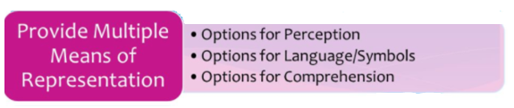  T: Let’s start by learning more about Options for Perception. | Adapted from Access MOOC Video
8 mins | Introduction to Options for Perception  T: Options for perception mean that a teacher must provide flexibility in how students can interact with or perceive the content. This mean that information is presented in multiple forms, such as visually, orally, or through movement or touch.  T: Let’s look at what options for perception might look like in the classroom using this short video clip. As you watch, record notes on the different strategies for perception in the graphic organizer in your student guide. (Share video. Pause after each guideline to allow students to record notes in student guide and to provide nonexamples. Stop video at 1:23)  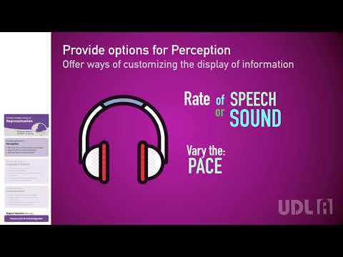  Adapted from CAST (2018). Universal Design for Learning Guidelines version 2.2. Retrieved from http://udlguidelines.cast.org  T: How did this video model options for perception?  S: There was a speaker who shared the information out loud. His voice was accompanied by text on the screen so that we could also see the information. Each slide also used graphics to highlight important information so that what we saw wasn’t only words but also images.  T: Yes, the video used audio, text, and images to provide options for perception.  T: Here are a few examples of different ways to present information to students:  T: Technology also provides many options for perception. What are some digital apps or tools you have seen used that could also help teachers present information in different ways?  S: (Answers will vary)  T: How do these strategies support multiple means of representation?  S: Students have options for how they access the content and information, which makes learning accessible for all learners. | Student Guide  PPT  UDL A Representation Perception Video Link: https://www.youtube.com/watch?v=AK5xMZYnf24
  Perception
  Guideline | Examples | Nonexamples
  Offer options for customizing the display of information | - Provide materials that allow students to modify the size of texts and graphics, colors, and layout  - Provide materials that allow students to change the rate of speech or sound and vary the pace and sequence of information | - Provide all students with the same written text to read.  - Require students to read an eBook without a read-aloud function or options to modify the size of the font.
  Offer alternatives for auditory information | - Show visuals  - Provide closed captioning  - Provide written transcripts from videos  - Offer tactile alternatives for sound effects | - Present information through a lecture  - Share videos without closed captioning or written transcripts
  Offer alternatives for visual information | - Use audio  - Provide descriptions for images and graphics  - Provide tactile resources | - Present a graph without a description of what the graph is about.  - Share picture of a globe without access to a tactile representation of a globe.
   | Sound, Music, Audio
   | Video
   | Closed Captioning
   | Graphs, charts, diagrams
   | PowerPoint or Lecture
   | eBooks
   | Books
   | Magazines
8 mins | Video Viewing  T: Let’s see what this looks like in the classroom. We are going to watch a short clip of a teacher’s instruction about making inferences. As you watch take note in your video guide of any evidence that shows use of multiple modalities. (Show 4th grade bilingual ELA Mitchell Video 20:17 – 23:00.)  S: (Take note of multiple modalities in student guide.)  T: What did you see in the video clip that showed the teacher using multiple modalities?  S: The teacher reviewed a chart at the front of the room about inferences. The chart for making inferences and the other charts the teacher reviewed about what good readers do all included visual cues. The teacher also explained the process of making inferences out loud for students and showed sentence stems on the board. She used audio and written verbal information. The teacher also showed a video with examples of students making inferences. The teacher did not use kinesthetic or sensory materials in this lesson.  T: That’s right. The teacher used audio, visual, and verbal information in this lesson. | Bilingual ELA Video Example
10 mins | Practice: Application of Multiple Modalities  T: Now it’s your turn to think about how you might use multiple modalities in a lesson. You will read a scenario, identify the modality the teacher is using and then brainstorm additional ways you might present the information to address multiple modalities. Find the practice activity in your student guide.  S: (Find practice activity.)  T: Let’s start the first one together. In this scenario, the teacher is using a podcast that explains the differences between rocks as a part of an introduction to an erosion unit. What modality is the teacher using here?  S: Audio.  T: That’s right. What might she do to address a different modality?  S: (Answers will vary.) She could let students read along with a transcript of the podcast or give some students the option of reading the transcript of the podcast instead of listening. She could create a video to go along with the podcast. The video could show images of important information. She could bring in actual rocks so students can touch them.  T: Now it’s your turn. Work with a partner to read the remaining scenarios and to brainstorm additional modalities the teacher could include. If you are in an odd row, find the person behind you to work with. Identify at least two more modalities for each scenario.  S: (Find partners and work on scenarios.)
3 mins | Debrief  T: What were some of the ideas you had to add modalities to the practice scenarios?  S: (Share multiple responses for each scenario.)  T: Why is it important to consider ways to include multiple modalities in a lesson?  S: Not all students process information the same way. Including multiple modalities provides opportunities for all students to perceive the information, including students who may have disabilities that make some modalities difficult for them. Multiple modalities also offer multiple opportunities for students to process information. Multiple opportunities also increase the likelihood of transfer to long-term memory.
3 mins | (Students complete the exit ticket.) | Exit Ticket

